**Lab Assingment-1**

1. display all suppliers who statys in state either in california or Texas or Arkansas.

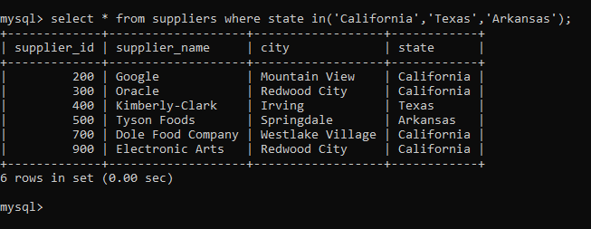

2. find all suppliers with supplierid >=200 and <=700

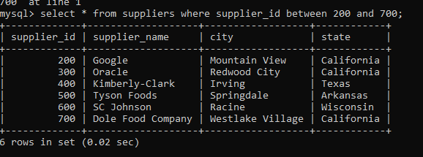

3. find all suppliers with supplierid not >=200 and not <=700

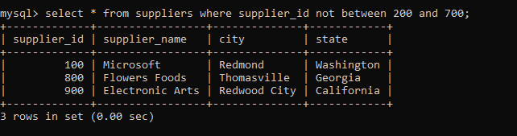

4.list all suppliers who does not stay in Springdale

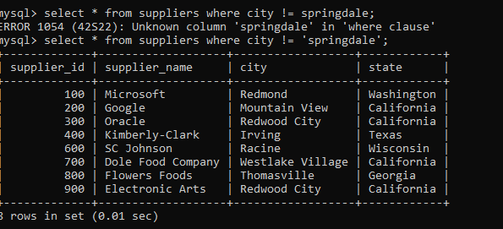

==============================================

5.find orderid and customerid for orders place on date 18-feb-16

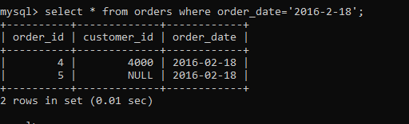

6.find orderid and customerid for orders place on feb 2016

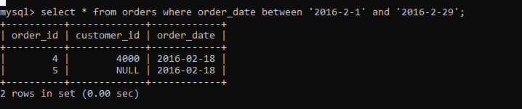

7.find all customers with name 'Reynolds', or Anderson

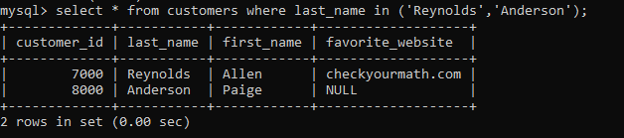

**8. find all customers for whome favorite_website is not given**

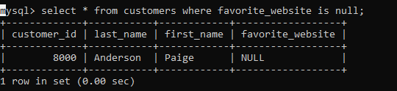

**9. find all customers for whome favorite_website is given**

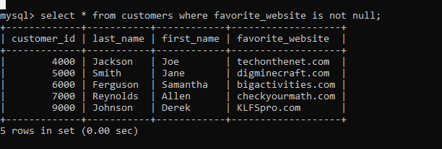

**Database Assignment 2**

Note : Use Emp, dept and salgrade table

1. To list all records with sal > 2000 and comm>200

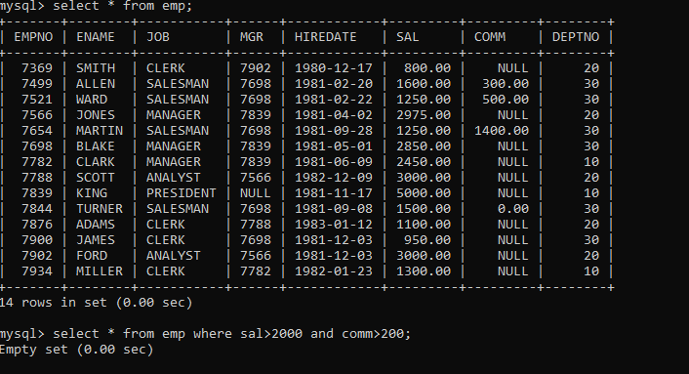

1. To list all record with job=’Clerk’ or sal>2000

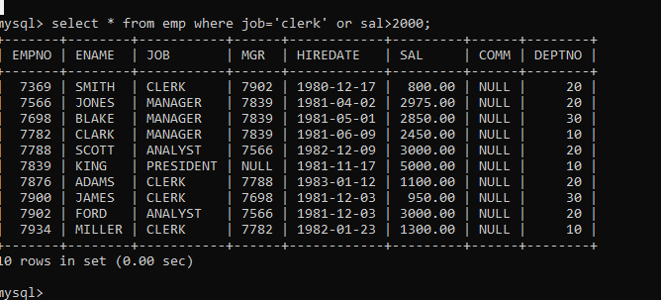

1. To list all the record with sal=1250 or 1100 or 2850

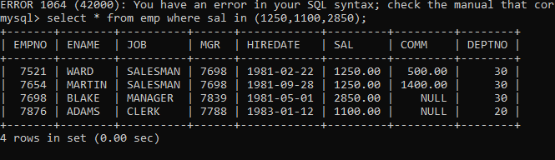

1. To list all employees with sal>1250 and <2850

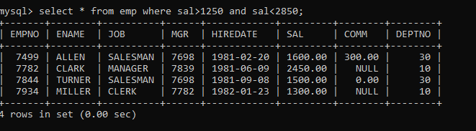

1. To list all employees with name ends with AS

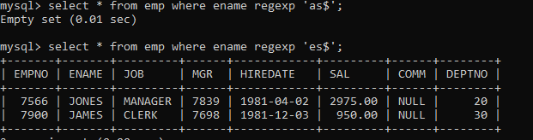

6. To list all employees with job starts with C and ends with K

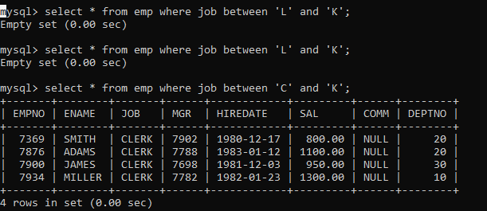

1. To list all employees with job contains L at third position and M at third last position.

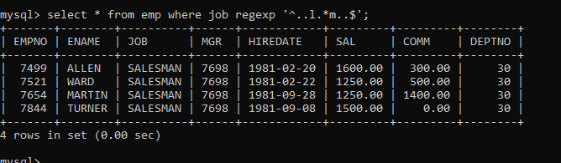

7. To list all the record with sal not equal to 1250 or 1100 or 2850

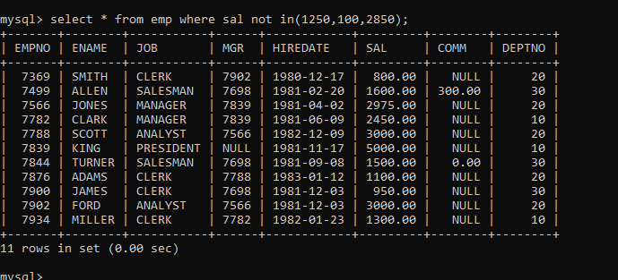

9. To list all employees with sal not >1250 and <2850

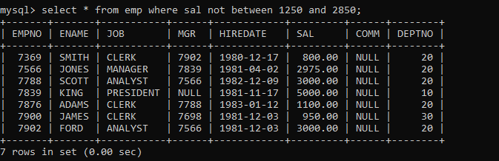

10. To list all employees with job starts with C , E at 3rd position and ends with K

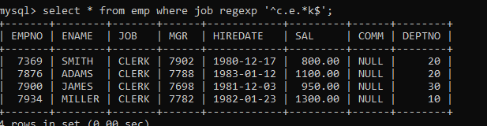

11. To list all rows with comm is null

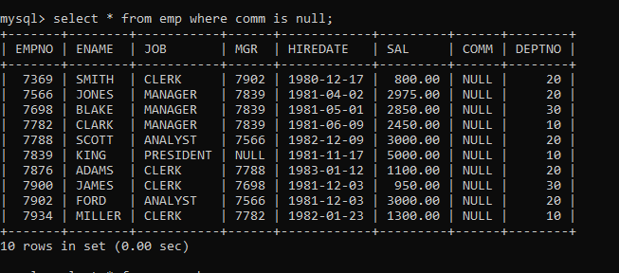

12. To list all employees with sal is null and name starts with ‘S’

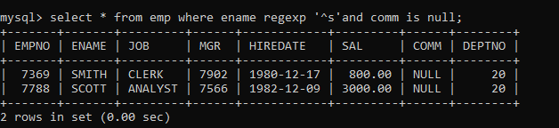

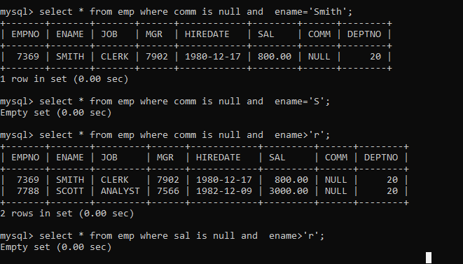

13. To list all employees with job contains 5 characters

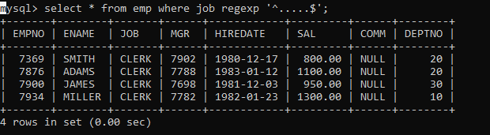

14. To list all employees with name contain ‘A’ at 1 position and job Contains 5 characters

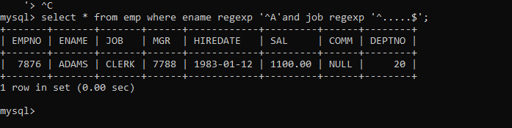

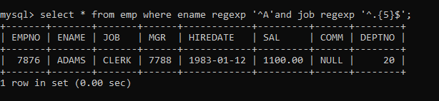

Single Row functions

1. To list all employees and their email, to generate email use 2 to 5 characters from ename

Concat it with 2 to 4 characters in job and then concat it with ‘@mycompany.com’

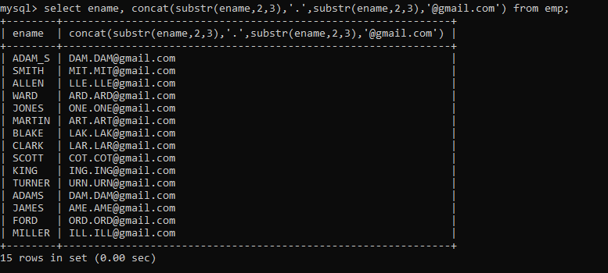

2. List all employees who joined in September.

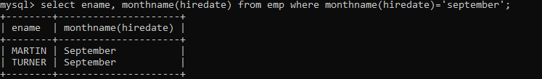

3. List the empno, name, and department number of the emp who have experience of 18 or

more years and sort them based on their experience.

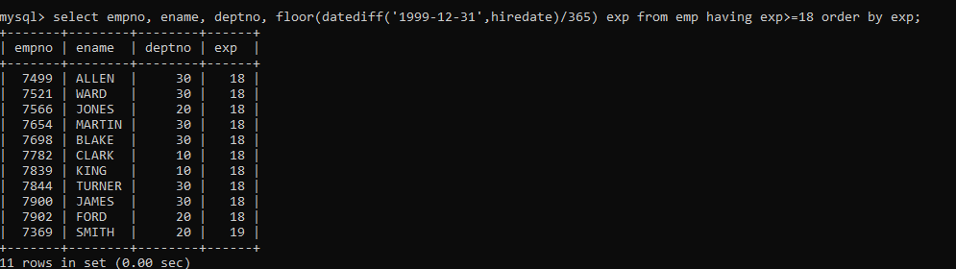

4. Display the employee details who joined on 3rd of any month or any year

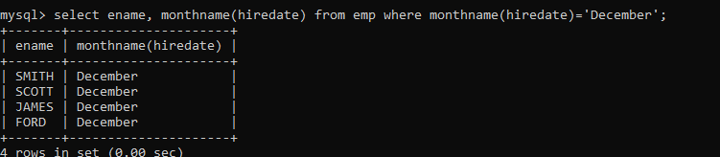

5. display all employees who joined between years 1981 to 1983.

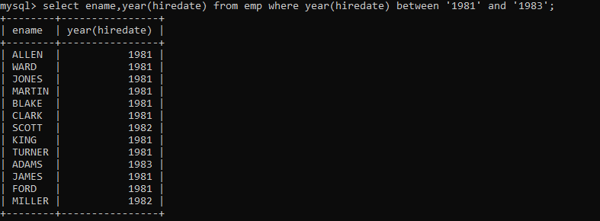

**DAY-2**

1. Retrieve the details (Name, Salary and dept no) of the emp who are working in

department code 20, 30 and 40.

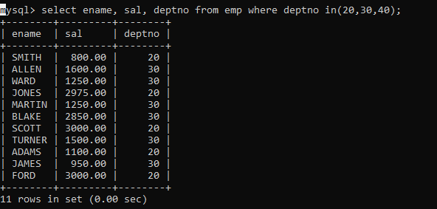

2. Display the total salary of all employees . Total salary will be calculated as

sal+comm+sal*0.10

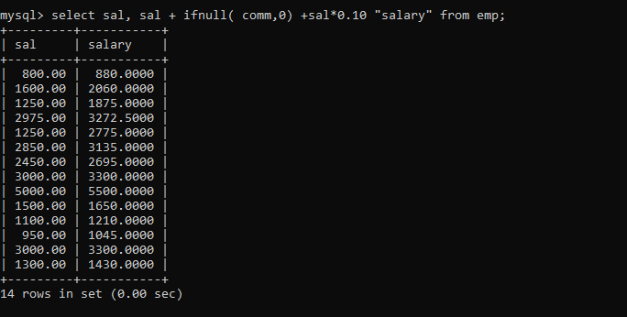

3. List the Name and job of the emp who have joined before 1 jan 1986 and whose

salary range is between 1200and 2500. Display the columns with user defined Column

headers.

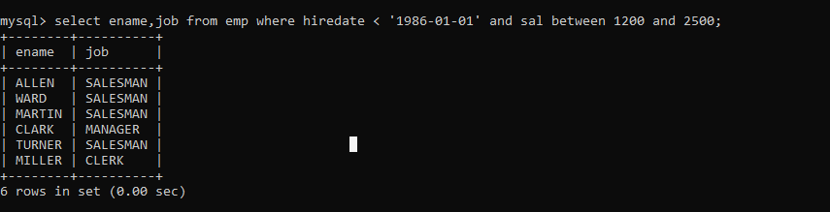

4. List the empno, name, and department number of the emp works under manager

with id 7698

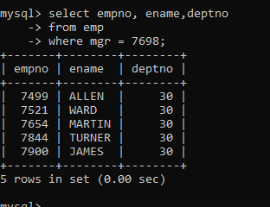

5. List the name, job, and salary of the emp who are working in departments 10 and

30.

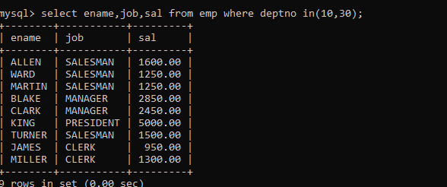

6. Display name concatenated with dept code separated by comma and space. Name

the column as ‘Emp info’.

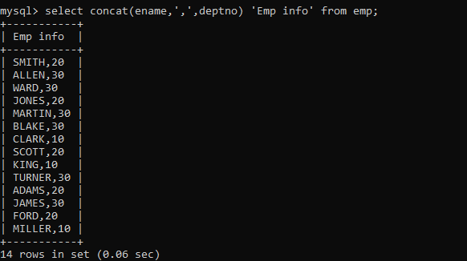

7. Display the emp details who do not have manager.

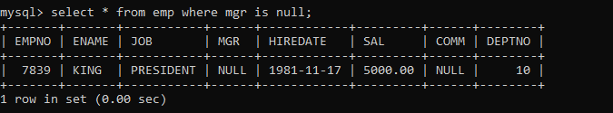

8. Write a query which will display name, department no and date of joining of all

employee who were joined January 1, 1981 and March 31, 1983. Sort it based on date of

joining (ascending).

select ename,deptno,hiredate

from emp

where hiredate between '1981-1-1' and '1983-3-31'

order by hiredate

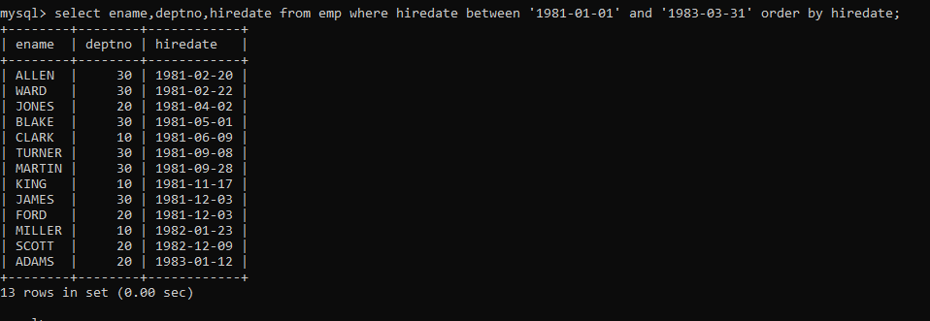

9. Display the employee details where the job contains word ‘AGE’ anywhere in the Job

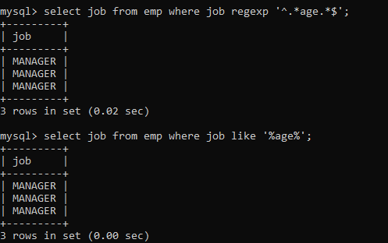

11. List the details of the employee , whose names start with ‘A’ and end with ‘S’ or

whose names contains N as the second or third character, and ending with either ‘N’ or ‘S’.

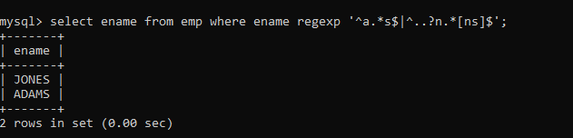

**DAY-3**

practice DQL statement

Write SQL statement for the following

1. To find all managers with salary >1500

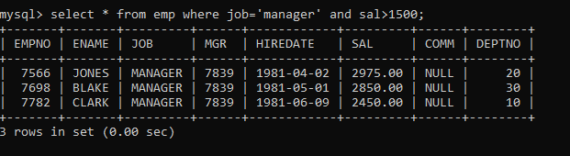

2. list all employees with sal >1200 and < 2000

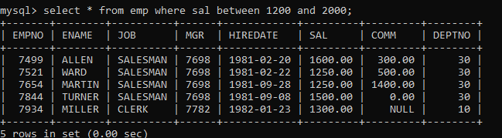

3. list all employees with sal is 1600 or sal is 800 or sal is 1900

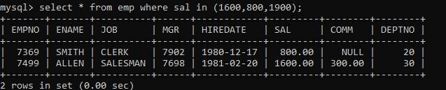

4. list all employees with R at second last position in name

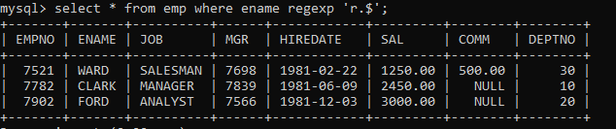

5. List all employees with name starts with A and ends with N

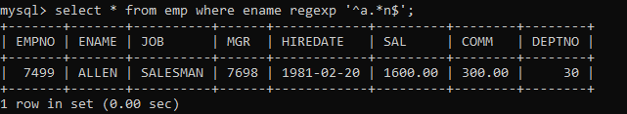

Q2. Solve following

1. list all employees with salary > 1250 and dept no=30

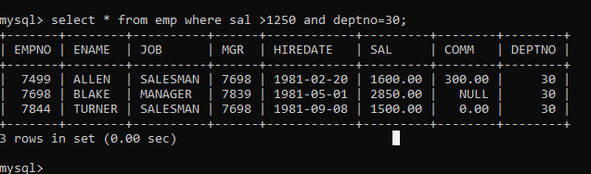

1. list all employees with salary >=1250 and <= 3000

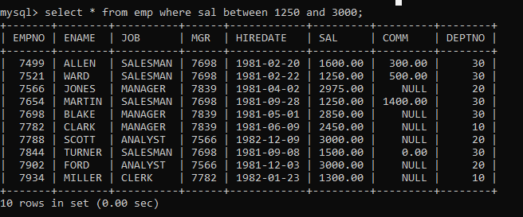

1. list all employees with salary >1250 and < 3000

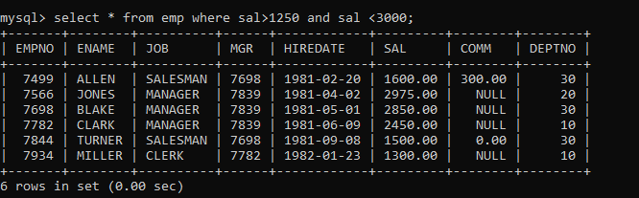

1. list all employees with salary either equal to 3000 or 1250 or 2500

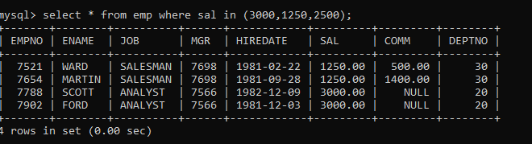

1. list all employee with name=SMITH

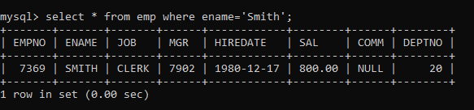

1. list all employees with name starting with S

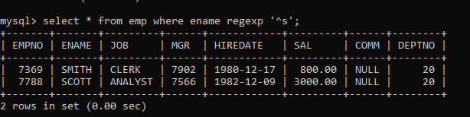

1. list all employees with name ending with S

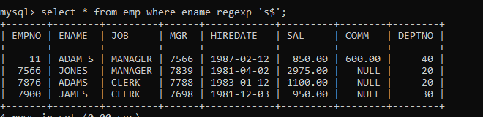

1. list all employees with name contains I at 2nd position

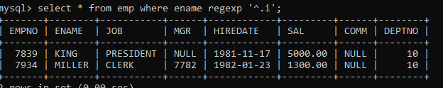

1. list all employees with name starts with A ends with N and somewhere in between L is there

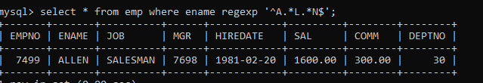

1. list all employees with name starts with A and B at 3 rd position and P at second last position

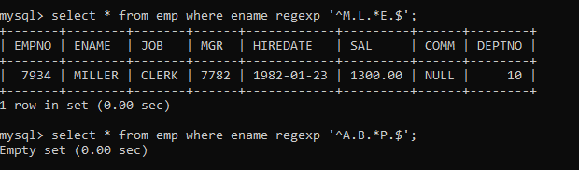

1. List all employees with name starts with either A or starts with S or starts with W

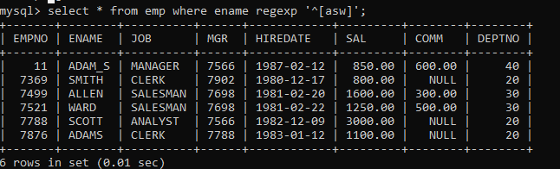

**DAY-4**

**Update :-**

35. Update employee sal ---- increase sal of each employee by 15 % sal +comm, change the job to

manager and mgr to 7777 for all employees in deptno 10.

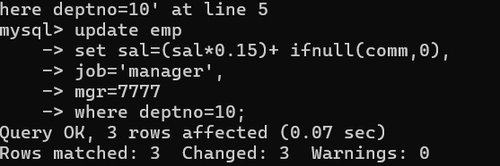

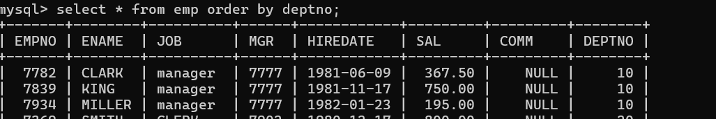

36. change job of smith to senior clerk

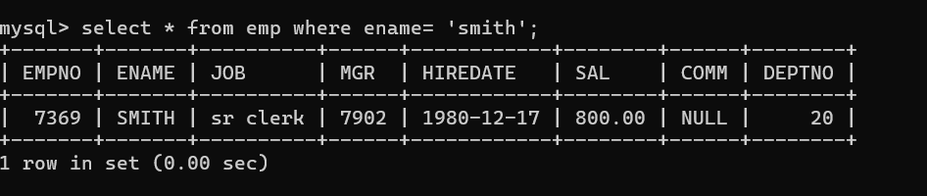

37. increase salary of all employees by 15% if they are earning some commission

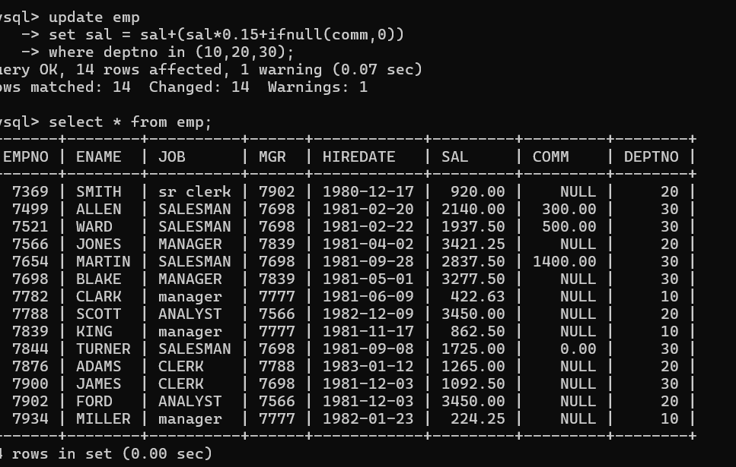

**Nested qury:-**

38. list all employees with sal>smith's sal

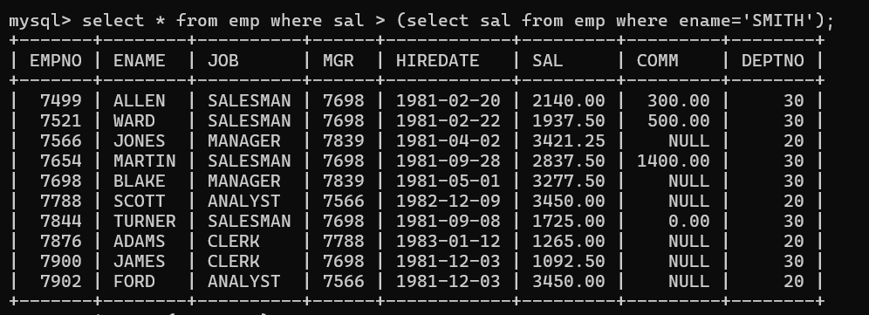

39. list all employees who are working in smith's department

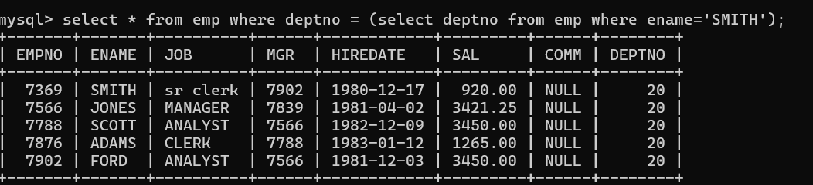

40. list all employees with sal < rajan's sal and salary > revati's sal

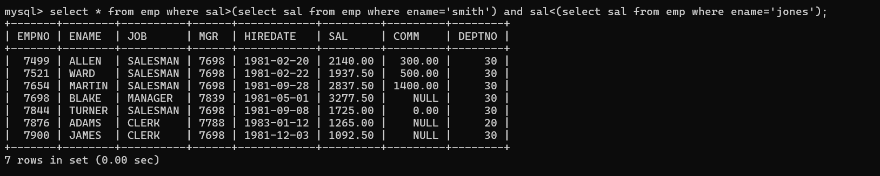

41. delete all employees working in alan's department

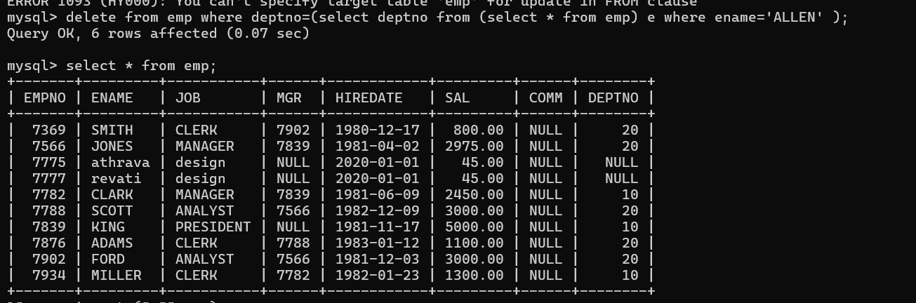

42. change salary of Alan to the salary of Miller.

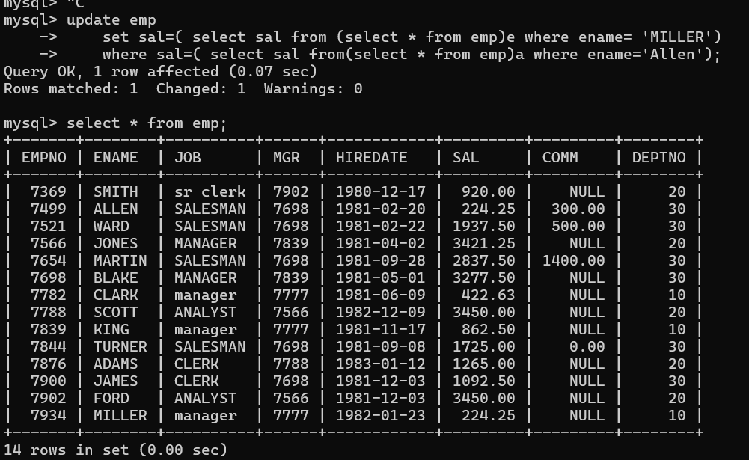

43. change salary of all emplees who working in Wall's (Ward)department to the salary of Miller.

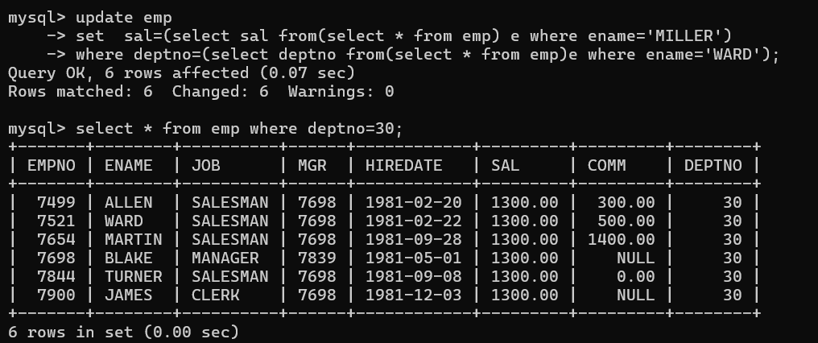

44. list all employees with salary > either Smith's salary or alan's sal (questin why we use aggeregate func max(sal))

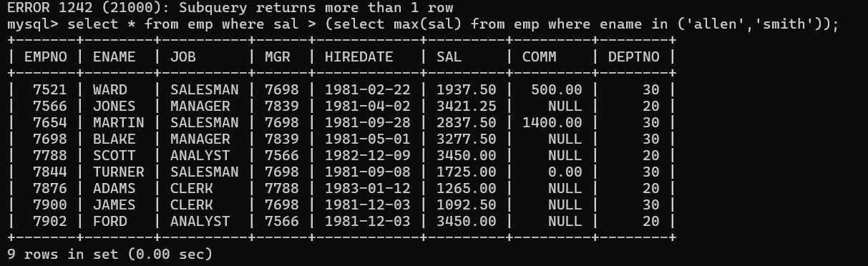

45. list all employees who earn more than average sal of dept 10

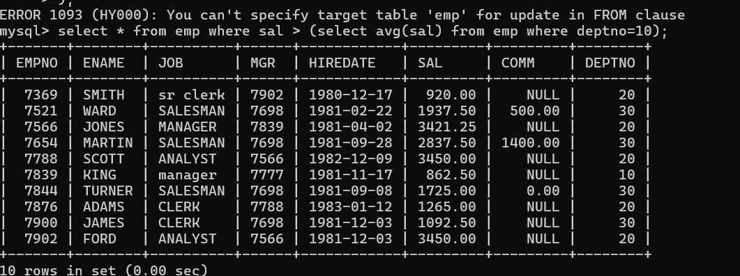

46. list all employees who earn more than average sal of Alan's department

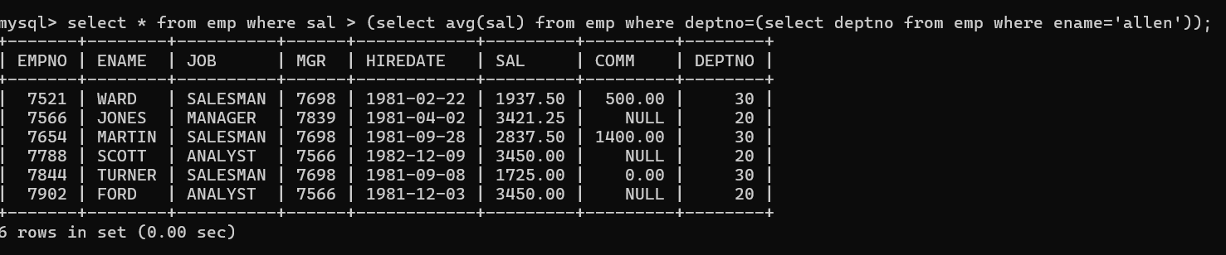

47. list all employees who are working in purchase (research)department

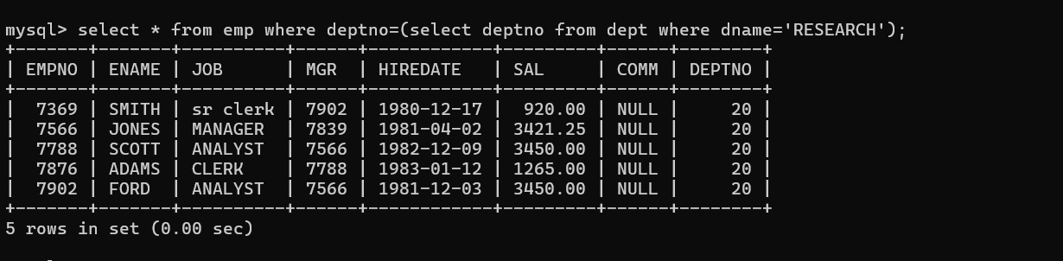

**CORELATED QUERIES:-**

48. list all employees who earn more than average salary of their own department

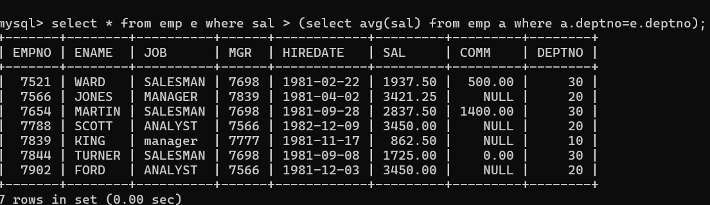

49. list all employees who earn sal < avg (sal )than their managers salary (mgr)

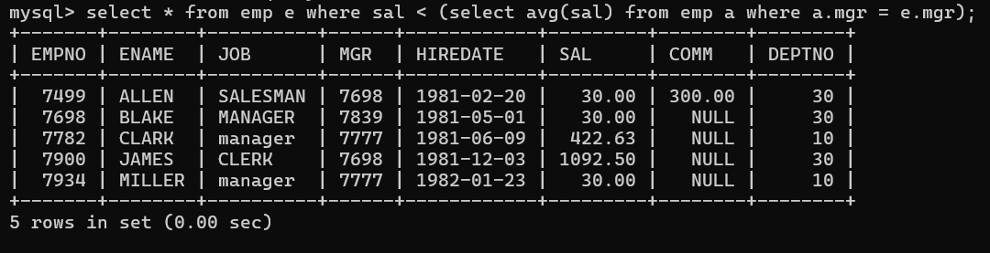

50. list all employees who are earning more than average salary of their job

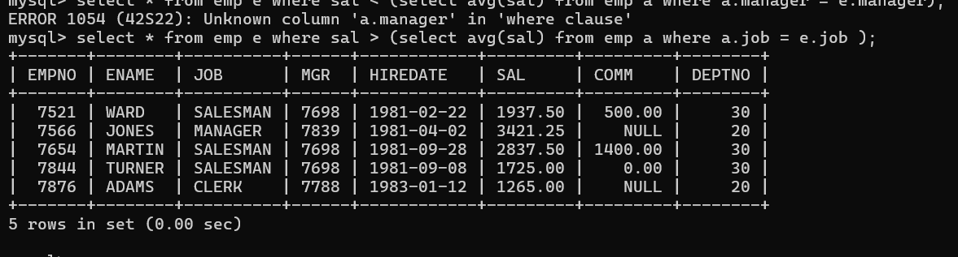

51. display empno,name,department name and grade (use emp,dept and salgrade table)

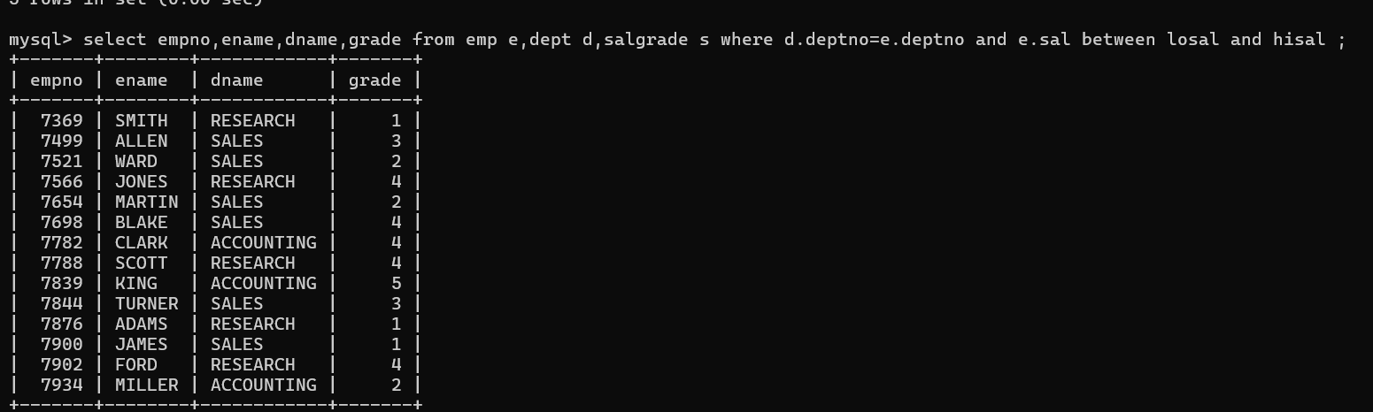

52. list all employees number,name, mgrno and manager name

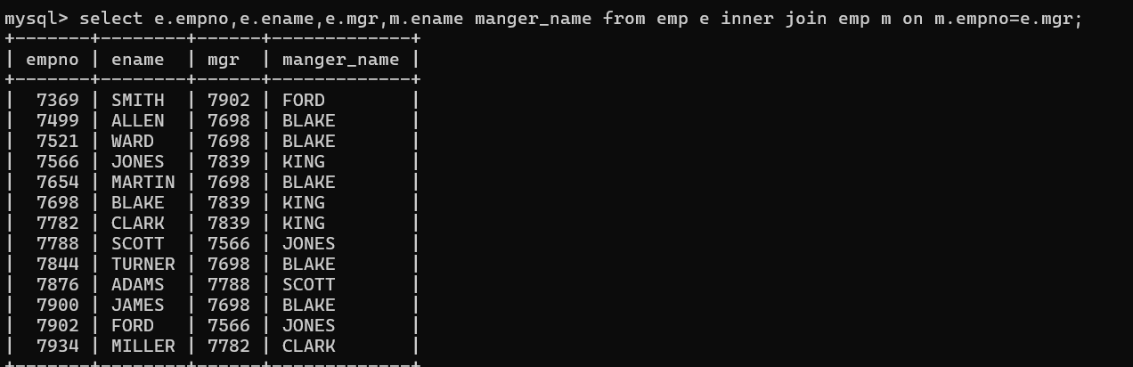

**DAY-5**

54. create following tables and solve following questions(primary keys are marked in yellow)

foreign keys are marked in green

product(pid,pname,price,qty,cid,sid)

salesman (sid,sname,address)category

category(cid,cnam,descritpion)

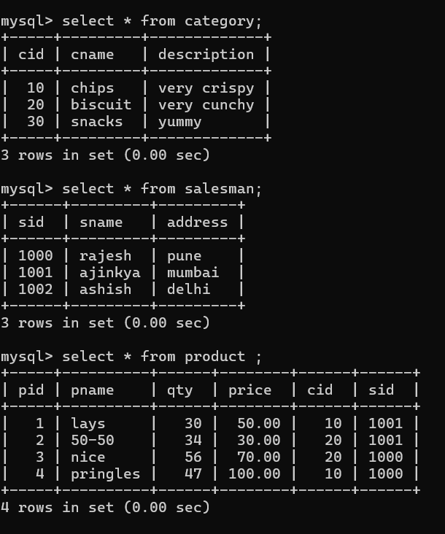

1. list all product name,their category name and name of a person, who sold that product (join)

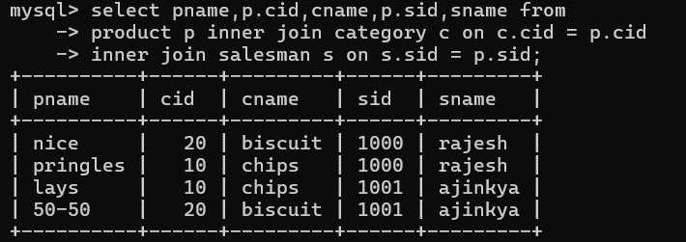

2.list all product name and salesman name for all salesman who stays in pune

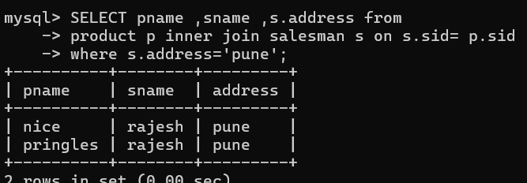

55. create following tables and solve following questions(primary keys are marked in yellow)

foreign keys are marked in green

faculty(fid,fname,sp.skill1,sp.skill2)

courses(cid,cname,rid,fid)

room(roomid,rname,rloc)

faculty

fid fname spskill1 spskill2

10 kjzhcjhz a b

11 sdd x z

12 lksjk a x

13 ksdjlkj a b

courses

cid cname rid fid

100 jasmin 1st floor

131 DAC 101

141 DTISS

151 DIOT 105 12

Room

roomid rname rloc

100 jasmin 1st floor

101 Rose 2nd floor

105 Lotus 1st floor

103 Mogra 1st floor

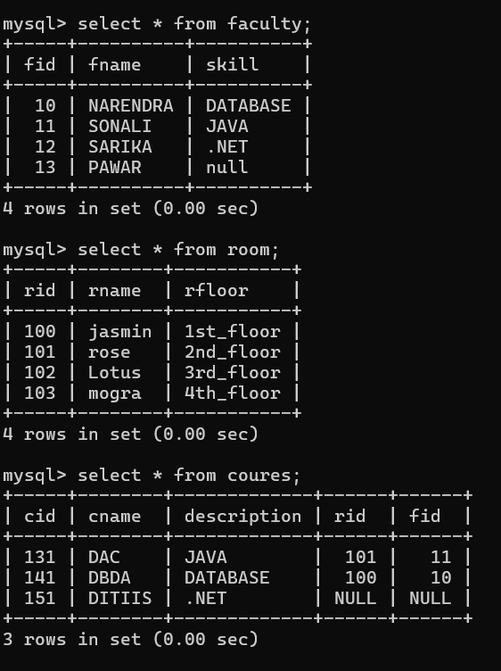

1. list all courses for which no room is assigned and all rooms for which are available

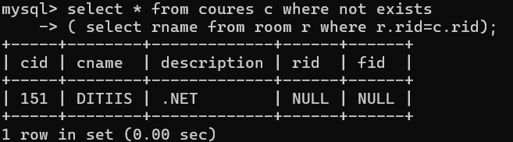

1. list all faculties who are not allocated to any course

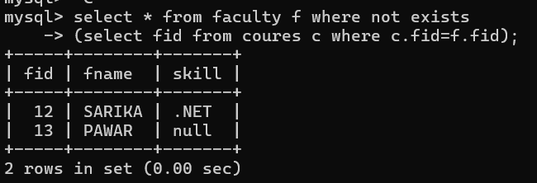

1. list all rooms which are allocated to any courses

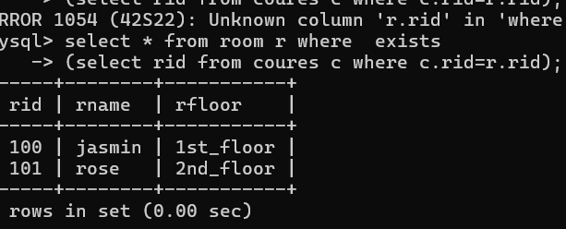

4 list all rooms which are not allocated to any courses

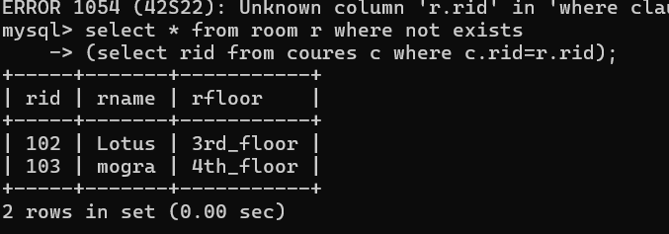

1. display courses and faculty assigned to those courses whose special skill is database

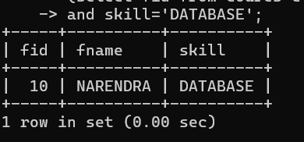

6. display time table --- it should contain course details , faculty and room details

56. create following tables with given constraints

product---- qty >0, default 20.00,pname not null and unique

prodid pname qty price catid sid

123 lays 30 30.00 1 12

111 pepsi 40 50.00 4 11

134 nachos 50 50.00 1 12

124 dairy milk 40 60.00 2 14

124 pringles 40 60.00 1 14

saleman ----- sname -----not null

sid sname city

11 Rahul Pune

12 Kirti Mumbai

13 Prasad Nashik

14 Arnav Amaravati

category ---- cname unique and not null

cid cname description

1 chips very crunchy

2 chocolate very chocolaty

3 snacks yummy

4 cold drinks thanda thanda cool cool

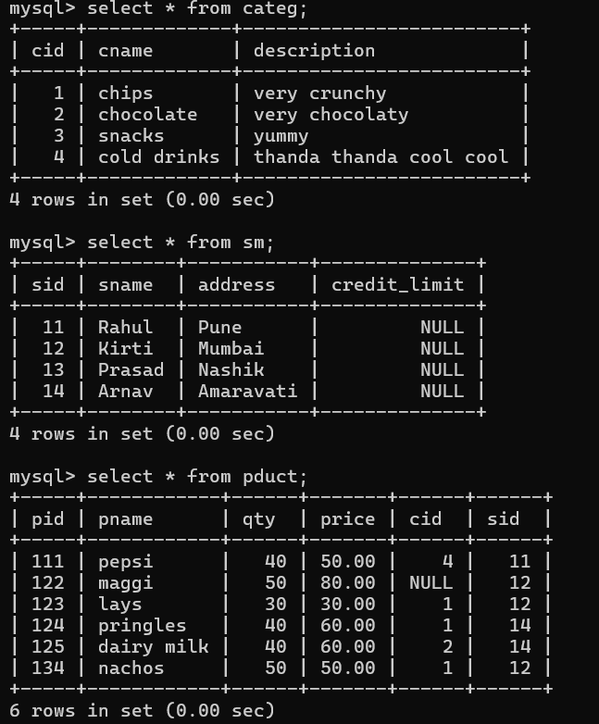

1. List all products with category chips

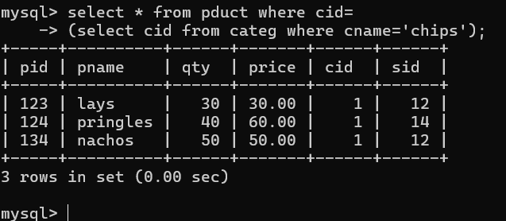

1. display all products sold by kirti

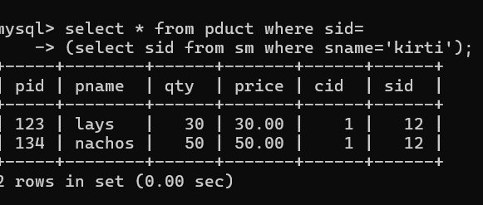

1. display all salesman who do not sold any product

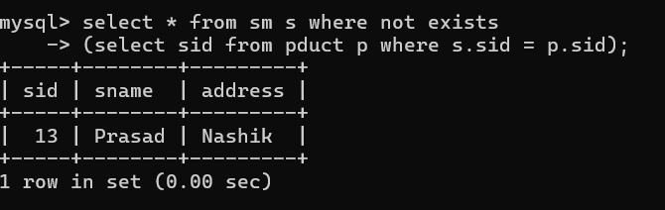

4. display all category for which no product is there

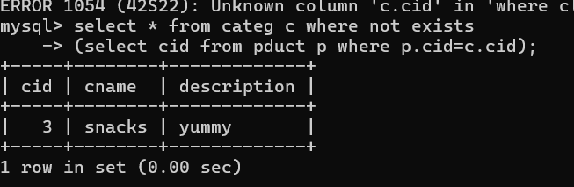

5. display all products with no category assigned

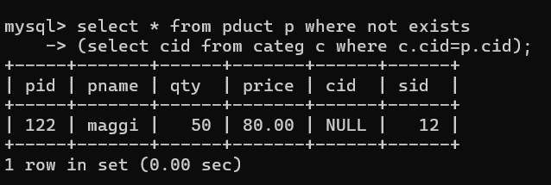

6. list all salesman who stays in city with name starts with P or N

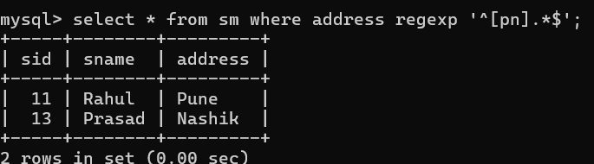

7. add new column in salesman table by name credit limit

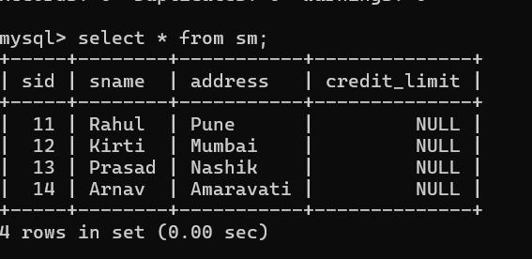

player (player_id, pname,speciality,date_of joining,num_matches,team_id)

team(team_id, tname,player_num)

matches(match_id, team1_id,team2_id,match_date,winner,man_of_the match)

simple query

1. display all players playerid, player name and experience

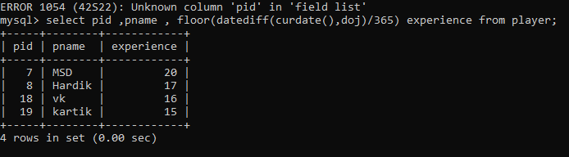

1. display all player with experience > 5 years (15 years)

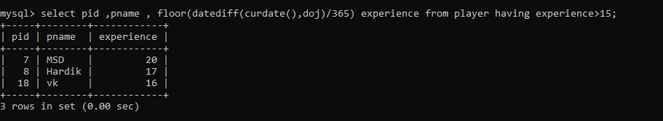

1. display all players joined in march month, any year (january)

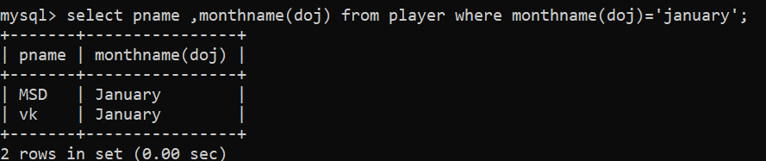

1. display all players joined in march 1995(august 2008)

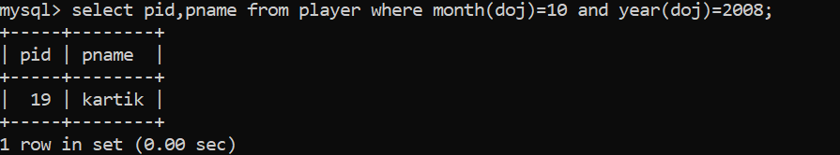

1. display all player with number of matches played are either 5 or 10 or 8 (289,199,189)

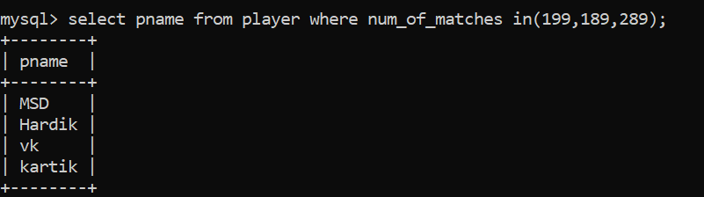

1. display all players who are either batsman, bowler

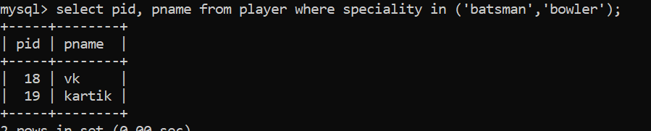

7. display all employees who joined in year 1995 or 1996 or 1997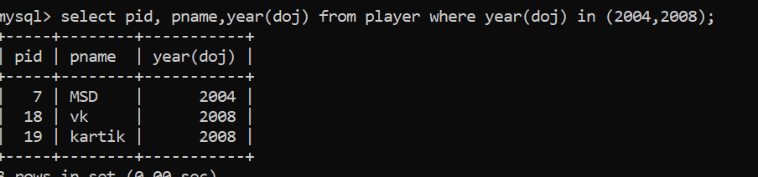

Nested query

1. list all player who plays in virat kohalis (msd)team

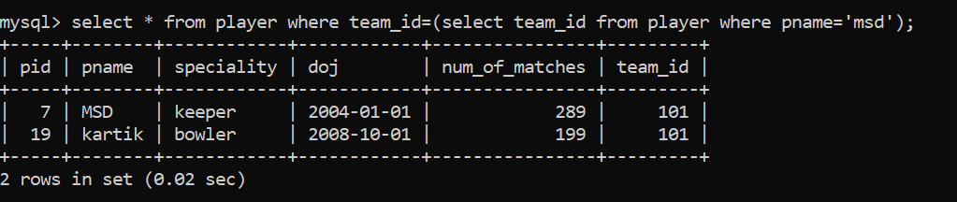

1. list all players who played matches in year 2024

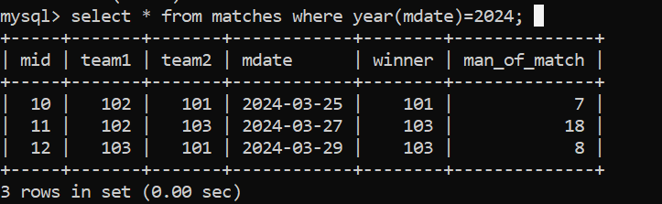

3. list all matches in which man of the match is from team1

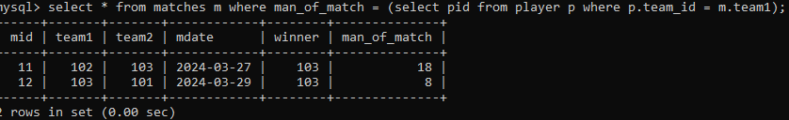

1. list all matches in which man of the match is from team2



5. list all matches in which csk team win.

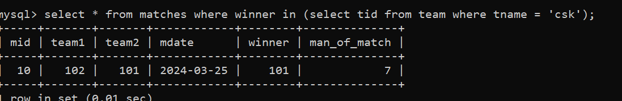

1. list all matches in which either csk or rcb team won the match

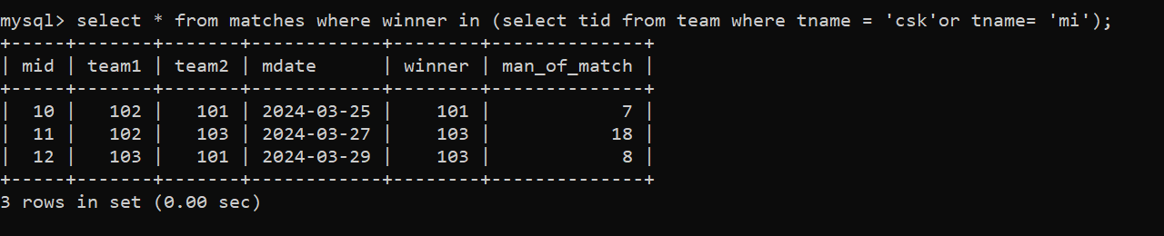

1. list all teams who one(won) atleast one match

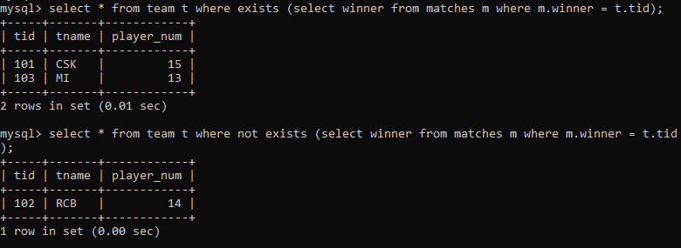

1. list all teams who does not played any match

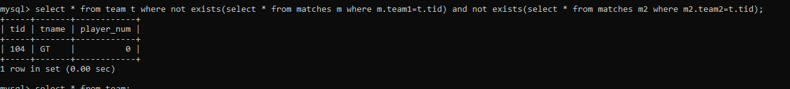

1. list all team name, in which no players are their

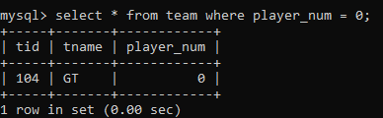

10. list all players who are in dhoni’s team

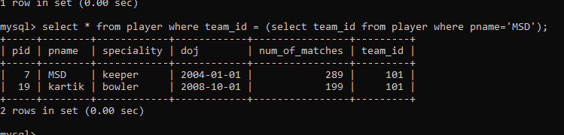

11. list all players who are in either dhoni’s or virat’s team

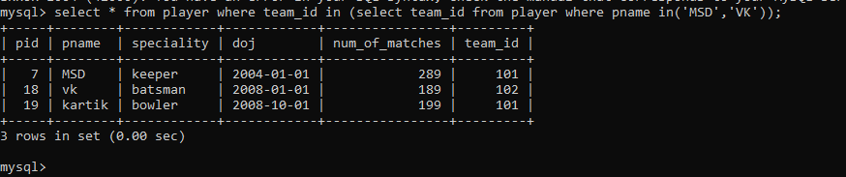

12. find all team names who won more than 3 matches

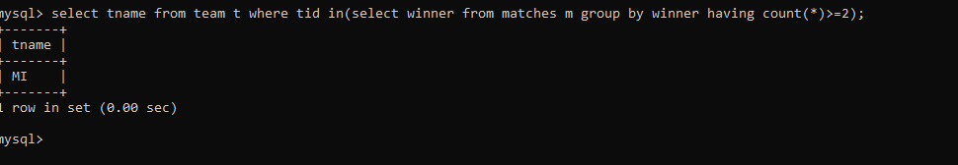

**DAY-6**

**Date and Time functions :**

1. Write a query to display the first day of the month (in datetime format) three months before the current month. Sample current date : 2014-09-03 Expected result : 2014-06-01

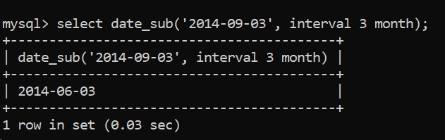

1. Write a query to display the last day of the month (in datetime format) three months before the current month.

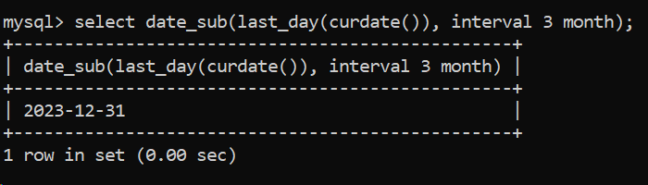

1. Write a query to get the distinct Mondays from hiredate in emp tables.

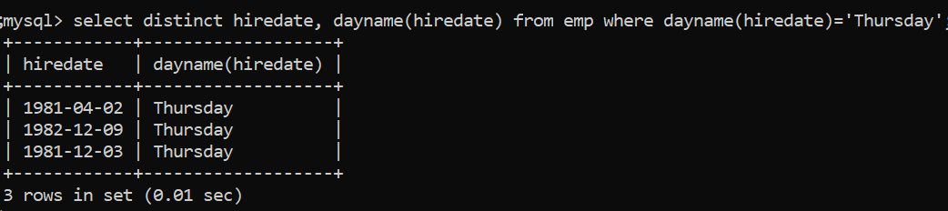

1. Write a query to get the first day of the current year.

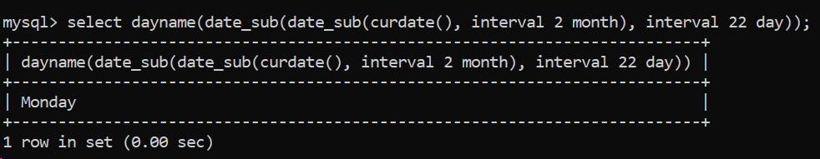

1. **Write a query to get the last day of the current year.**

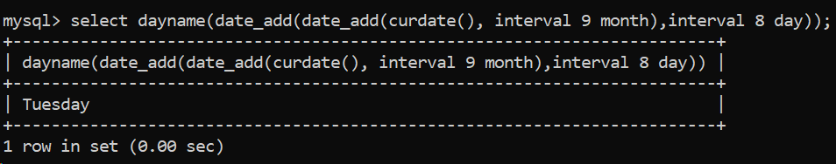

1. Write a query to calculate your age in year.

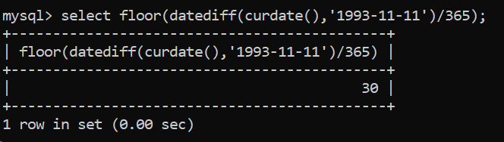

1. **Write a query to get the current date in the following format.** Sample date : 04-sep-2014 Output : September 4, 2014

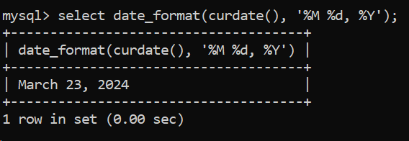

1. **Write a query to get the current date in Thursday September 2014 format. (**Thursday September 2014 ).

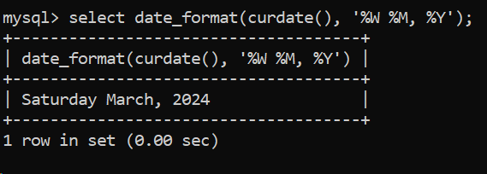

1. **Write a query to extract the year from the current date.**

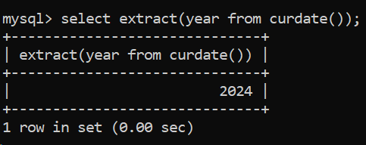

1. Write a query to get the first name and hire date from employees table where hire date between '1987-06-01' and '1987-07-30'

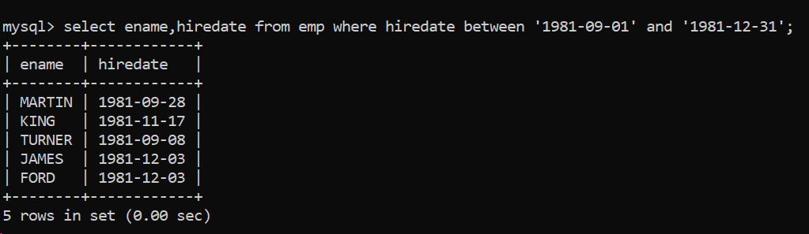

1. Write a query to display the current date in the following format. Sample output: Thursday 4th September 2014 00:00:00

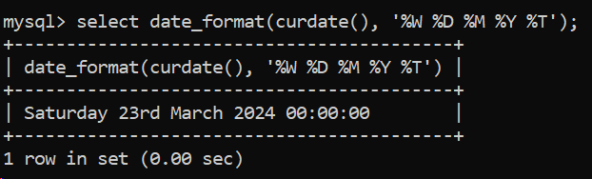

1. **Write a query to display the current date in the following format.** Sample output: 05/09/2014

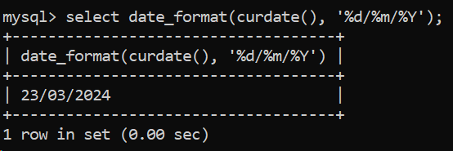

1. **Write a query to display the current date in the following format.** Sample output: 12:00 AM Sep 5, 2014

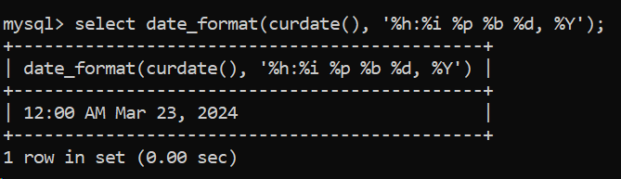

1. Write a query to get the employees who joined in the month of June.

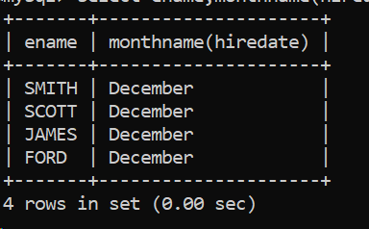

1. Write a query to get the years in which more than 10 employees joined.

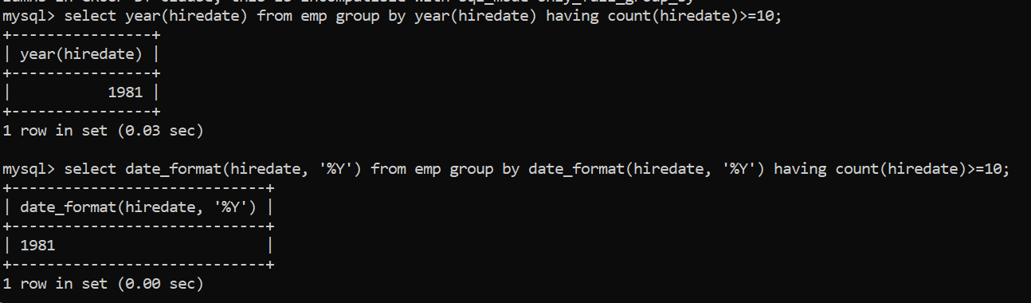

1. **Write a query to get first name of employees who joined in 1987.**

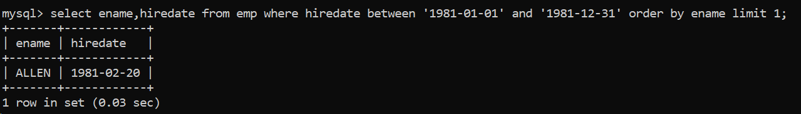

1. Write a query to get employees whose experience is more than 5 years.

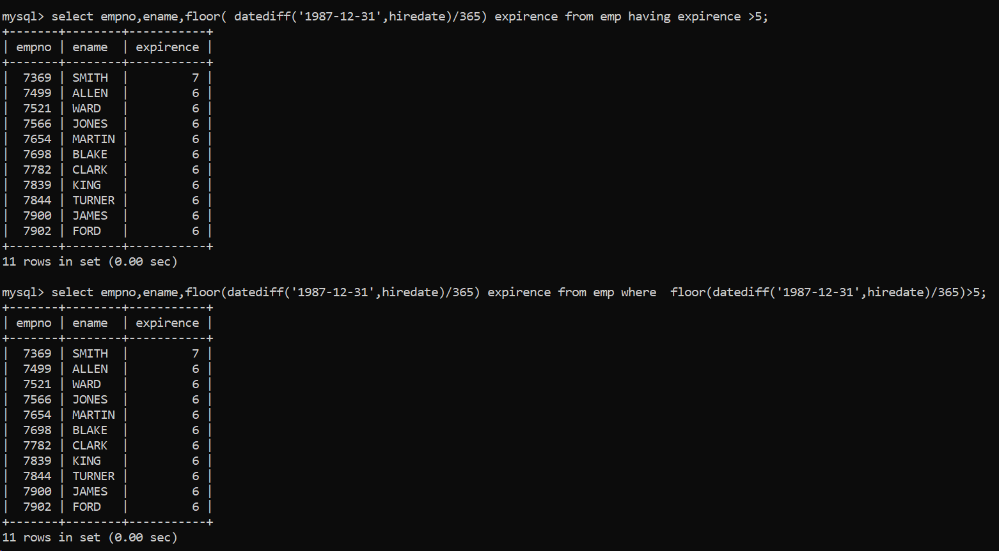

1. Write a query to get employee ID, last name, and date of first salary of the employees.

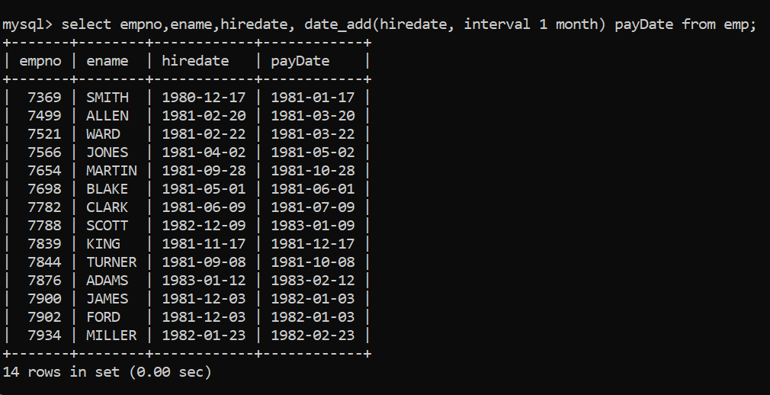

1. Write a query to get first name, hire date and experience of the employees.

Sample table: employees

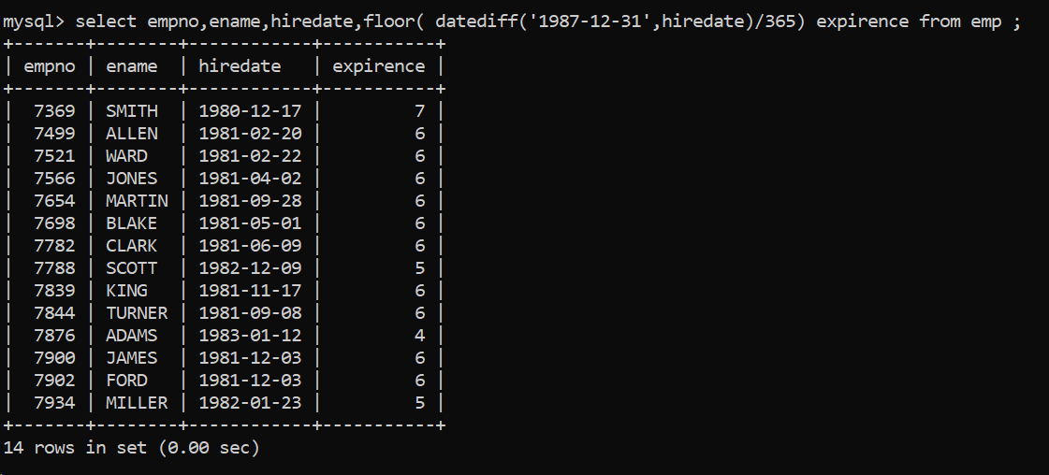

1. Write a query to get the department ID, year, and number of employees joined.

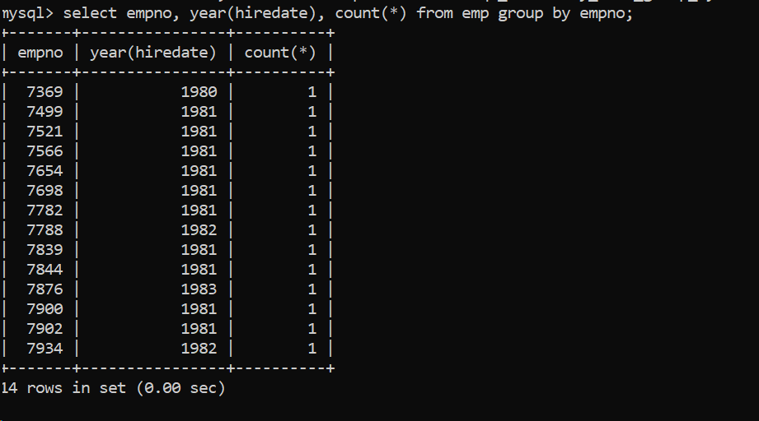

Group functions  
6. Display the Highest, Lowest, Total & Average salary of all employee. Label the columns  
Maximum, Minimum, Total and Average respectively for each Department. Also round the  
result to the nearest whole number.

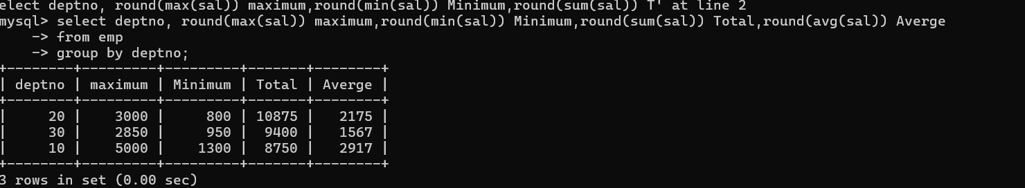

7. Display Department no and number of managers working in that department. Label the  
column as ‘Total Number of Managers’ for each department.

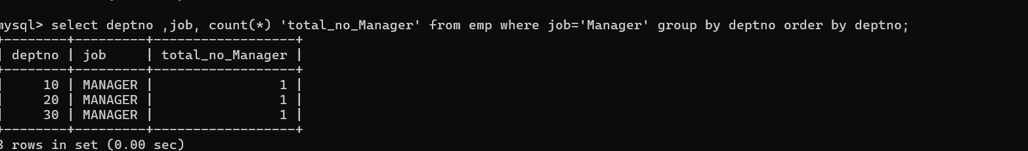

8. Get the Department number, and sum of Salary of all non managers where the sum is  
greater than 20000.

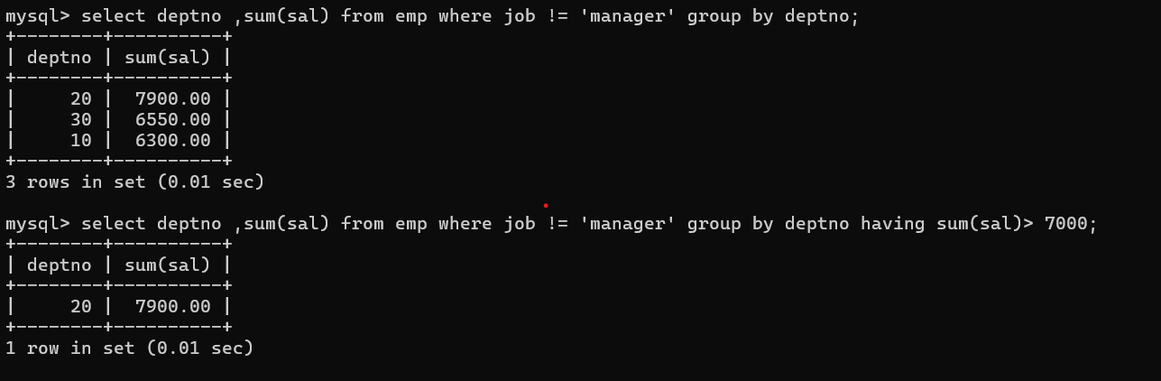

**DAY-7**

Vehicle

Vid Vname Price desc

1 Activa 80000 ksldjfjksj

2 Santro 8,00000 kdjfkjsd

3 Motor bike 100000 fdkdfj

customer

Custid Cname address

1 Nilima Pimpari

2 Ganesh Pune

3 Pankaj Mumbai

salesman

Sid Sname adress

10 Rajesh mumbai

11 Seema Pune

13 Rakhi pune

cust-vehicle (customer is buying Many vehicle and 1 vehicle can be bought by many customers)

Custid Vid Sid Buy_price

1 1 10 75000

1 2 10 7,90,000

2 3 11 80000

3 3 11 75000

1. 2 10 8,00000

1.create all given tables

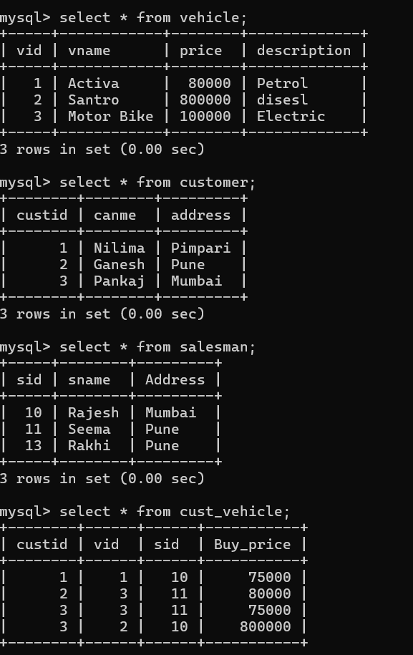

2. create index on vehicle table based on price

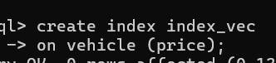

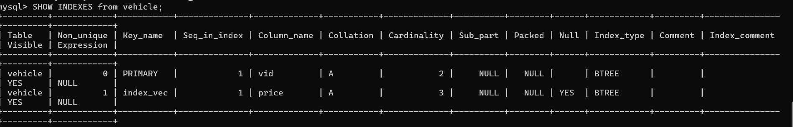

3. find all customer name,vehicle name, salesman name, discount earn by all customer

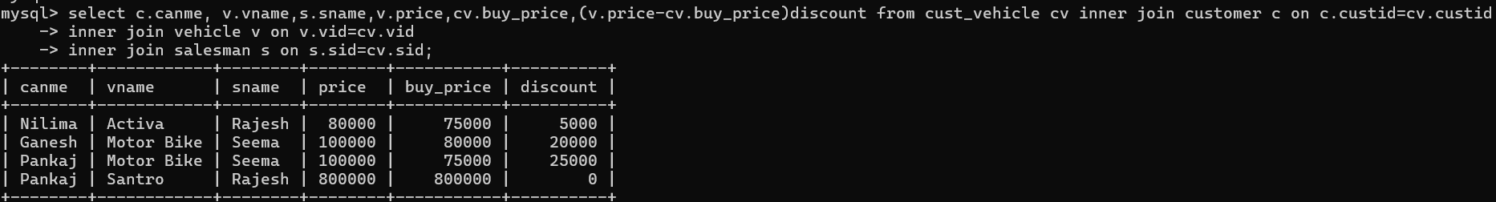

4. find all customer name,vehicle name,salesman name for all salesman who stays in pune

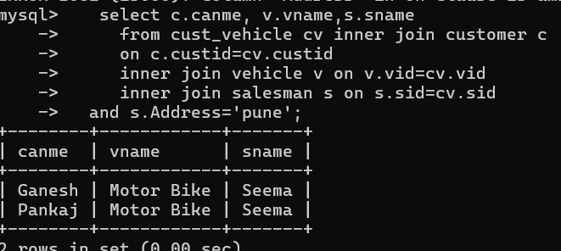

5. find how many customers bought motor bike

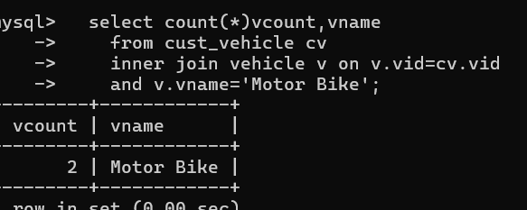

6. create a view find_discount which displays output

-------to create view

create view find_discount

as

select cname,vname,price,buying_price,price-buying_price “discount”

from customer c inner join cust_vehicle cv on c.custid=cv.cid inner join vehicle v on

v.vid=cv.vid

--------to display discount

select * from find_discount;

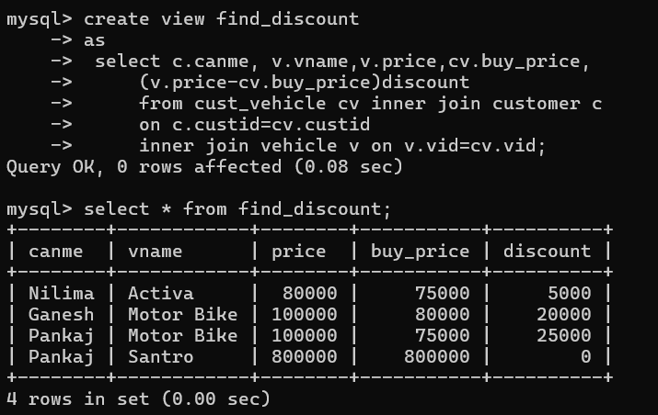

7. find all customer name, vehicle name, salesman name, discount earn by all customer



8. create view my_hr to display empno,ename,job,comm for all employees who earn Commission

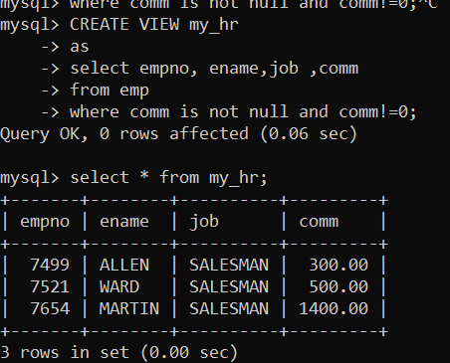

9. create view mgr30 to display all employees from department 30

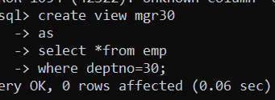

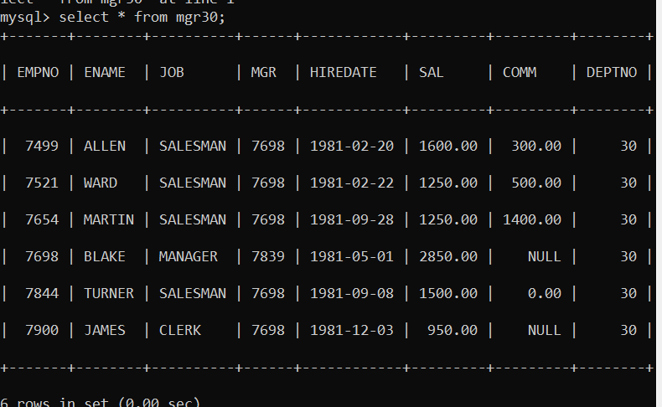insert

10. insert 3 employees in view mgr30 check whether insertion is possible

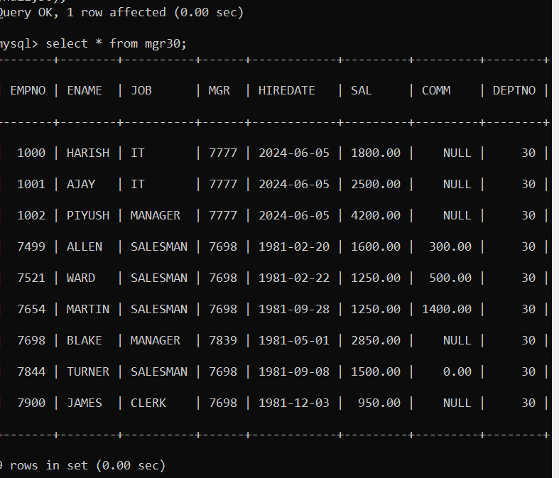

11. insert 3 records in dept and display all records from dept

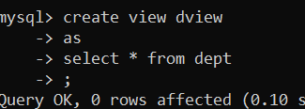

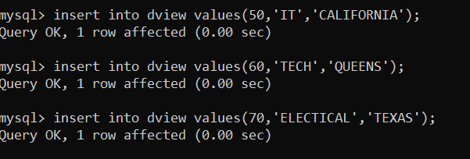

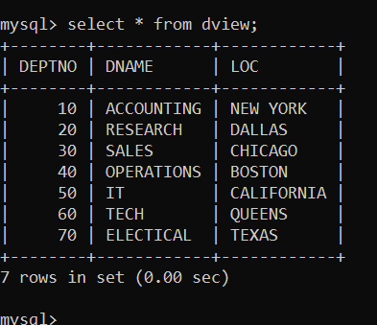

12. use rollback command check what happens

13. do the following

insert row in emp with empno 100

insert row in emp with empno 101

insert row in emp with empno 102

add savepoint A

insert row in emp with empno 103

insert row in emp with empno 104

insert row in emp with empno 105

add savepoint B

delete emp with empno 100

delete emp with emp no 104

rollback upto svaepoint B

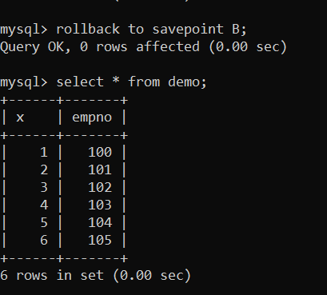

check what all records will appear in employee table

rollback upto A

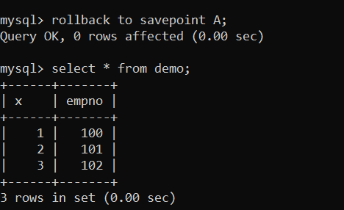

check what all records will appear in employee table

commit all changes

check what all records will appear in employee table

check whether you can roll back the contents.

14. create a procedure getMin(deptno,minsal) to find minimum salary of given table

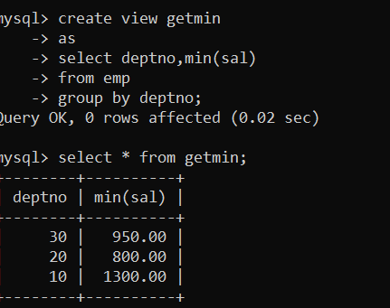

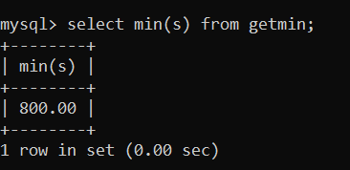

**DAY-8**

**Practice Aggregate Functions**12. find max sal and min sal for each job

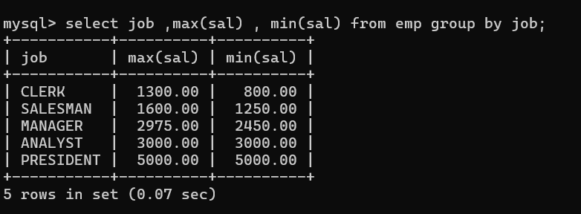  
13. find how many employess have not received commission

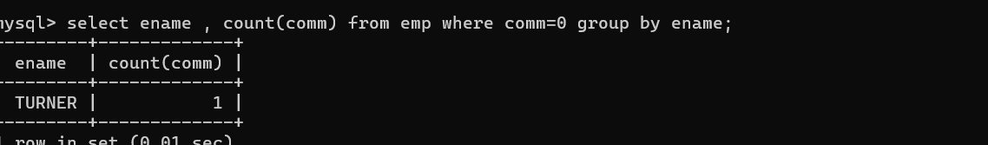

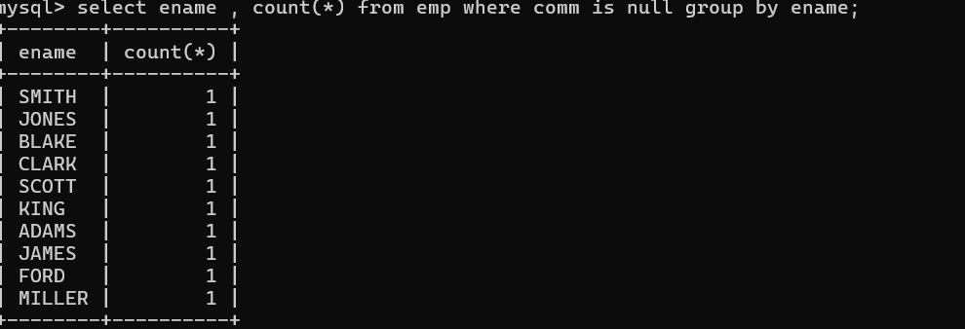

14. find sum of sal of all employees working in dept no 10

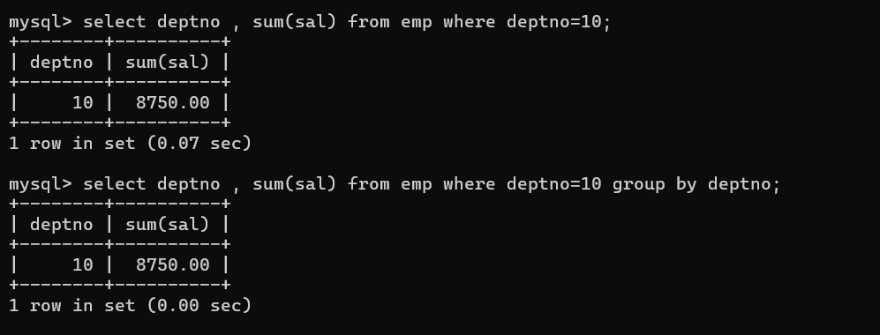  
15. find maximum salary,average sal for each job in every department

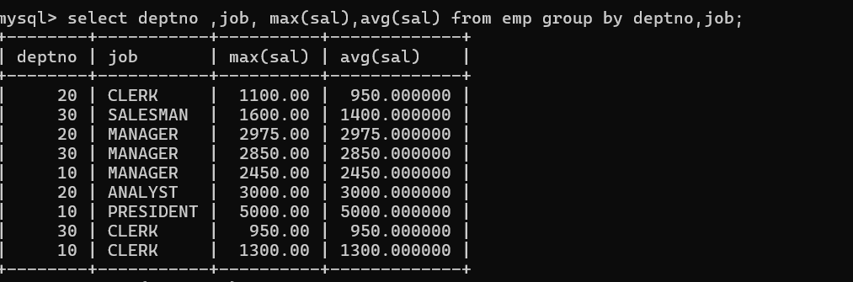  
16. find max salary for every department if deptno is > 15 and arrange data in deptno order.

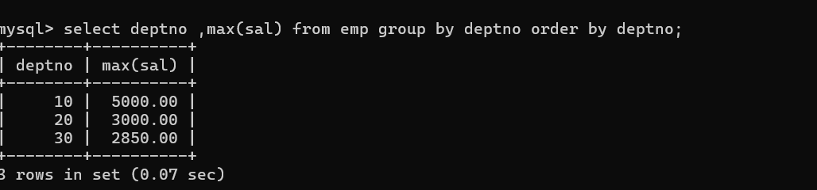

17. find sum salary for every department if sum is > 3000

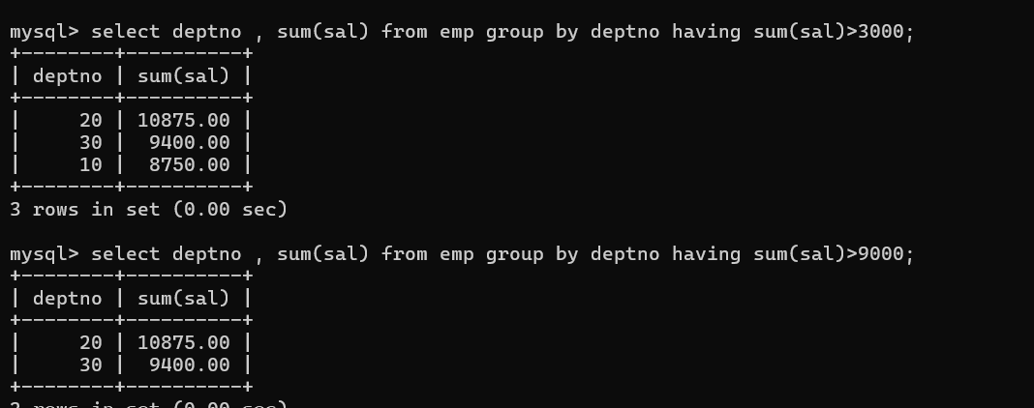  
18. list all department which has minimum 5 employees

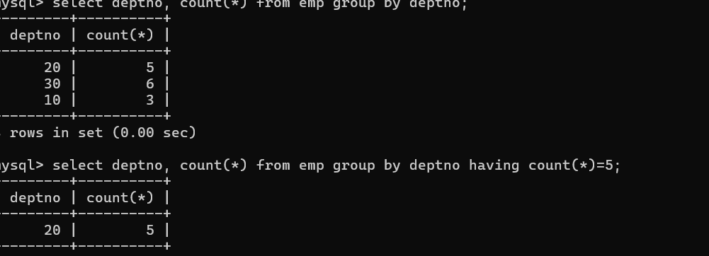  
19. count how many employees earn salary more than 2000 in each job

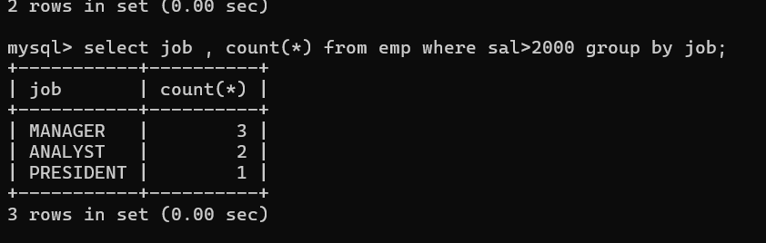

**Function used for strings**

20. list all enames and jobs in small case letter

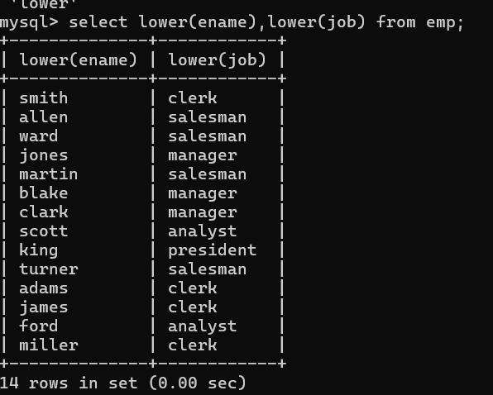

21. list all names and jobs so that the length of name should be 15 if it is smaller then add spaces  
to left

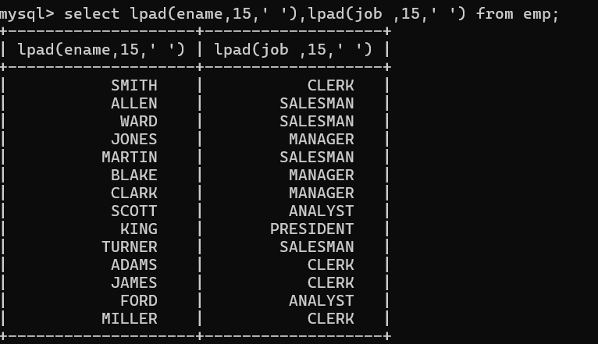  
22. display min sal,max sal, average sal for all employees working under same manager

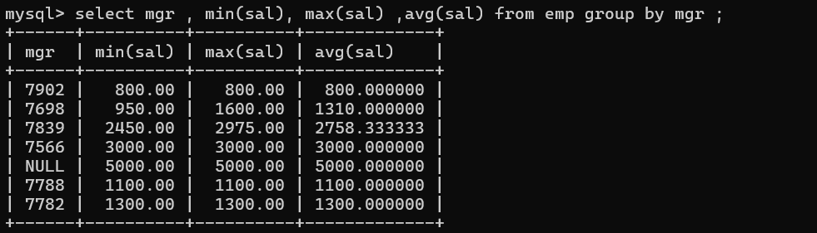  
23. find sum of total earnings(sal+comm), average of sal+comm,  
for all employees who earn sal > 2000 and work in either dept no 10 or 20

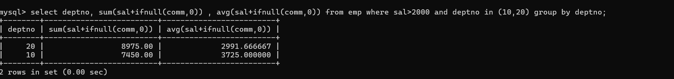  
24. list all employees who joined in Aug 1980 and salary is >1500 and < 2500

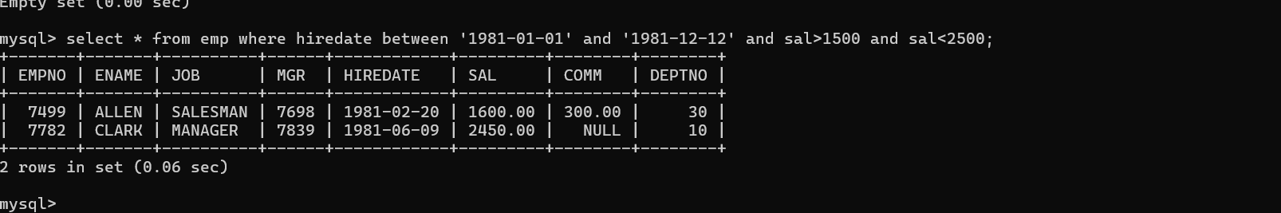  
25. list all employees joined in either aug or may or dec

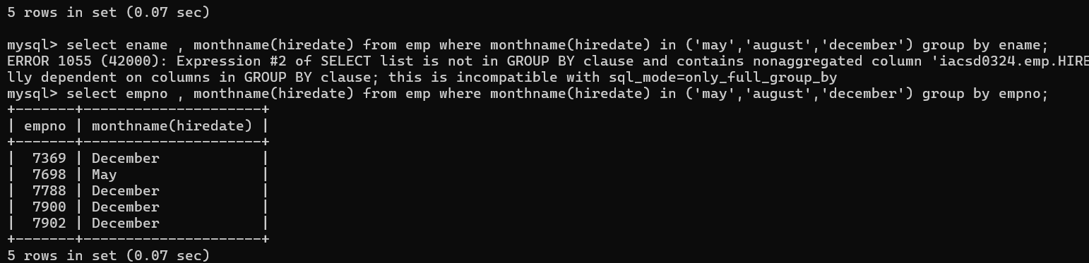  
26. display name and hiredate in dd/mm/yy format for all employees whose job is clerk and they  
earn some commission

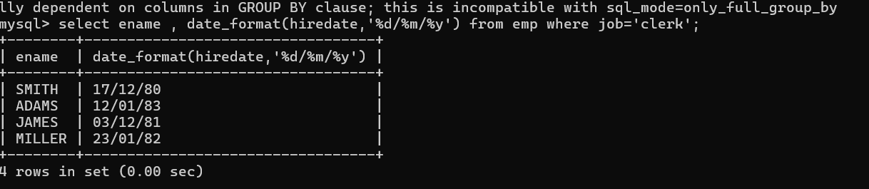  
27. list empcode,empno,name and job for each employee. (note :empcode is 3 to 5 characters  
from name and last 2 characters of job)

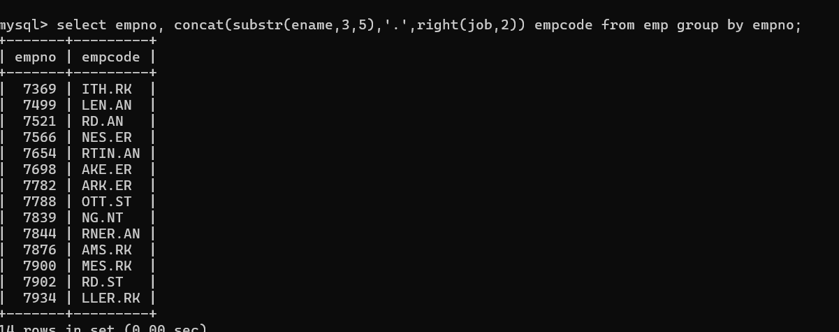

28. display thousand separator and $ symbol for commission if it is null then display it as 0 for all  
employees whose name starts with A and ends with N

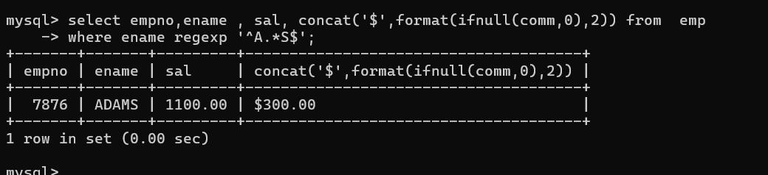

29. Display empid,name,sal,comm,remark Remark should base on following conditions  
comm >= 600 "excellent Keep it up"  
if it < 600 or not null "good"  
otherwise "Need improvement"

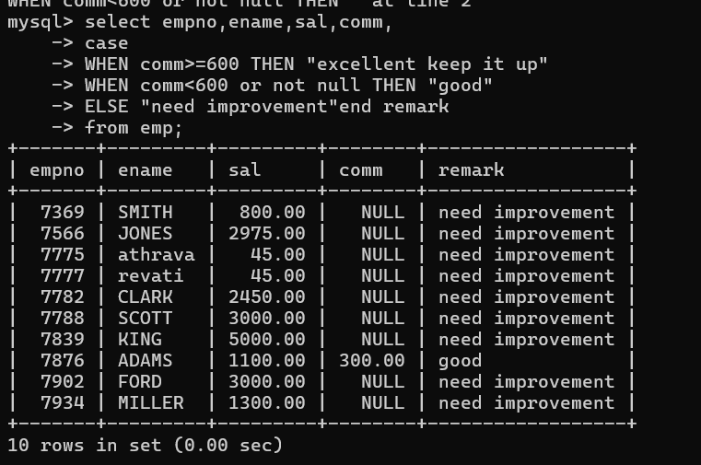

30. Display empid, name, deptno and department name by using following conditions.  
dept 10 then "Hr"  
if 20 then "Admin"  
if 30 then "accounts"  
otherwise purchase

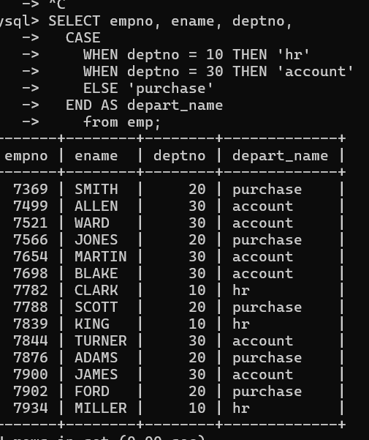

DAY-9

Solve the following

1. write a procedure to insert record into employee table.

the procedure should accept empno, ename, sal, job, hiredate as input parameter

write insert statement inside procedure insert_rec to add one record into table

create procedure insert_rec(peno int,pnm varchar(20),psal decimal(9,2),pjob

varchar(20),phiredate date)

begin

insert into emp(empno,ename,sal,job,hiredate)

values(peno,pnm,psal,pjob,phiredate)

end//

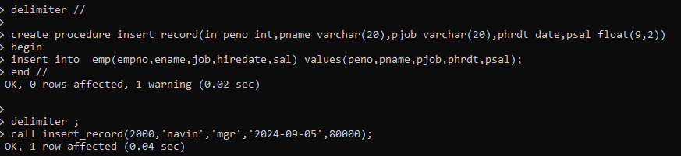

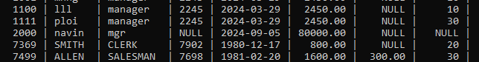

2. write a procedure to delete record from employee table.

the procedure should accept empno as input parameter.

write delete statement inside procedure delete_emp to delete one record from emp

table

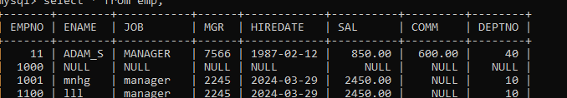

Delete

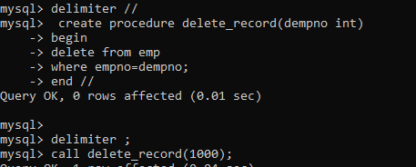

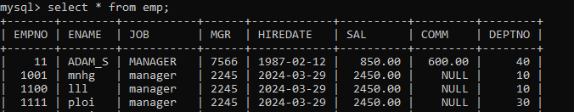

3. write a procedure to display empno,ename,deptno,dname for all employees with sal

> given salary. pass salary as a parameter to procedure

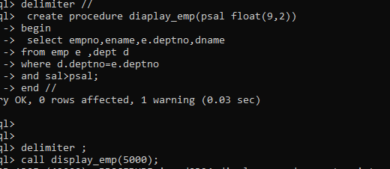

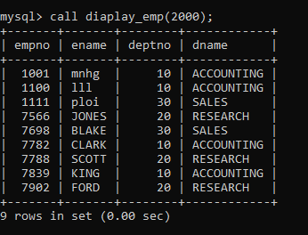

4. write a procedure to find min,max,avg of salary and number of employees in the

given deptno.

deptno --→ in parameter

min,max,avg and count ---→ out type parameter

execute procedure and then display values min,max,avg and count

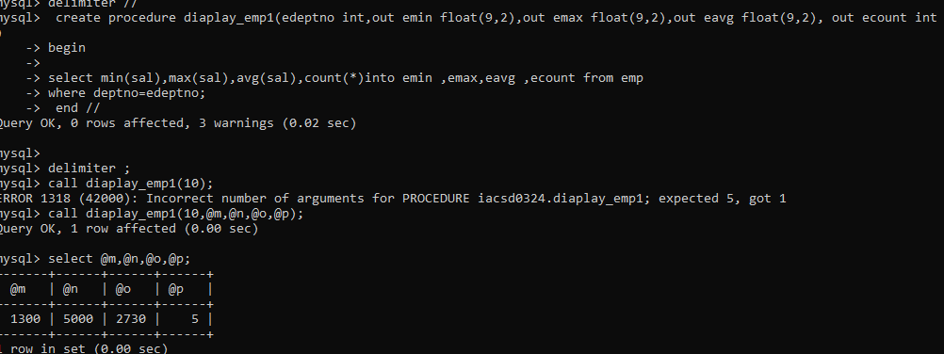

5. write a procedure to display all pid,pname,cid,cname and salesman name(use product,category and salesman table)

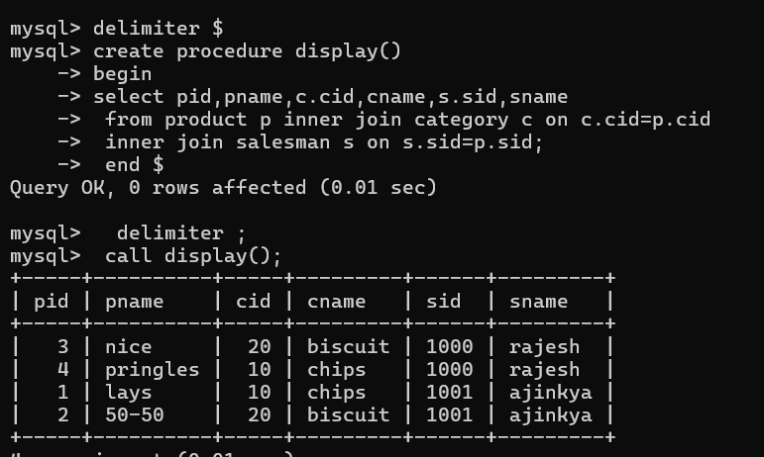

6. write a procedure to display all vehicles bought by a customer. pass cutome name as

a parameter.(use vehicle,salesman,custome and relation table)

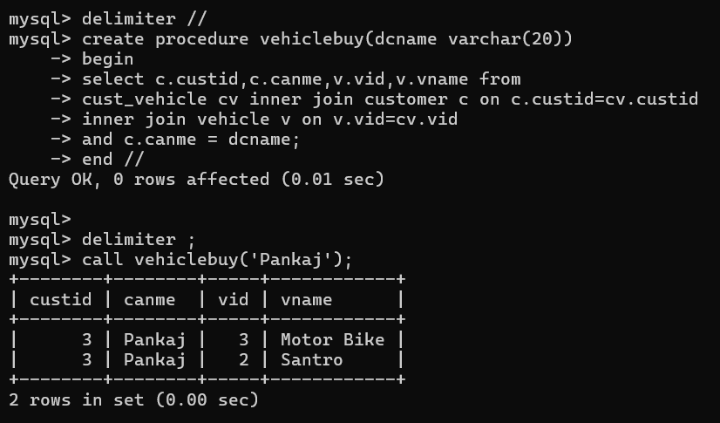

7. Write a procedure that displays the following information of all emp

Empno,Name,job,Salary,Status,deptno

Note: - Status will be (Greater, Lesser or Equal) respective to average salary of their own

department. Display an error message Emp table is empty if there is no matching

record.

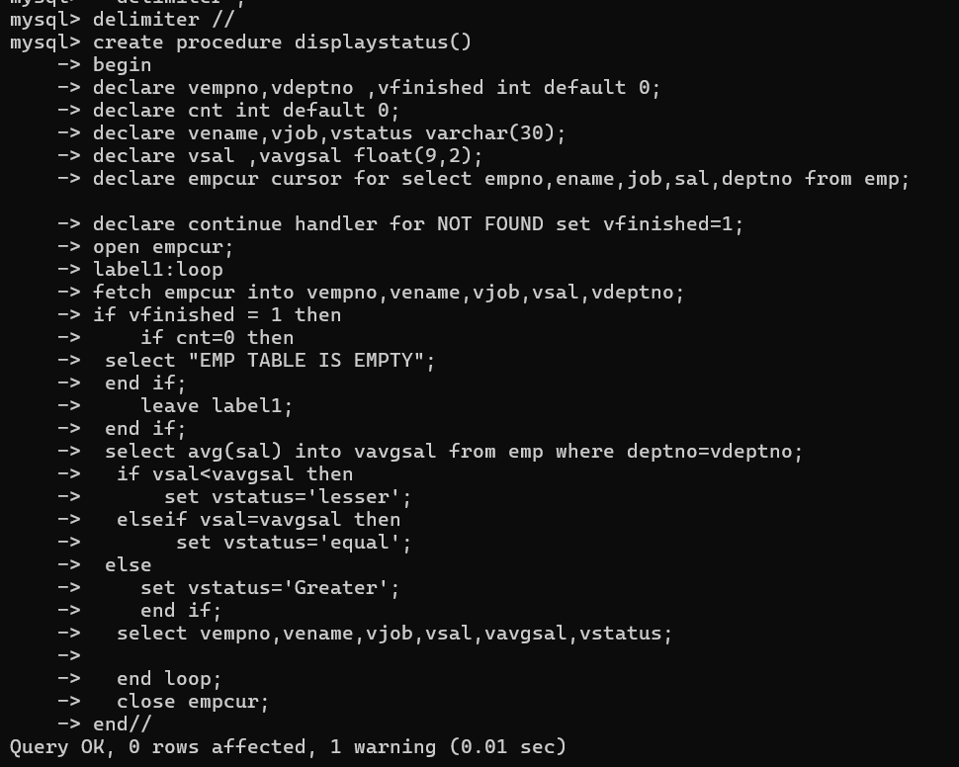

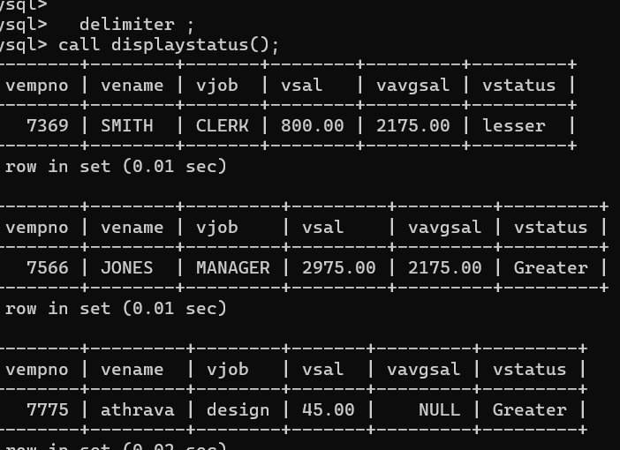

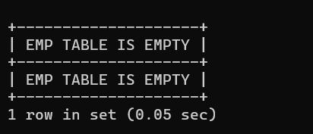

8. Write a procedure to update salary in emp table based on following rules.

Exp< =35 then no Update

Exp> 35 and <=38 then 20% of salary

Exp> 38 then 25% of salary

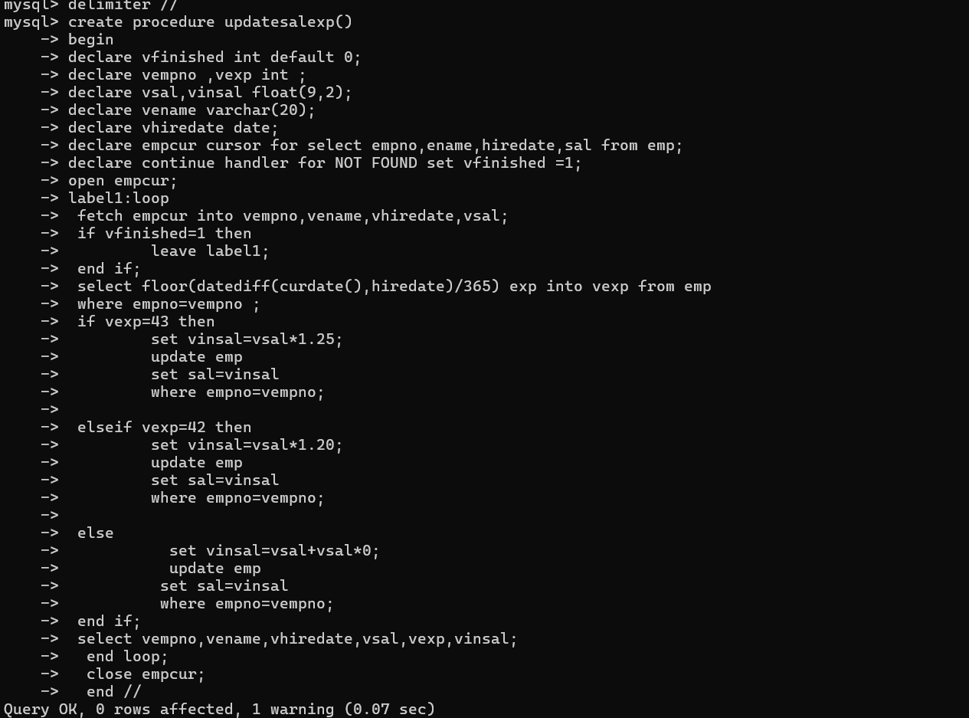

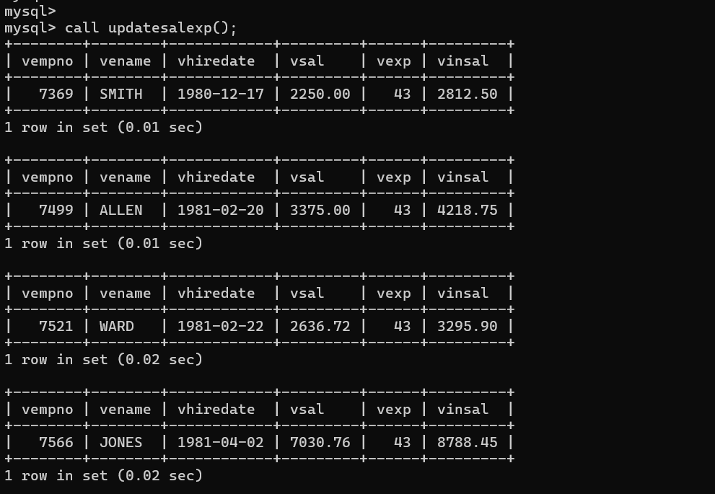

9. Write a procedure and a function.

Function: write a function to calculate number of years of experience of employee.(note:

pass hiredate as a parameter)

Procedure: Capture the value returned by the above function to calculate the additional

allowance for the emp based on the experience.

Additional Allowance = Year of experience x 3000

Calculate the additional allowance

and store Empno, ename,Date of Joining, and Experience in

years and additional allowance in Emp_Allowance table.

create table emp_allowance(

empno int,

ename varchar(20),

hiredate date,

experience int,

allowance decimal(9,2));

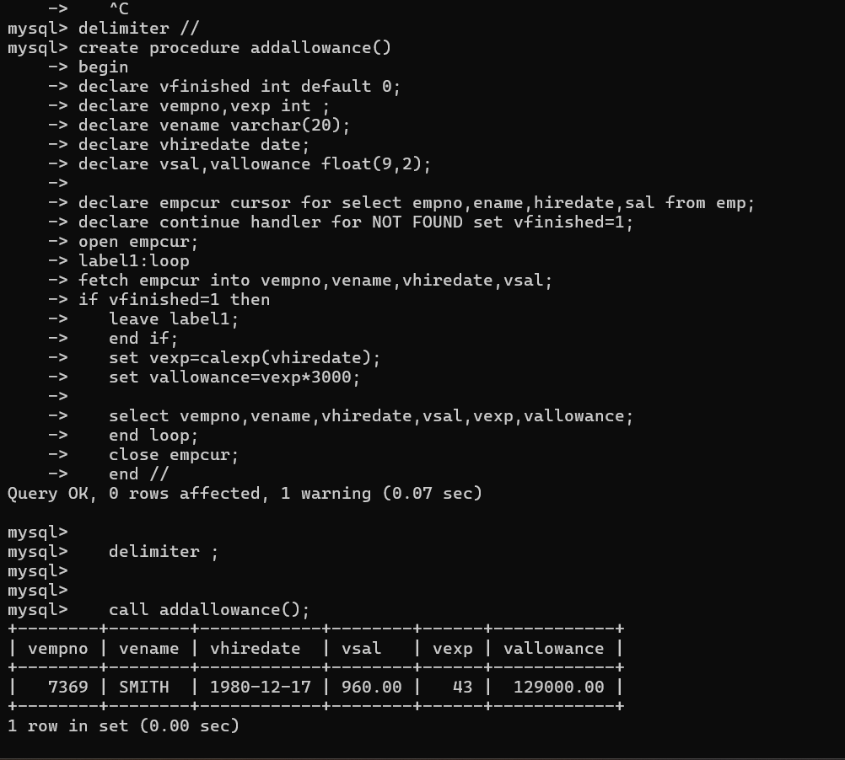

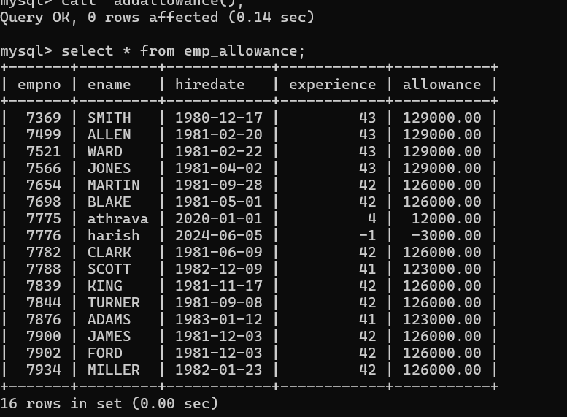

11. Write query to 10. Write a function to compute the following. Function should take sal and hiredate

as i/p and return the cost to company.

DA = 15% Salary, HRA= 20% of Salary, TA= 8% of Salary.

Special Allowance will be decided based on the service in the company.

< 1 Year Nil

>=1 Year< 2 Year 10% of Salary

>=2 Year< 4 Year 20% of Salary

>4 Year 30% of Salary

display empno,ename,sal,cost to company for all employees(note:

use function written in question 10)

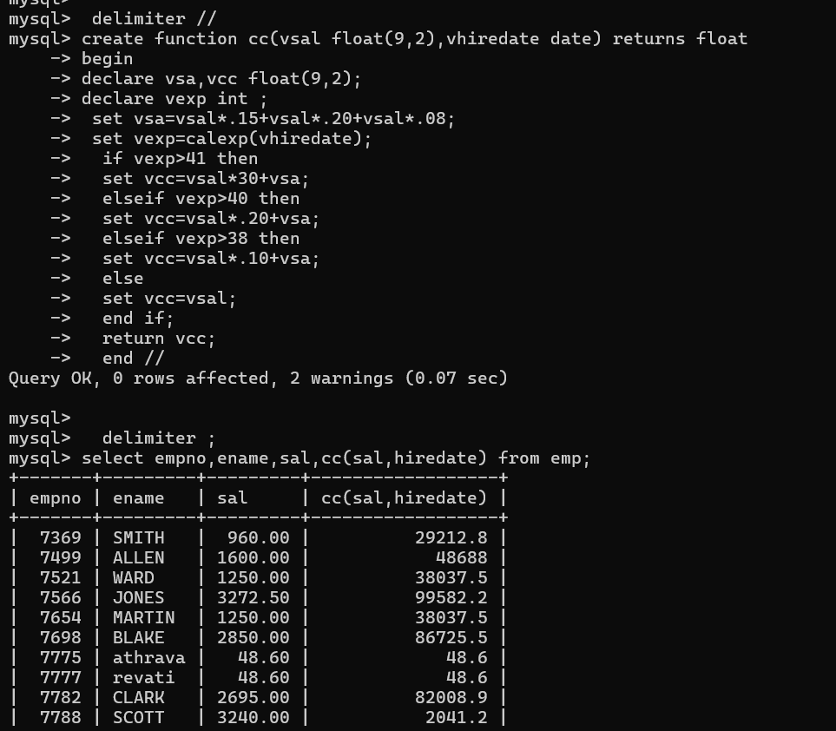

Q2. Write trigger

1. Write a tigger to store the old salary details in Emp _Back (Emp _Back has the

same structure as emp table without any

constraint) table.

(note :create emp_back table before writing trigger)

----- to create emp_back table

create table emp_back(

empno int,

ename varchar(20),

oldsal decimal(9,2),

newsal decimal(9,2)

)

(note :

execute procedure written in Q8 and

check the entries in EMP_back table after execution of the procedure)

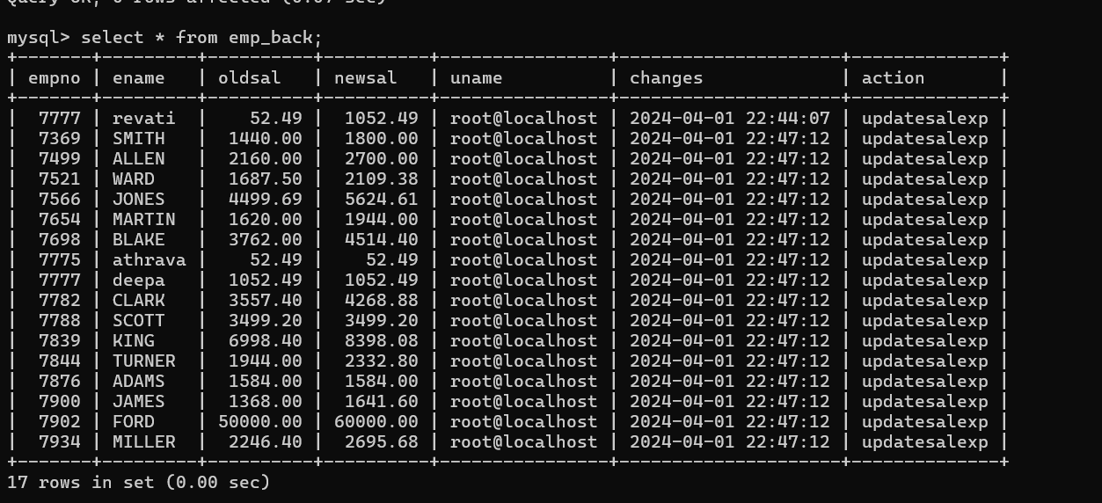

2. Write a trigger which add entry in audit table when user tries to insert or delete

records in employee table store empno,name,username and date on which

operation performed and which action is done insert or delete. in emp_audit table.

create table before writing trigger.

create table empaudit(

empno int;

ename varchar(20),

username varchar(20);

chdate date;

action varchar(20)

);

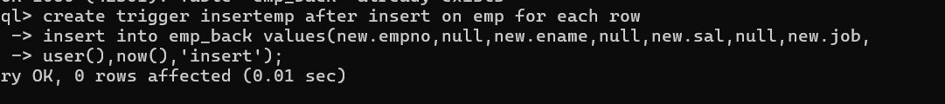

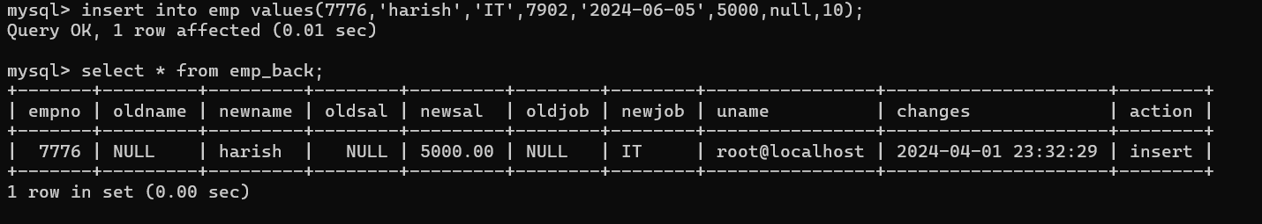

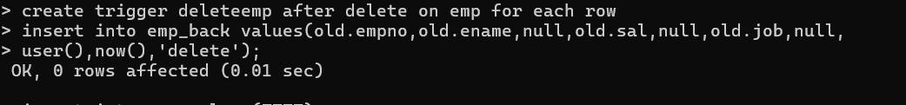

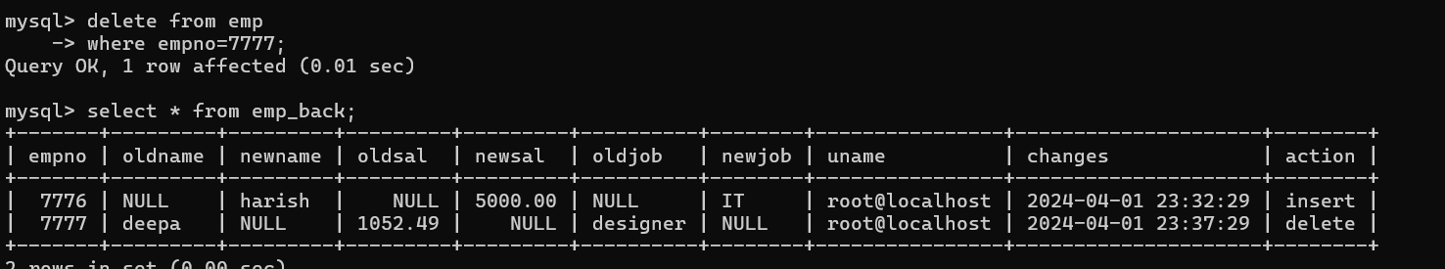

3. Create table vehicle_history. Write a trigger to store old vehicleprice and new vehicle

price in history table before you update price in vehicle table

(note: use vehicle table).

create table vehicle_history(

vno int,

vname varchar(20),

oldprice decimal(9,2),

newprice decimal(9,2),

chdate date,

username varchar(20)

);

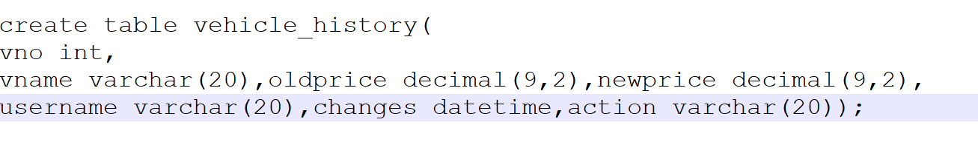

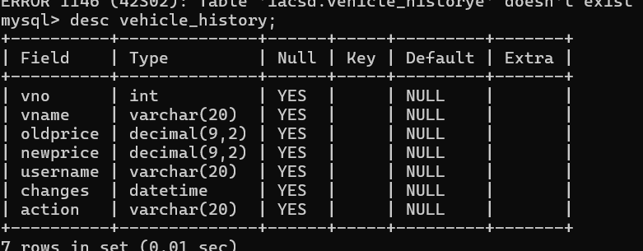

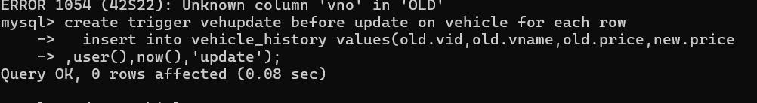

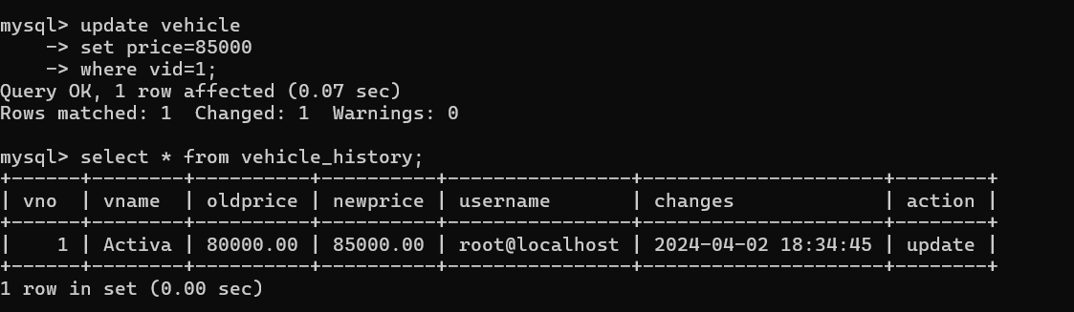

**IACSD**

**Assignment 1**

1. Create the table SEMP with the following structure:-

EMPNO CHAR(4)

EMPNAME CHAR(20)

BASIC FLOAT(9,2)

DEPTNO CHAR(2)

DEPTHEAD CHAR(4)

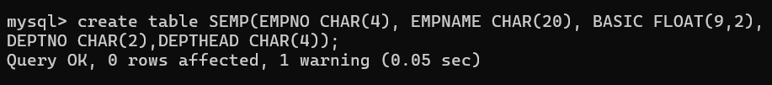

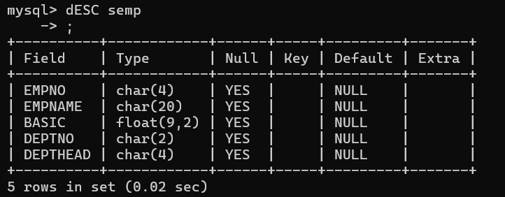

1. Create the table SDEPT with the following structure:-

DEPTNO CHAR(2)

DEPTNAME CHAR(15)

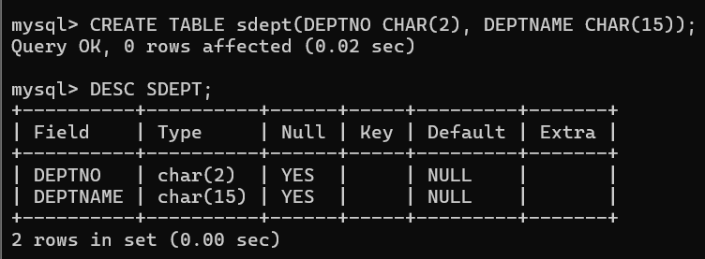

1. Insert into the SDEPT table the following values:-

10, Development

20, Training

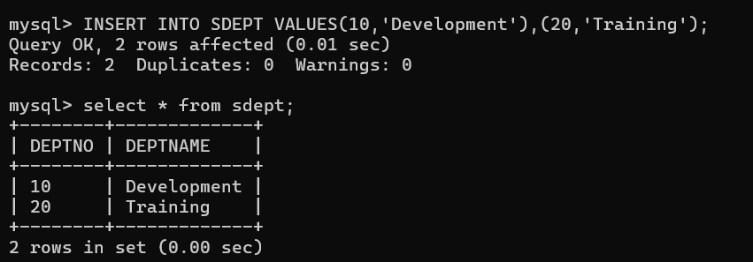

1. Insert into the SEMP table the following values:-

0001, SUNIL, 6000, 10

0002, HIREN, 8000, 20

0003, ALI, 4000, 10, 0001

0004, GEORGE, 6000, 0002

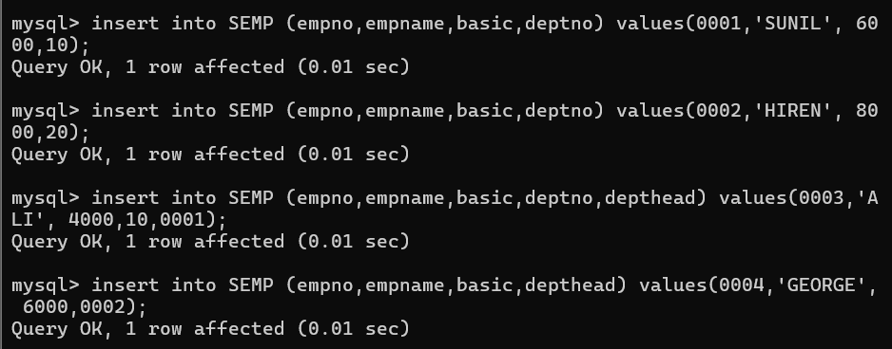

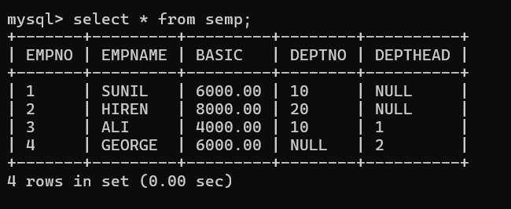

Create S, P, J, SPJ tables as specified below and insert a few rows in each table:-

SUPPLIER

(S#, Sname, Status, City)



PARTS

(P#, Pname, Color, Weight, City)



PROJECTS

(J#, Jname, City)



SUPPLIER-PARTS-PROJECT (S#, P#, J#, Qty) - SPJ

Sample data for S# column:- ‘S1’, ‘S2’, ‘S3’, etc.

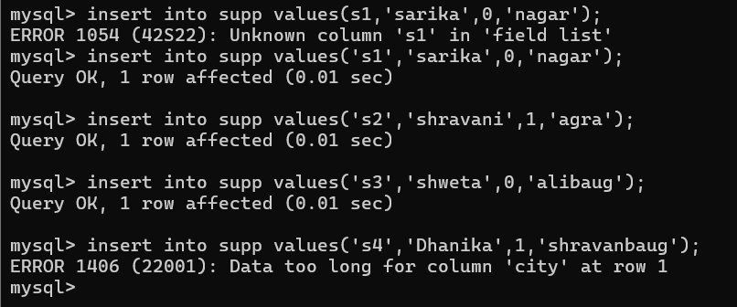

Sample data for P# column:- ‘P1’, ‘P2’, ‘P3’, etc.

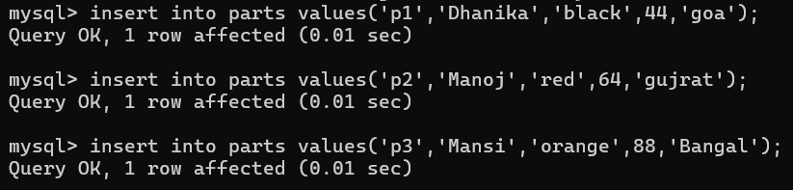

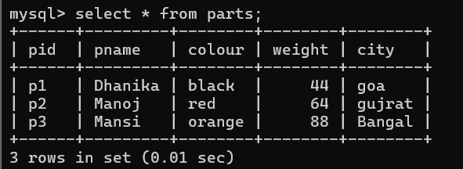

Sample data for J# column:- ‘J1’, ‘J2’, ‘J3’, etc.

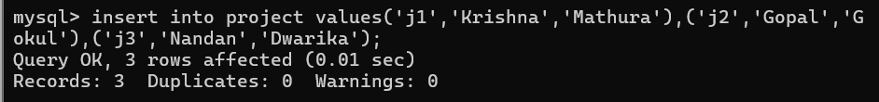

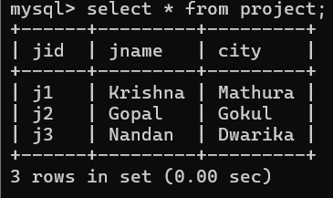

Write the SELECT queries to do the following:-

1. Display all the data from the S table.

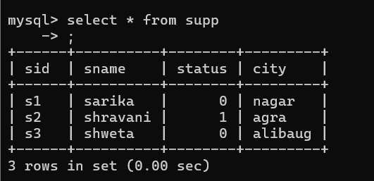

1. Display only the S# and SNAME fields from the S table.

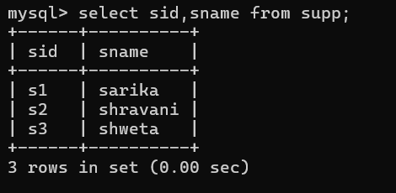

1. Display the PNAME and COLOR from the P table for the CITY=”London”.

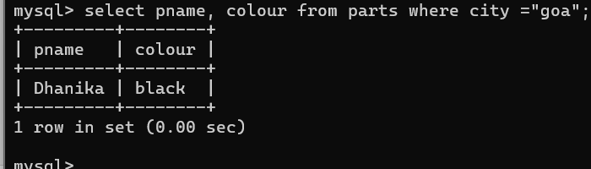

1. Display all the Suppliers from London.

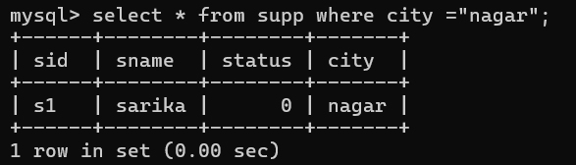

1. Display all the Suppliers from Paris or Athens.

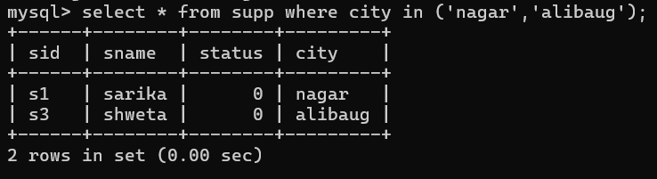

1. Display all the Projects in Athens.

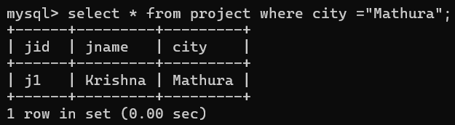

1. Display all the Partnames with the weight between 12 and 14 (inclusive of both).



1. Display all the Suppliers with a Status greater than or equal to 20.

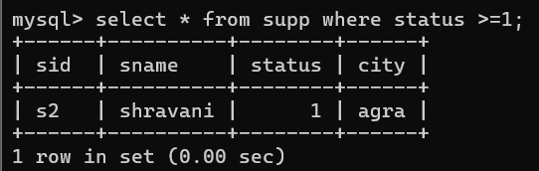

1. Display all the Suppliers except the Suppliers from London.

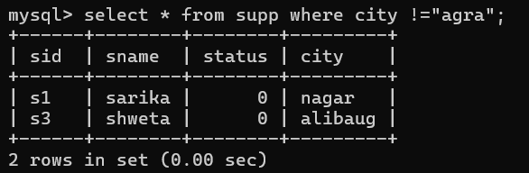

1. Display only the Cities from where the Suppliers come from.

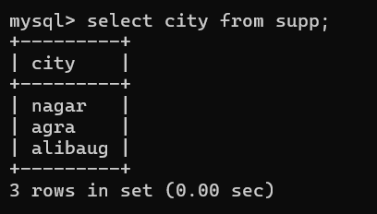

15. Assuming that the Part Weight is in GRAMS, display the same in MILLIGRAMS and KILOGRAMS.

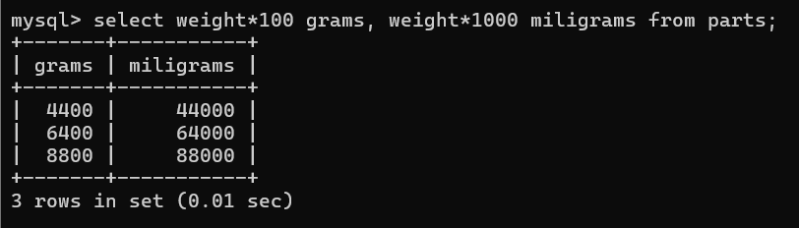

**SQL Exercise 2**

1. Display the Supplier table in the descending order of CITY.

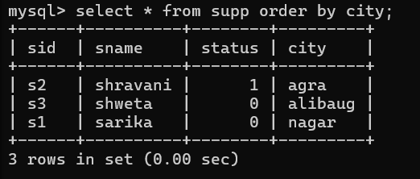

1. Display the Part Table in the ascending order of CITY and within the city in the ascending order of Part names

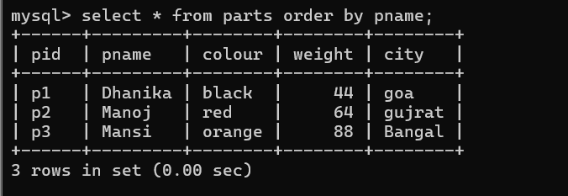

1. Display all the Suppliers with a status between 10 and 20.



1. Display all the Parts and their Weight, which are not in the range of 10 and 15.

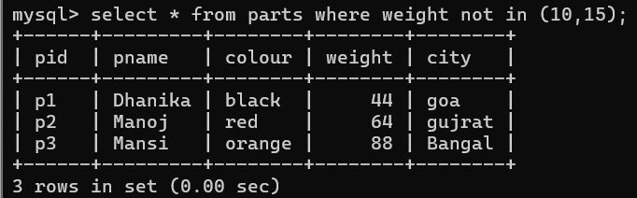

1. Display all the Part names starting with the letter ‘S’.

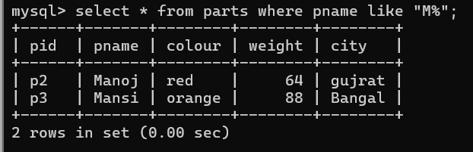

1. Display all the Suppliers, belonging to cities starting with the letter ‘L’.

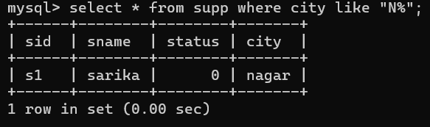

1. Display all the Projects, with the third letter in JNAME as ‘n’.



**SQL Exercise 3**

1. Display all the Supplier names with the initial letter capital.

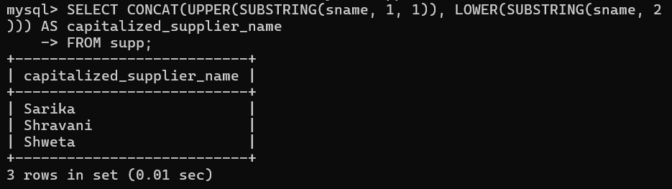

1. Display all the Supplier names in upper case.

select upper(sname) from supplier;

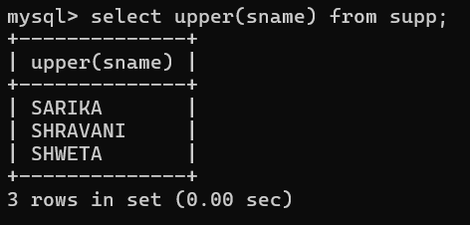

1. Display all the Supplier names in lower case.

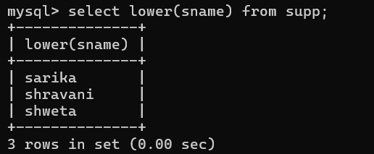

1. Display all the Supplier names padded to 25 characters, with spaces on the left.

select lpad(sname,25,' ') from supplier;

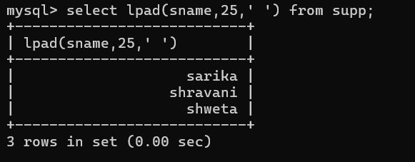

1. Display all the Supplier names (with ‘la’ replaced by ‘ro’).

HINT: REPLACE.

select sname,replace(sname,'ra','ro') ra_ro from supplier;

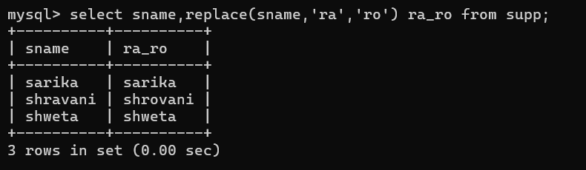

1. Execute the above command with the translate function and note the difference in output.

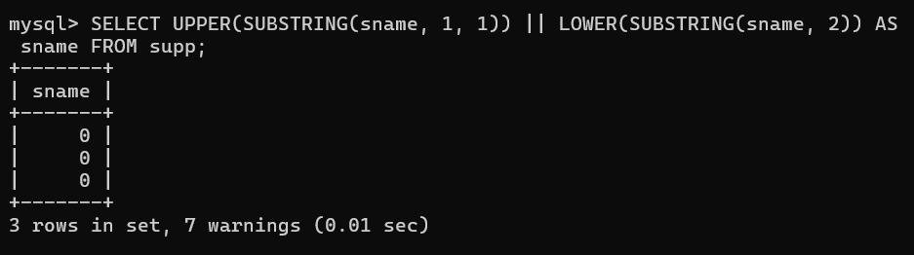

1. Display the Supplier names and the lengths of the names.

select sname, length(sname) from supplier;

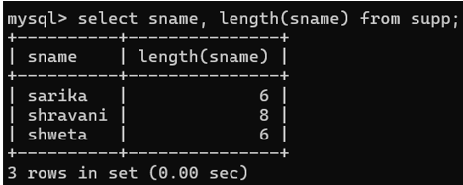

1. Use the soundex function to search for a supplier by the name of ‘BLOKE’.

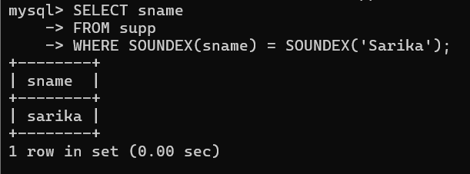

1. Display the Supplier name and the status (as Ten, Twenty, Thirty, etc.).

select sname, status from supplier;

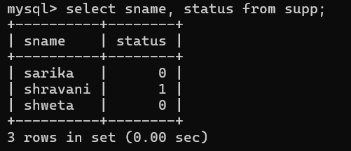

1. Display the current day (e.g. Thursday).

select dayname(curdate()) day;

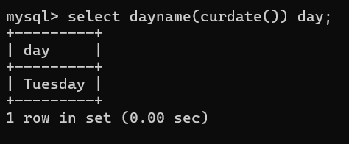

**SQL Exercise 4**

1. Display the minimum Status in the Supplier table.

select min(status) from supplier;

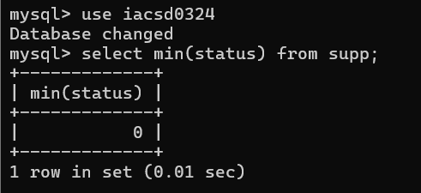

1. Display the maximum Weight in the Parts table.

select max(weight) from parts;

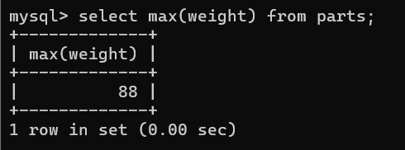

1. Display the average Weight of the Parts.

select avg(weight) from parts;

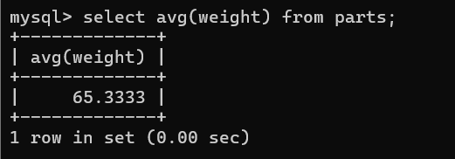

1. Display the total Quantity sold for part ‘P1’.

select qty from spj where pid=101;

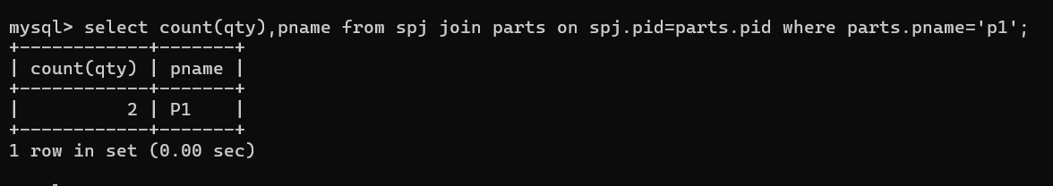

1. Display the total Quantity sold for each part.

select pid,count(qty) from spj group by pid;

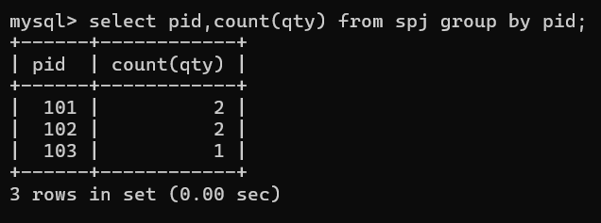

1. Display the average Quantity sold for each part.

select pid,avg(qty) from spj group by pid;

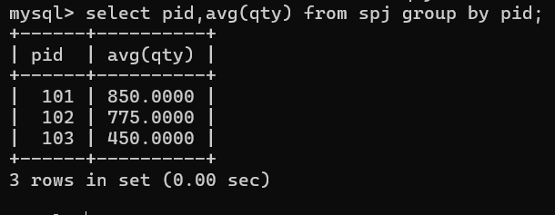

1. Display the maximum Quantity sold for each part, provided the maximum Quantity is greater than 800.

select pid,max(qty) from spj group by pid having max(qty)>800;

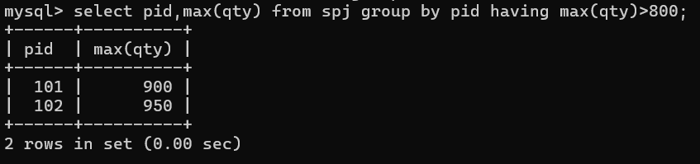

1. Display the Status and the count of Suppliers with that Status.

select status, count(sid) from supplier group by status;

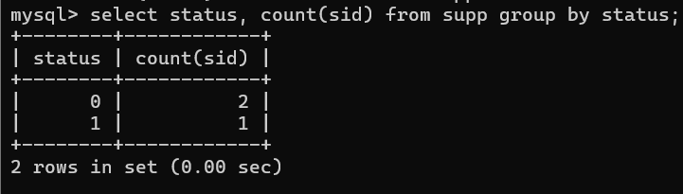

1. Display the count of Projects going on in different cities.

select city,count(jid) no_of_projects from projects group by city;

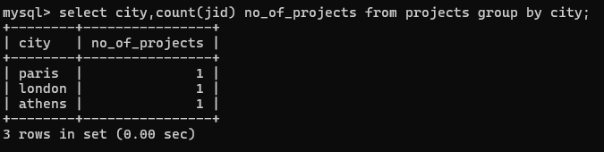

1. What is the difference between COUNT(Status) and COUNT(*) ?

select count(*),count(Status) from supplier;

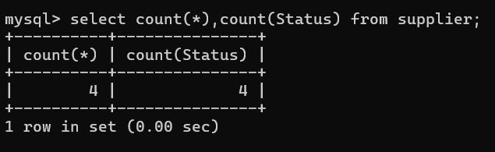

1. Display the Status and the Count of Suppliers with that Status in the following format as shown below:-

**Status Count**

Ten 1

Twenty 2

Thirty 3

select status, count(status) from supplier group by status;

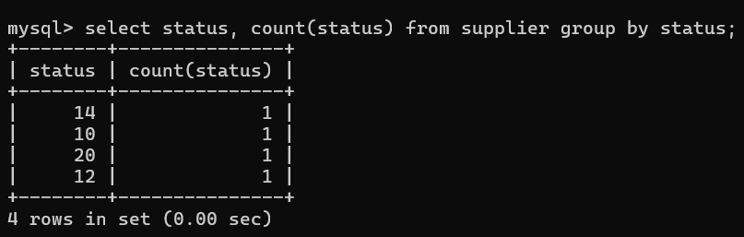

**SQL Exercise 5**

1. Display the Supplier name and the Quantity sold.

select sname,qty from supplier join spj on supplier.sid=spj.sid group by supplier;

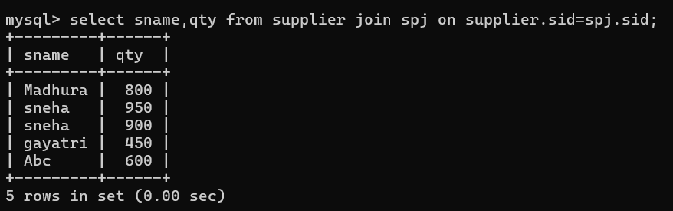

1. Display the Part name and Quantity sold.

select pname,qty from parts join spj on parts.pid=spj.pid;

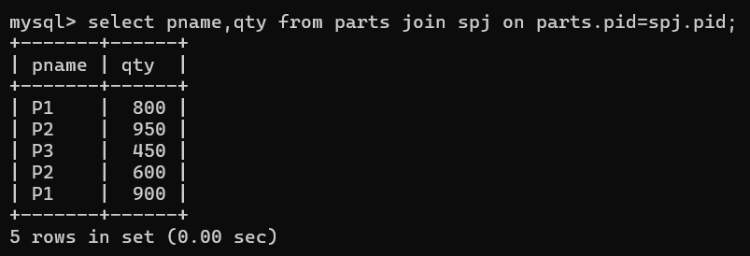

1. Display the Project name and Quantity sold.

select jname,qty from projects join spj on projects.jid=spj.jid;

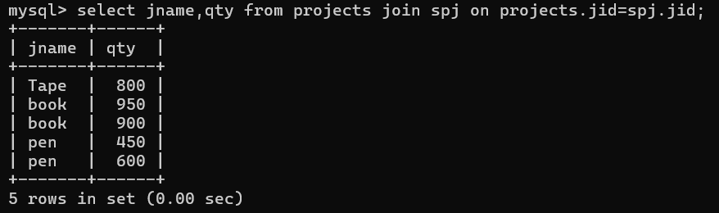

1. Display the Supplier name, Part name, Project name and Quantity sold.

select sname,pname,jname,qty from spj

join supplier on supplier.sid=spj.sid

join parts on parts.pid=spj.pid

join projects on projects.jid=spj.jid;

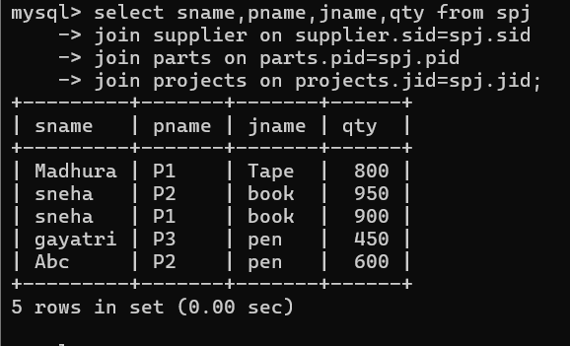

1. Display the Supplier name, Supplying Parts to a Project in the same City.

select sname,pname,jname,projects.city from spj

join projects on projects.jid=spj.jid

join supplier on spj.sid=supplier.sid

join parts on spj.pid=parts.pid

where supplier.city=projects.city;

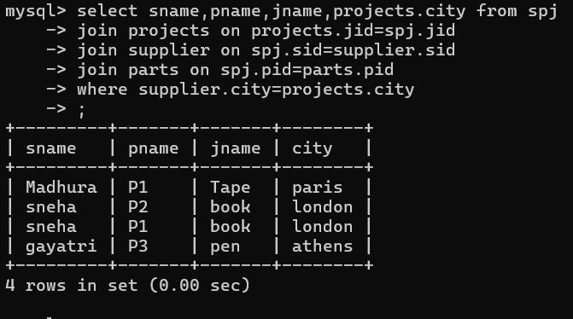

1. Display the Part name that is ‘Red’ is color, and the Quantity sold.

select pname,qty from spj join parts on parts.pid=spj.pid

where parts.color='red';

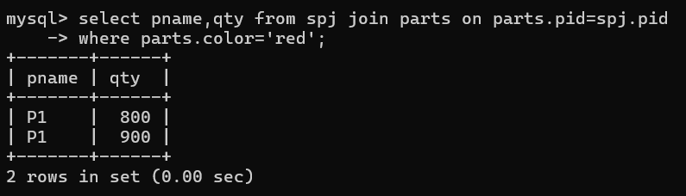

1. Display all the Quantity sold by Suppliers with the Status = 20.

select qty,sname from spj join supplier on supplier.sid=spj.sid

where supplier.status=20;

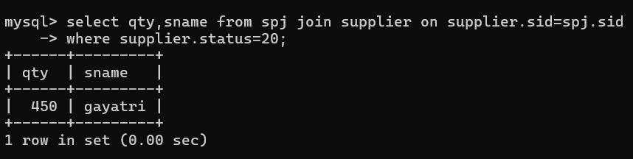

1. Display all the Parts and Quantity with a Weight > 14.

select qty,pname,weight from spj join parts on parts.pid=spj.pid

where parts.weight>14;

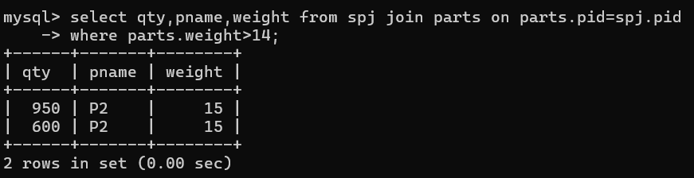

1. Display all the Project names and City, which has bought more than 500 Parts.

select jname,projects.city,qty from spj

join parts on parts.pid=spj.pid

join projects on projects.jid=spj.jid

where spj.qty>500;

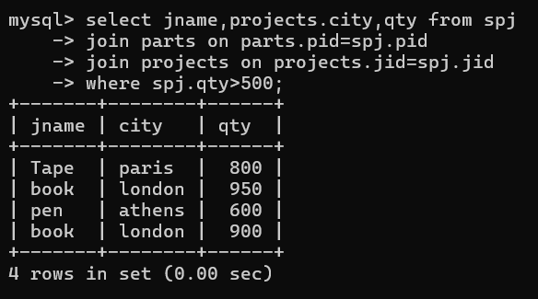

1. Display all the Part names and Quantity sold that have a Weight less than 15.

select pname,qty,parts.weight from spj

join parts on parts.pid=spj.pid

where parts.weight<15;

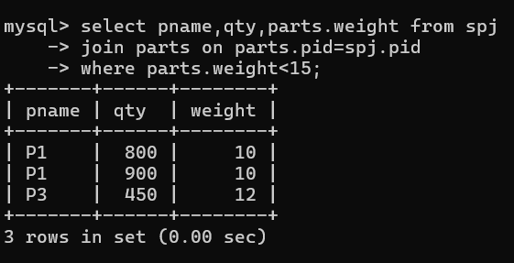

**SQL Exercise 6**

1. Display all the Suppliers with the same Status as the supplier, ‘CLARK’.

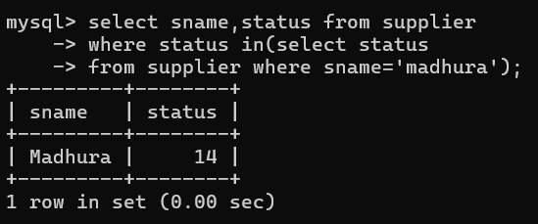

1. Display all the Employees in the same department as the employee ‘MILLER’.

select * from emp where deptno in(select deptno from dept where ename

='miller');

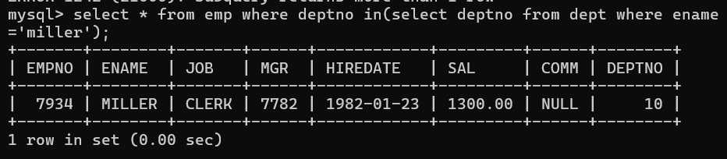

1. Display all the Parts which have more Weight than all the Red parts.

select * from parts p where p.weight>(select weight from parts m

where m.color='red');

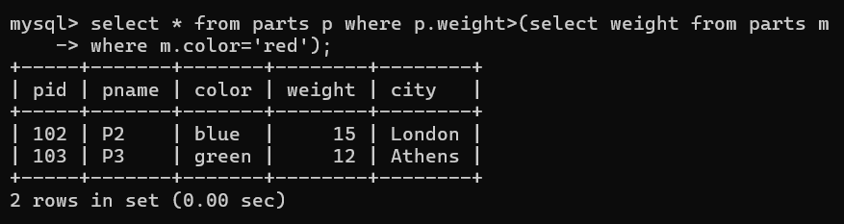

1. Display all the Projects going on in the same city as the project ‘TAPE’.

select jname from projects where city=(select city from projects wher

e jname='tape');

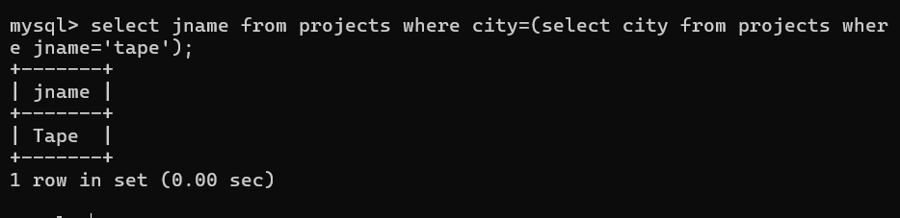

1. Display all the Parts with Weight less than all the Green parts.

select pid,pname,color from parts where weight <(select weight from p

arts where color='green');

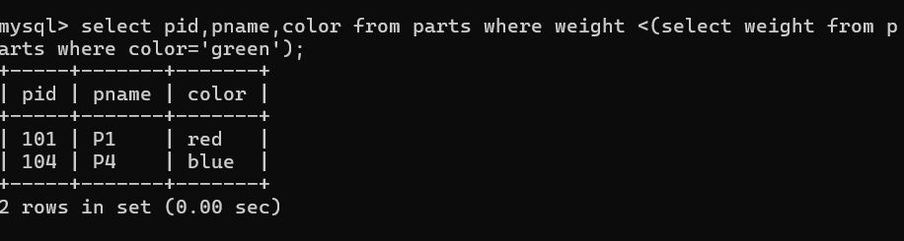

1. Display the name of the Supplier who has sold the maximum Quantity (in one sale).

select sname from supplier where sid =(select sid from spj where qty =(select max(qty) from spj));

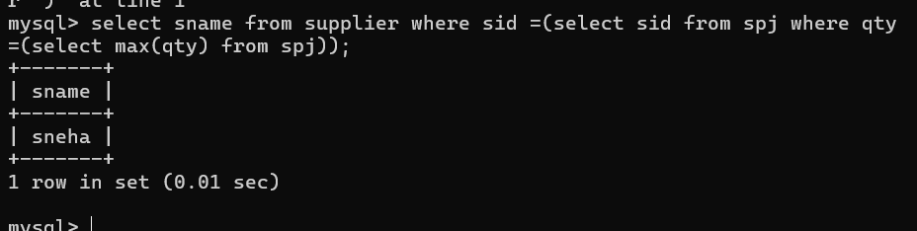

1. Display the name of the Employee with the minimum Salary.

select ename,min(sal) from emp having min(sal);

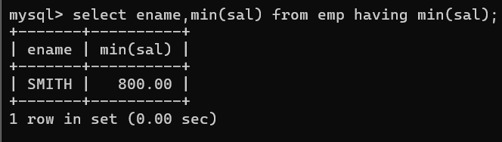

1. Display the name of the Supplier who has sold the maximum overall Quantity (sum of Sales).

select sname from supplier where sid = (select sid from spj where qty

=(select max(qty) from spj));

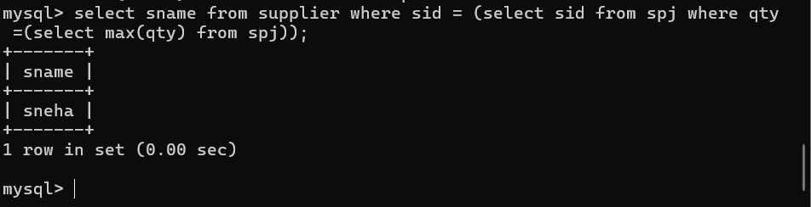

1. Display the name of the Department with the maximum number of Employees.

select d.deptno,d.dname,count(*) from dept d,emp e where d.deptno=e.deptno group by deptno order by deptno desc limit 1;

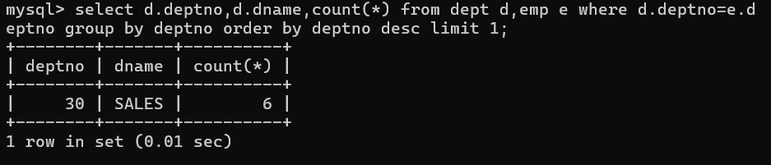

**DAY-10**

1. Write a MongoDB query to display all the documents in the collection restaurants

db.restaurent.find()

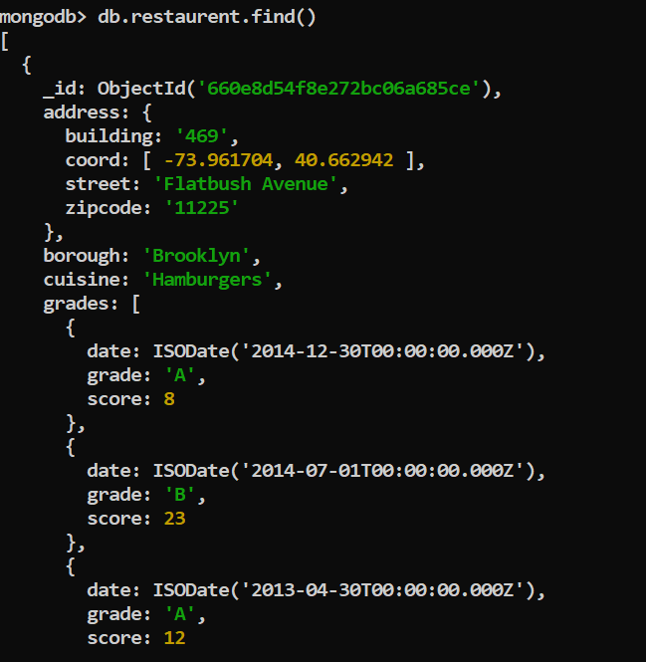

1. Write a MongoDB query to display the fields restaurant_id, name, borough and cuisine for db.all the documents in the collection restaurant.

db.restaurent.find({},{name:1,borough:1,cuisine:1})

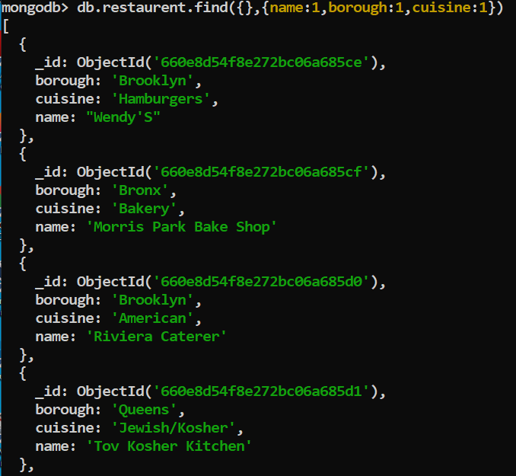

3. Write a MongoDB query to display the fields restaurant_id, name, borough and cuisine,

but exclude the field _id for all the documents in the collection restaurant.

db.restaurent.find({},{_id:0,name:1,borough:1,cuisine:1})

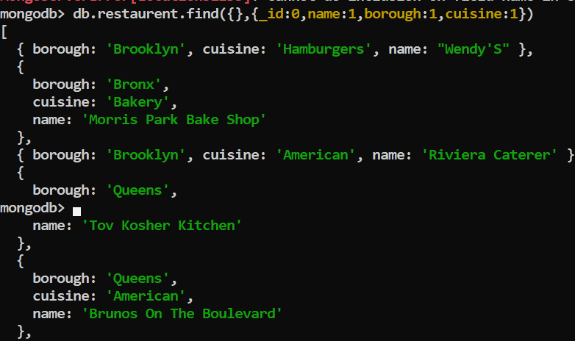

4. Write a MongoDB query to display the fields restaurant_id, name, borough and zip code,

but exclude the field _id for all the documents in the collection restaurant.

db.restaurent.find({},{restaurent_id:1,name:1,borough:1,zipcode:1,_id:0})

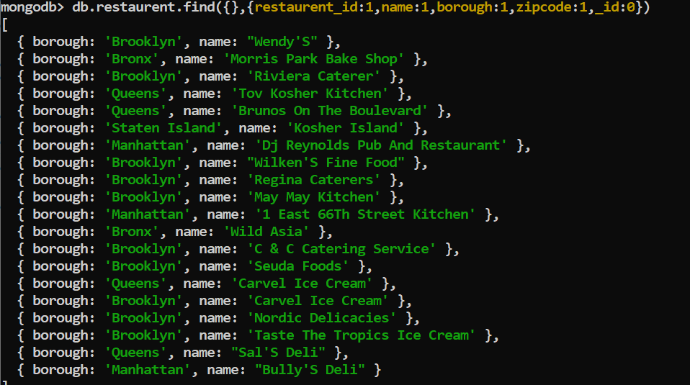

5. Write a MongoDB query to display all the restaurant which is in the borough Bronx

db.restaurent.find({borough:'Bronx'},{name:1,borough:1,_id:0})

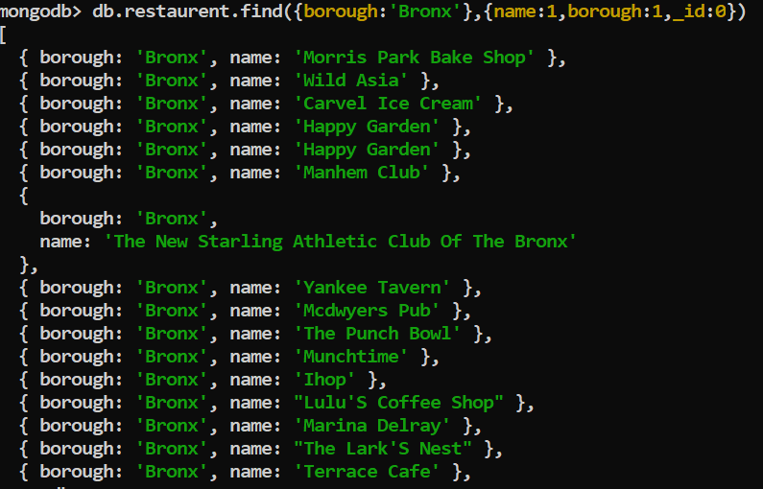

6. Write a MongoDB query to display the first 5 restaurant which is in the borough Bronx.

db.restaurent.find({borough:'Bronx'}).limit(5)

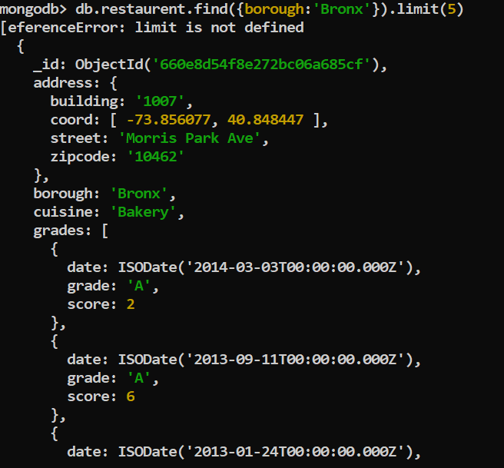

7.Write a MongoDB query to display the next 5 restaurants after skipping first 5 which are in

the borough Bronx.

db.restaurent.find({borough:'Bronx'}).skip(5)

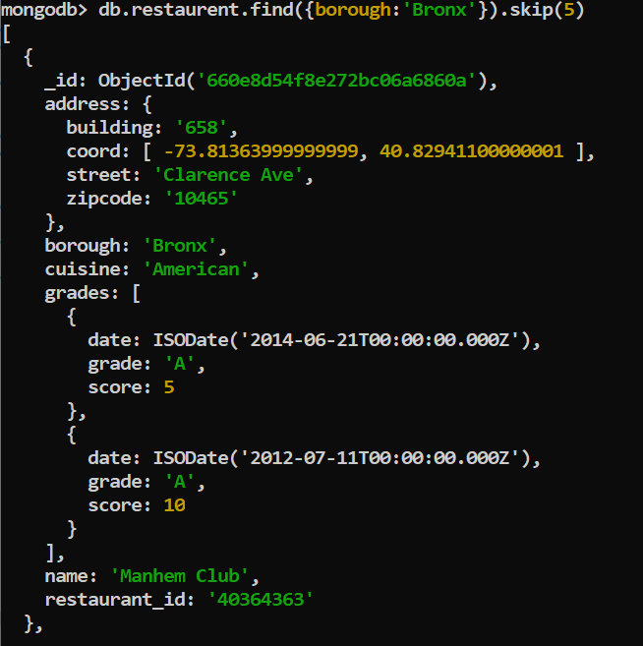

8. Write a MongoDB query to find the restaurants who achieved a score more than 90.

db.restaurent.find({grades:{$elemMatch:{score:{$gt:90}}}})

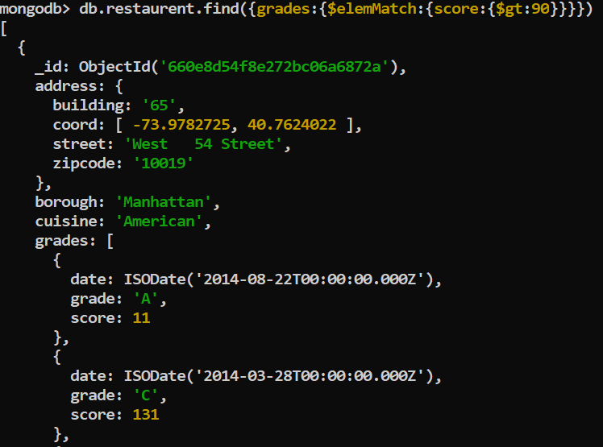

09. Write a MongoDB query to find the restaurants that achieved a score, more than 80 but

less than 100.

db.restaurent.find({grades:{$elemMatch:{score:{$gt:80,$lt:100}}}})

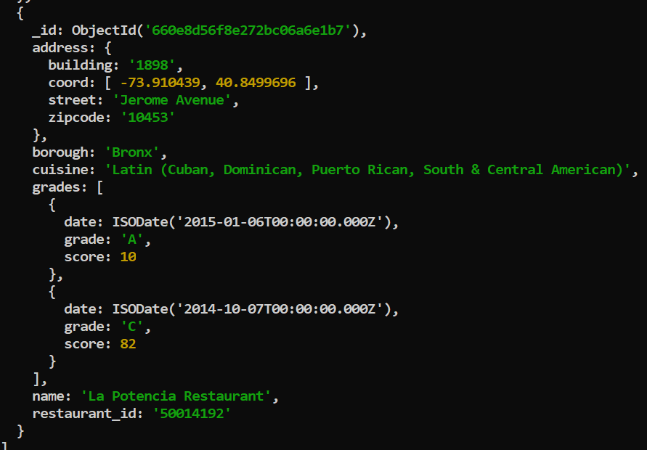

10. Write a MongoDB query to find the restaurants which locate in latitude value less than -

95.754168.

db.restaurent.find({'address.coord':{$lt:-95.754168}})

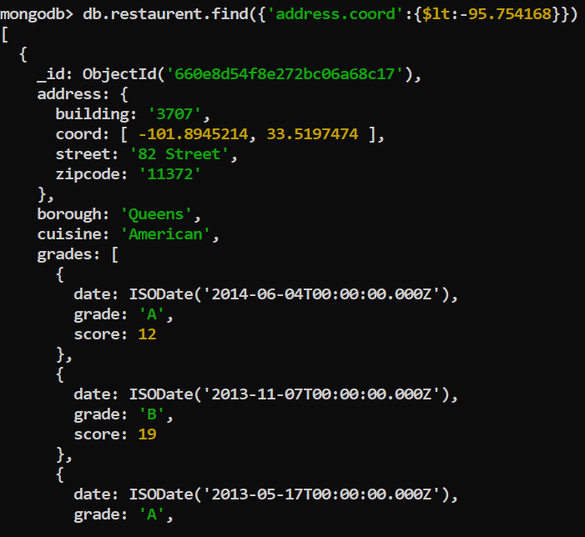

11. Write a MongoDB query to find the restaurants that do not prepare any cuisine of

'American' and their grade score more than 70 and latitude less than -65.754168.

db.restaurent.find({cuisine:{$ne:'American'},'grades.score':{$gt:70},'address.coord':{$lt:-65.754168}})

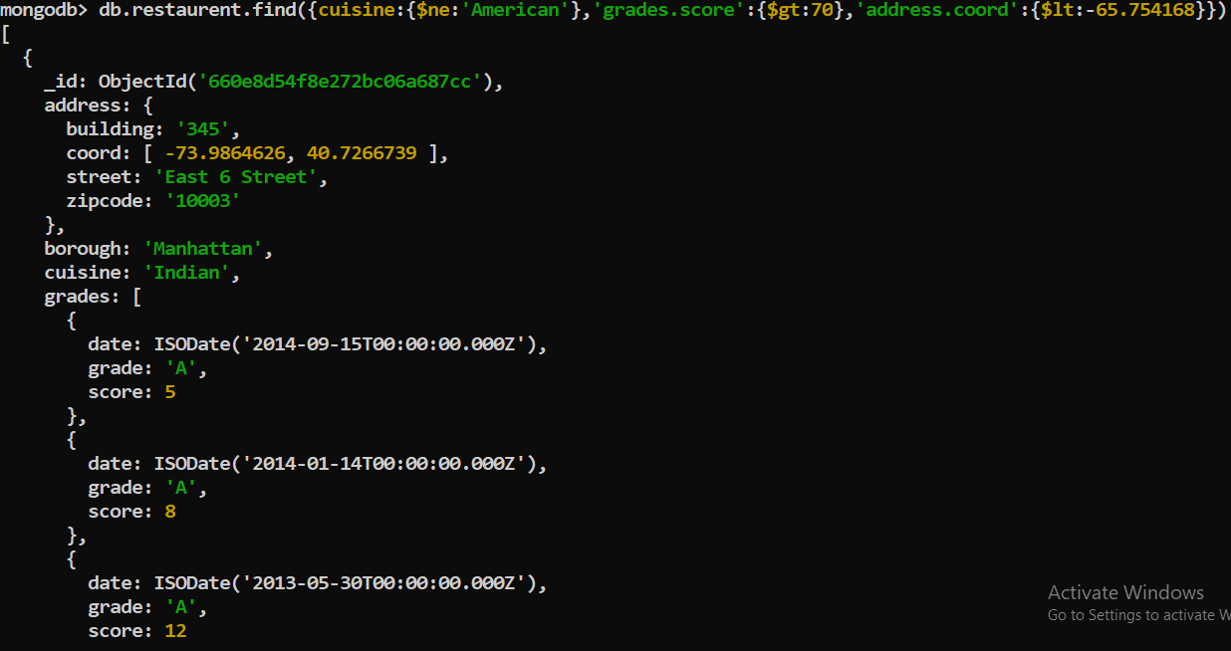

12. Write a MongoDB query to find the restaurants which do not prepare any cuisine of

'American' and achieved a score more than 70 and located in the longitude less than -

65.754168.

db.restaurent.find({cuisine:{$ne:'Amercian'},'grades.score':{$gt:70},'address.coord':{$lt:-65.754168}})

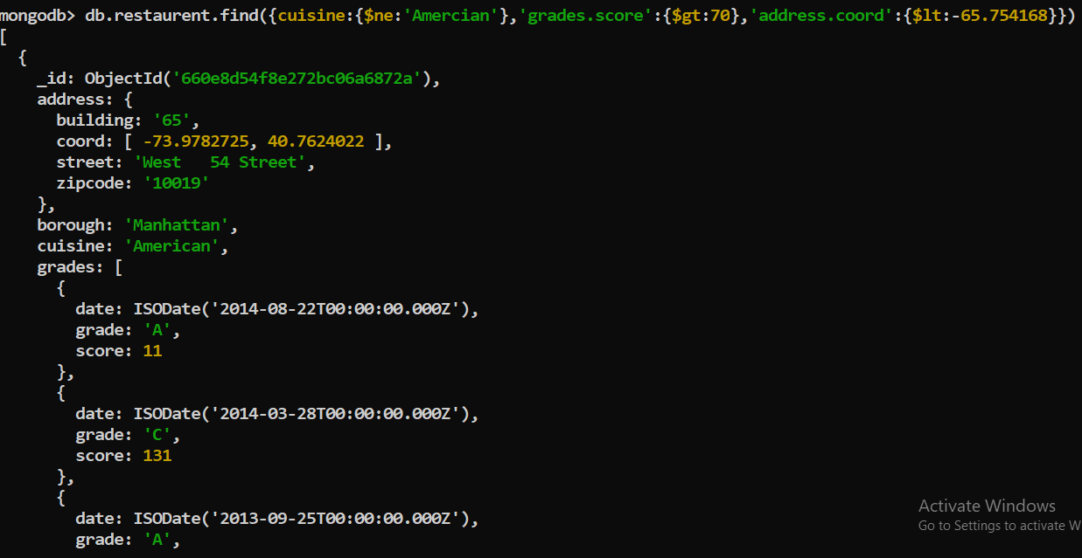

13. Write a MongoDB query to find the restaurants which do not prepare any cuisine of

'American ' and achieved a grade point 'A' not belongs to the borough Brooklyn. The

document must be displayed according to the cuisine in descending order.

db.restaurent.find({cuisine:{$ne:'Amercian'},'grades.grade':'A',borough:{$ne:'Brooklyn'}}). sort({cuisine:1})

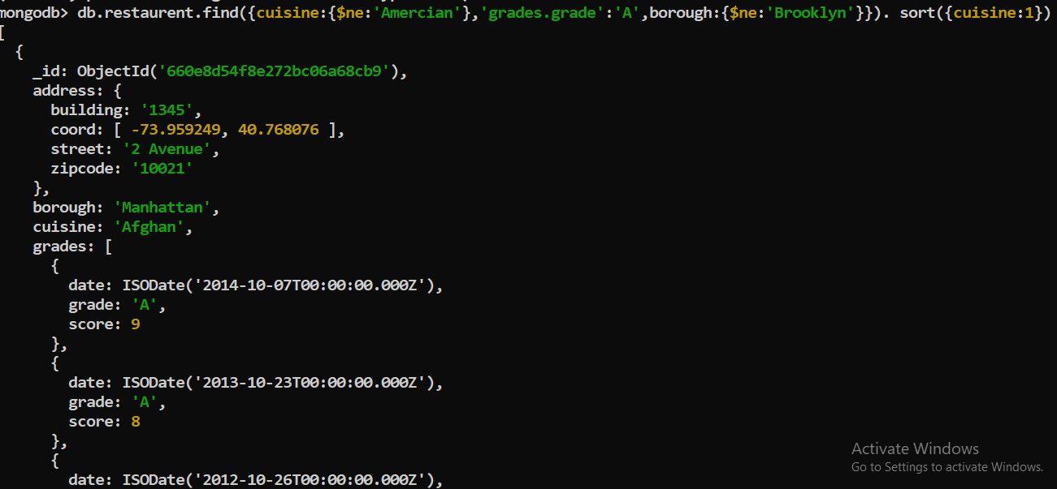

14. Write a MongoDB query to find the restaurant Id, name, borough and cuisine for those

restaurants which contain 'Wil' as first three letters for its name.

db.restaurent.find({name:/^Wil/},{restaurent_id:1,name:1,borough:1,cuisine:1})

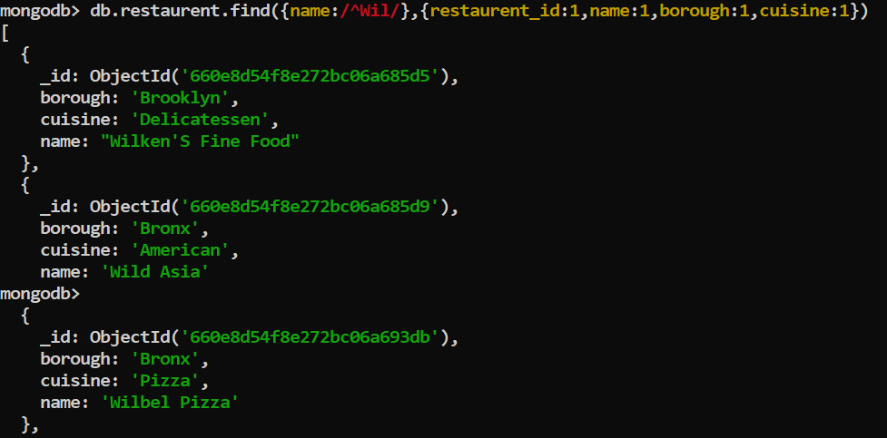

15. Write a MongoDB query to find the restaurant Id, name, borough and cuisine for those

restaurants which contain 'ces' as last three letters for its name.

db.restaurent.find({name:/ces$/},{restaurent_id:1,name:1,borough:1,cuisine:1,_id:0})

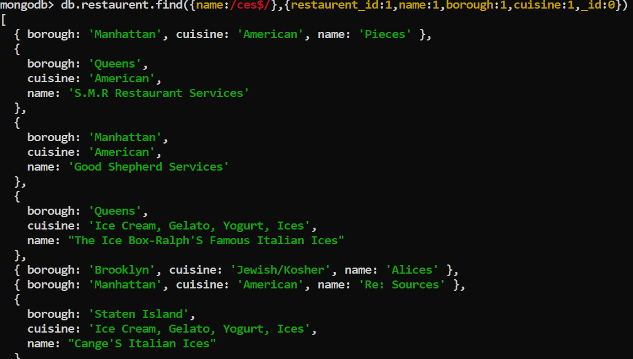

16. Write a MongoDB query to find the restaurant Id, name, borough and cuisine for those

restaurants which contain 'Reg' as three letters somewhere in its name.

db.restaurent.find({name:/reg/},{restaurent_id:1,name:1,borough:1,cuisine:1,_id:0})

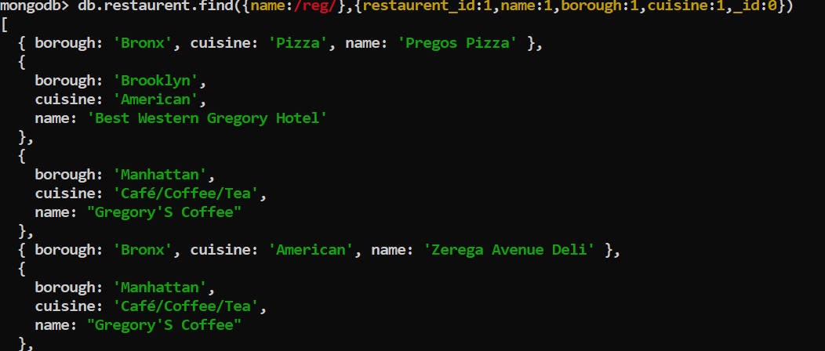

17. Write a MongoDB query to find the restaurants which belong to the borough Bronx and

prepared either American or Chinese dish.

db.restaurent.find({borough:'Bronx',cuisine:{$in:['American','Chinese']}})

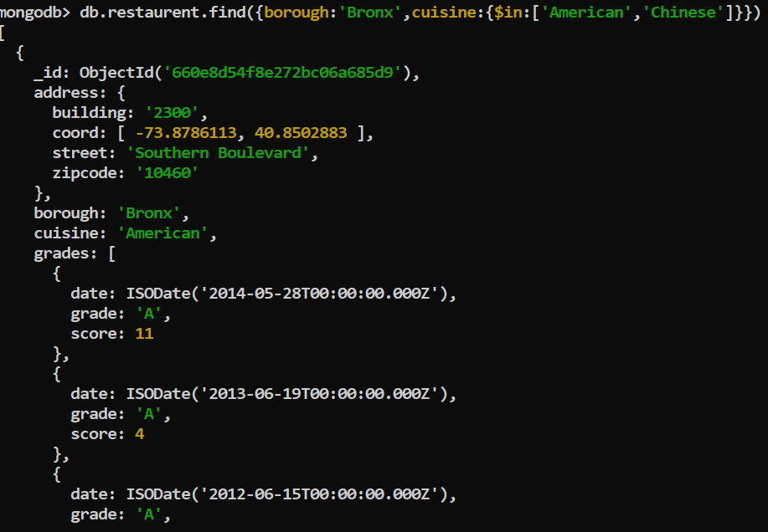

18. Write a MongoDB query to find the restaurant Id, name, borough and cuisine for those

restaurants which belong to the borough Staten Island or Queens or Bronxor Brooklyn.

db.restaurent.find({borough:{$in:['Staten Island','Queens','Bronx','Brooklyn']}},{restaurent_id:1,name:1,borough:1,cuisine:1})

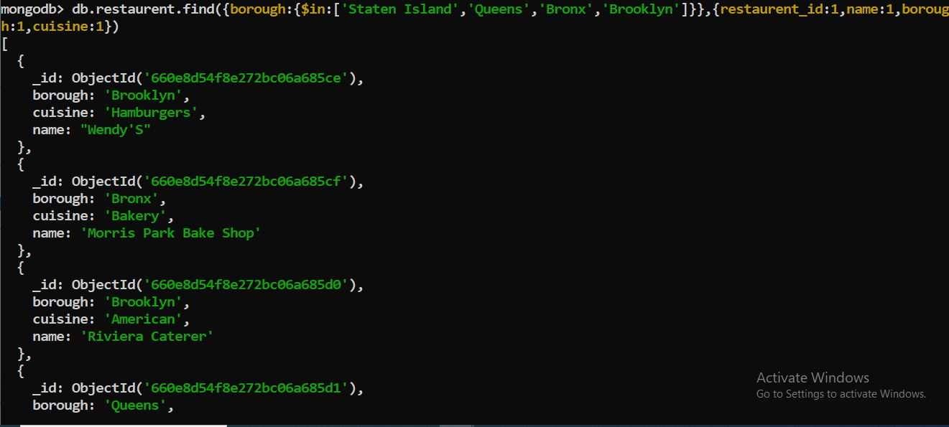

19. Write a MongoDB query to find the restaurant Id, name, borough and cuisine for those

restaurants which are not belonging to the borough Staten Island or Queens or Bronxor

Brooklyn.

db.restaurent.find({borough:{$nin:['Staten Island','Queens','Bronx','Brooklyn']}},{restaurent_id:1,name:1,borough:1,cuisine:1})

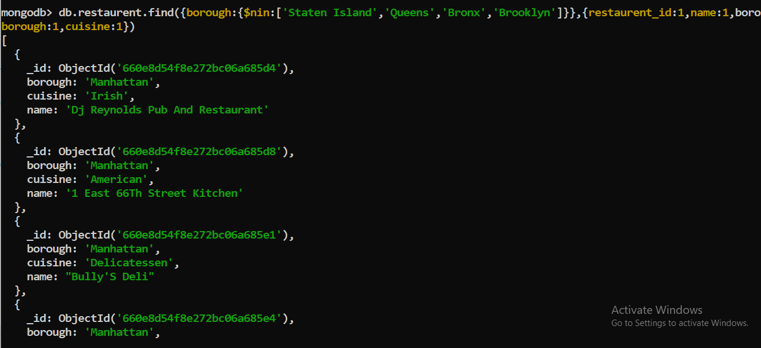

20. Write a MongoDB query to find the restaurant Id, name, borough and cuisine for those

restaurants which achieved a score which is not more than 10.

db.restaurent.find({grades:{$elemMatch:{score:{$lt:10}}}})

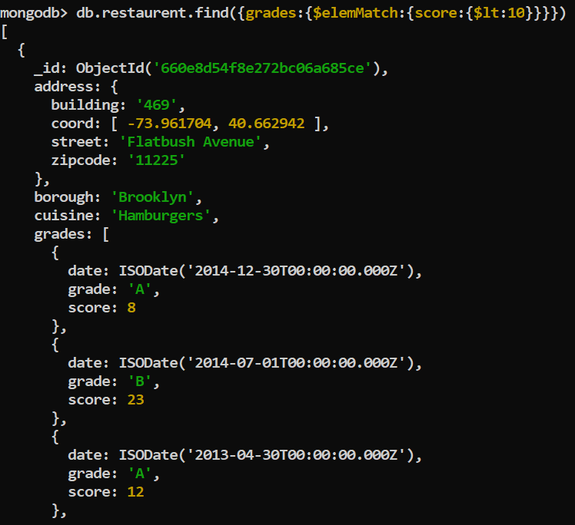

21. Write a MongoDB query to find the restaurant Id, name, borough and cuisine for those

restaurants which prepared dish except 'American' and 'Chinees' or restaurant's name begins

with letter 'Wil'.

db.restaurent.find({$or:[{name:/^wil/i},{cuisine:{$nin:['Amercian','Chinese']}}]},{_id:0,name:1,borough:1,cuisine:1});

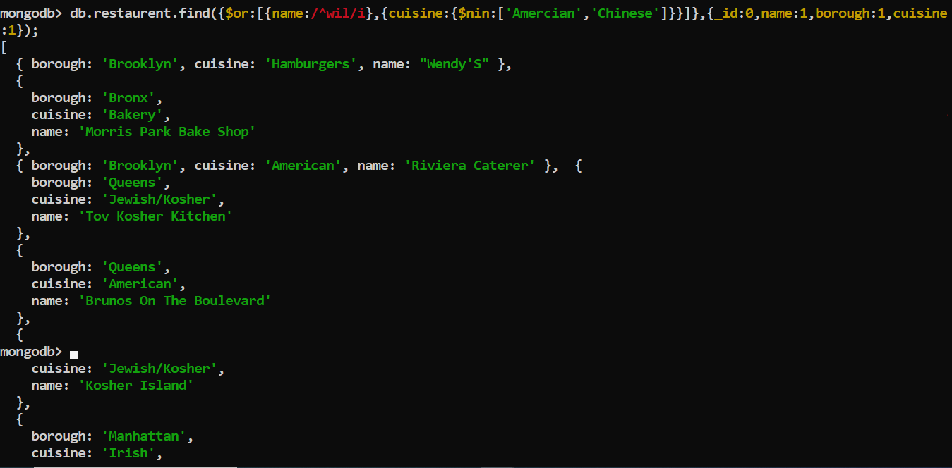

22. Write a MongoDB query to find the restaurant Id, name, and grades for those restaurants

which achieved a grade of "A" and scored 11 on an ISODate "2014-08-11T00:00:00Z"

among many of survey dates

db.restaurent.find({'grades.grade':'A','grades.score':11,'grades.date':ISODate('2014-08-11T00:00:00Z')},{restaurent_id:1,name:1,grade:1})

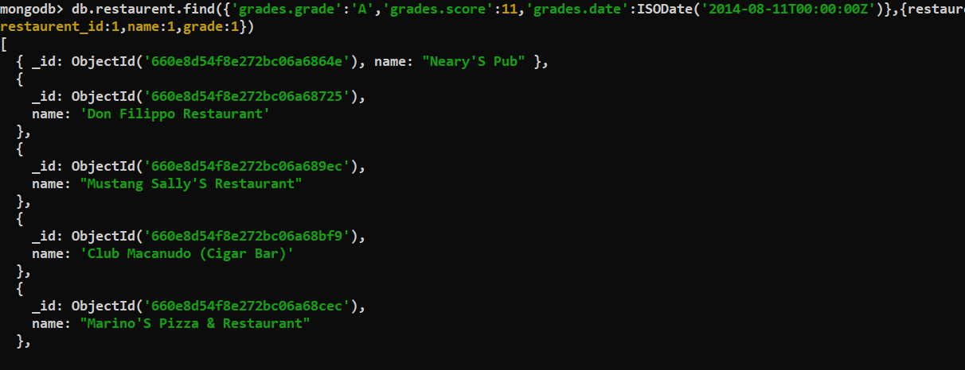

23. Write a MongoDB query to find the restaurant Id, name and grades for those restaurants

where the 2nd element of grades array contains a grade of "A" and score 9 on an ISODate

"2014-08-11T00:00:00Z".

db.restaurent.find({'grades.1.grade':'A','grades.score':9,'grades.date':ISODate('2014-08-11T00:00:00Z')},{restaurent_id:1,name:1,'grades.grade':1})

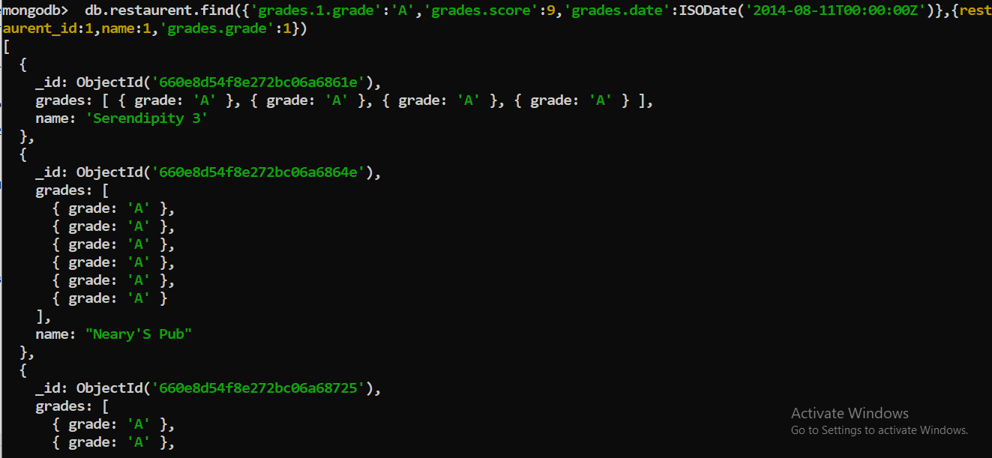

24. Write a MongoDB query to find the restaurant Id, name, address and geographical

location for those restaurants where 2nd element of coord array contains a value which is

more than 42 and upto 52

db.restaurent.find({ 'address.1.coord':{$gt:42,$lt:52},{restaurent_id:1,name:1,'address.coord':1} })

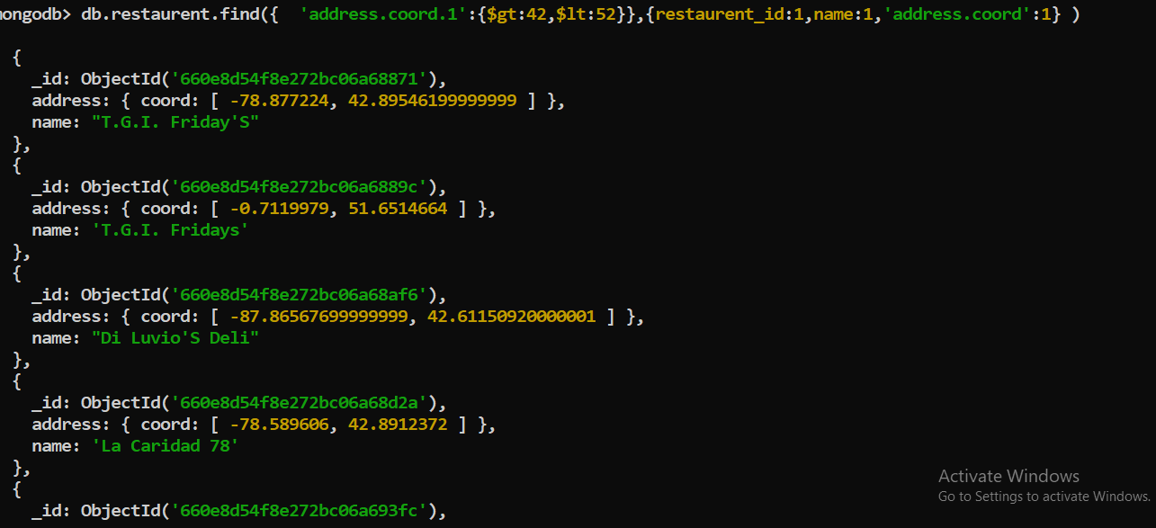

25. Write a MongoDB query to arrange the name of the restaurants in ascending order along

with all the columns.

db.restaurent.find().sort({name:1})

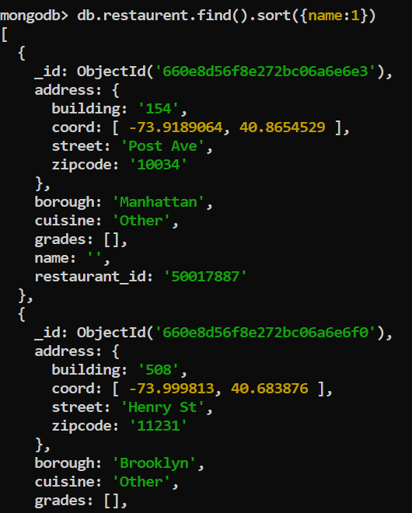

26. Write a MongoDB query to arrange the name of the restaurants in descending along with

all the columns.

db.restaurent.find().sort({name:-1})

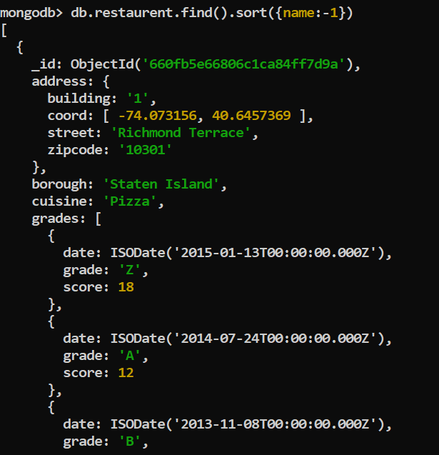

27. Write a MongoDB query to arranged the name of the cuisine in ascending order and for

that same cuisine borough should be in descending order.

db.restaurent.find().sort({cuisine:1},{borough:-1})

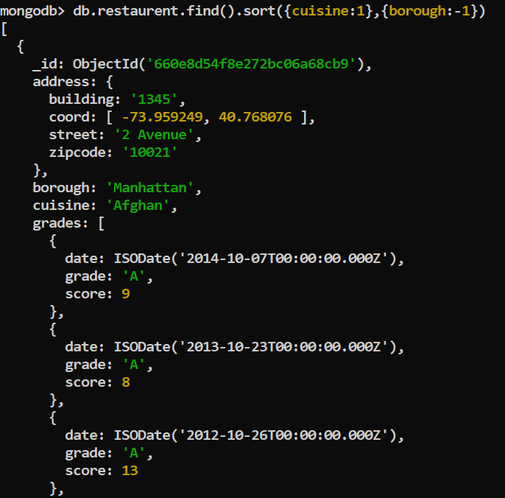

28. Write a MongoDB query to know whether all the addresses contains the street or not.

db.restaurent.find({'address.street':{$exist:'true'}})

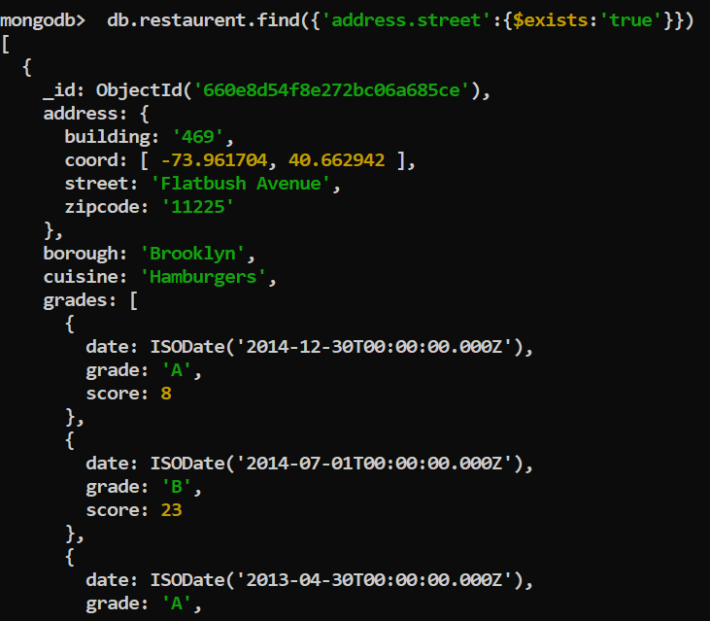

29. Write a MongoDB query which will select all documents in the restaurants collection

where the coord field value is Double.

db.restaurent.find({'address.coord':{$type:"Double"}})

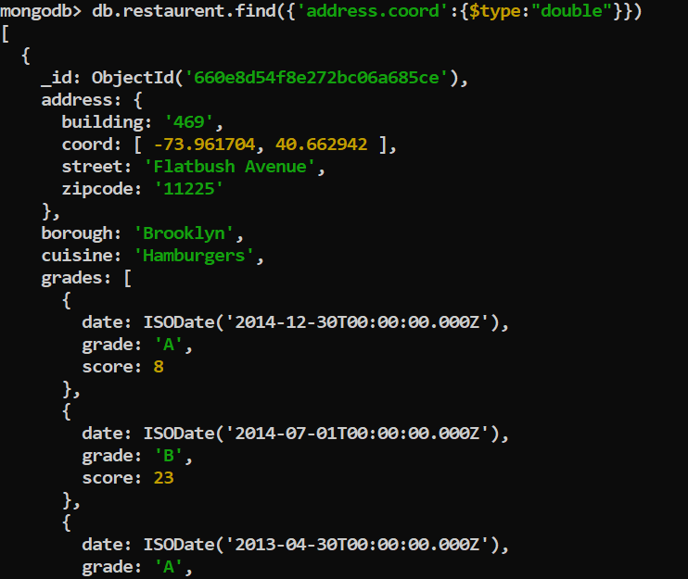

30. Write a MongoDB query which will select the restaurant Id, name and grades for those

restaurants which returns 0 as a remainder after dividing the score by 7.

db.restaurent.find({'grades.score':{$mod:[7,0]}})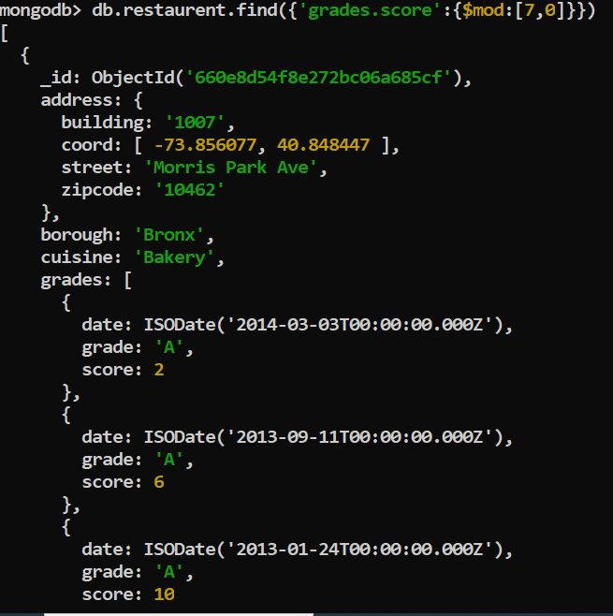

31. Write a MongoDB query to find the restaurant name, borough, longitude and attitude and

cuisine for those restaurants which contains 'mon' as three letters somewhere in its name.

db.restaurent.find({name:/mon/},{restaurent_id:1,name:1,borough:1,cuisine:1,'address.coord':1}) 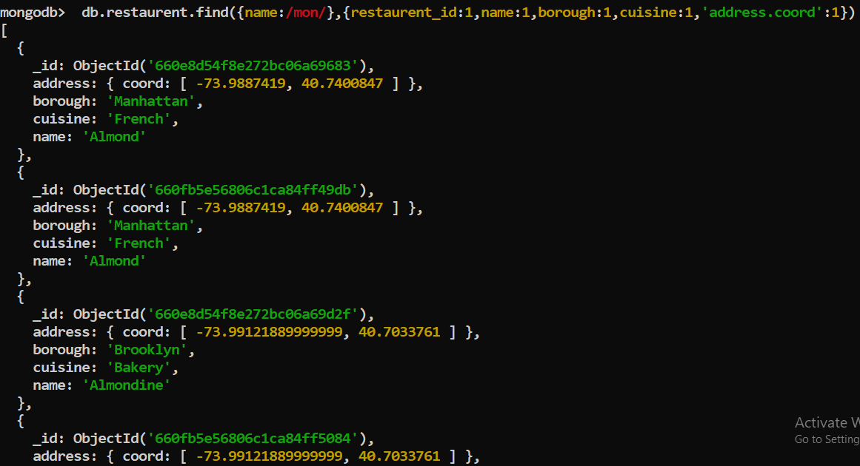

32. Write a MongoDB query to find the restaurant name, borough, longitude and latitude and

cuisine for those restaurants which contain 'Mad' as first three letters of its name.

db.restaurent.find({name:/^Mad/},{restaurent_id:1,name:1,borough:1,cuisine:1,'address.coord':1})

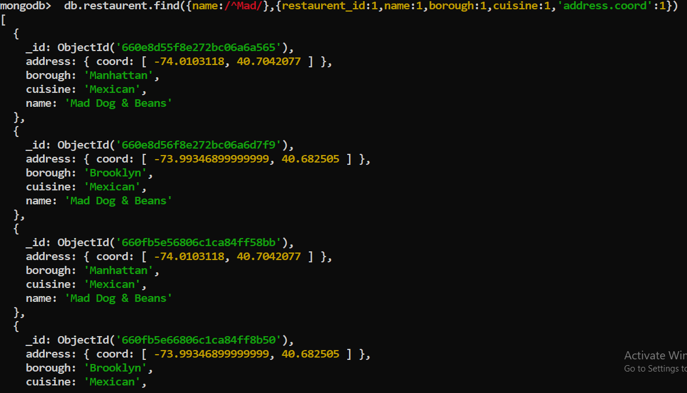

**DAY-11**

1. Find all books whose author is Faisal Abid and display name of book authors and categories

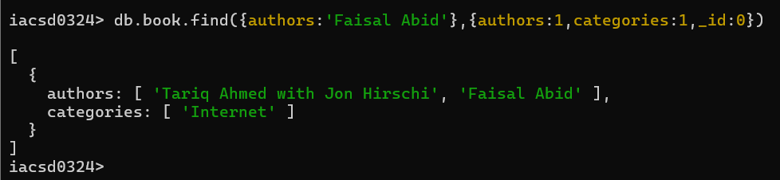

2. List all the books with category Internet at first position in category array

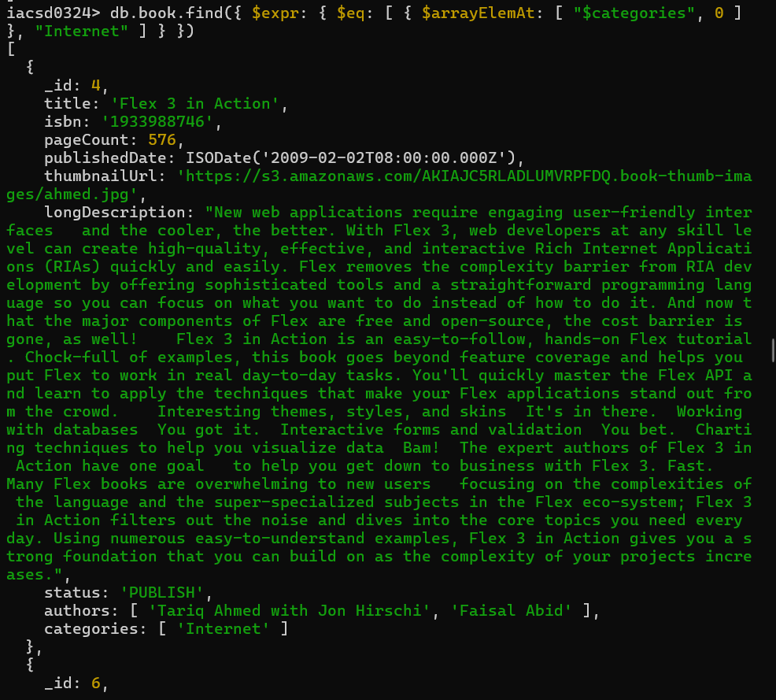

3. Change the status of books “undergoing change” for books having more than 500 pages and published in 2009

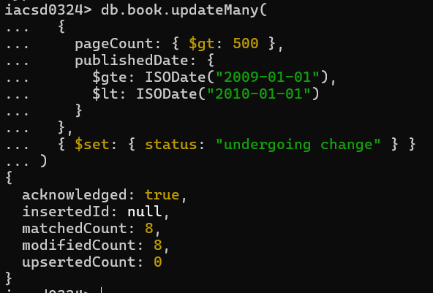

4. Find all the books containing word highlighting and depth in long description of the book



5. Display all books published in 2009

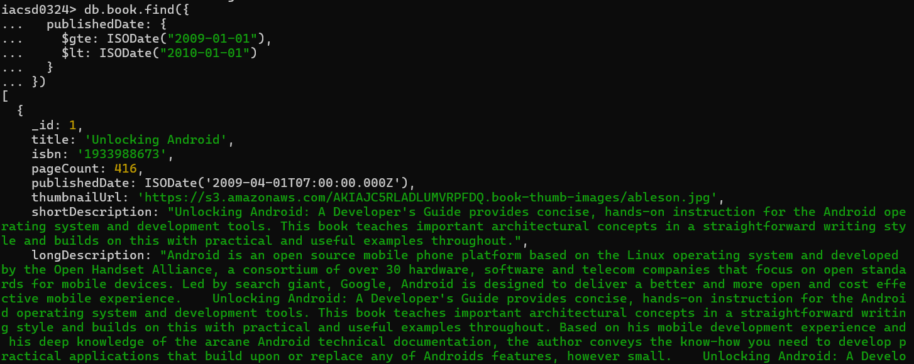

6. Find all books with pageCount is either 500 or 556 or 670

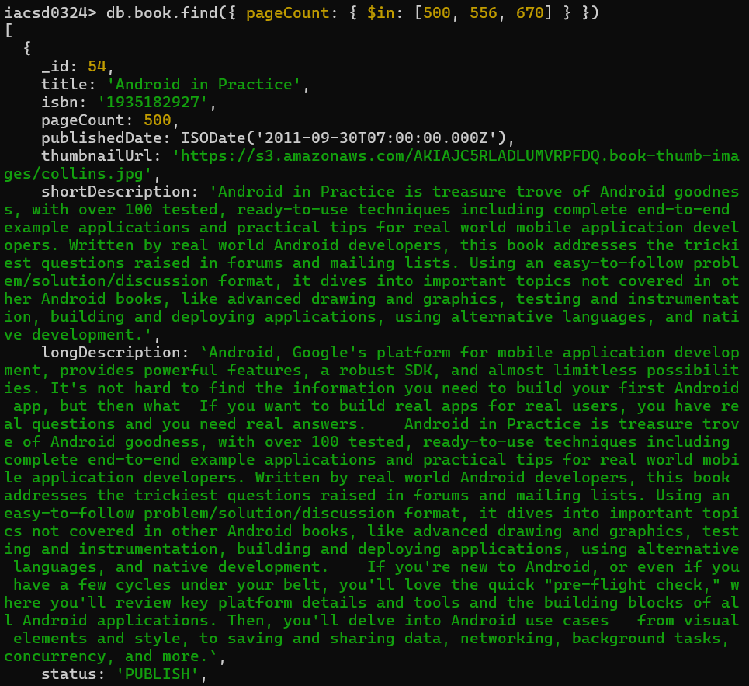

7. Add 2 categories “kindle” and “hard bind” in all the books if its pageCount >200 and < 500 or number of pages >500

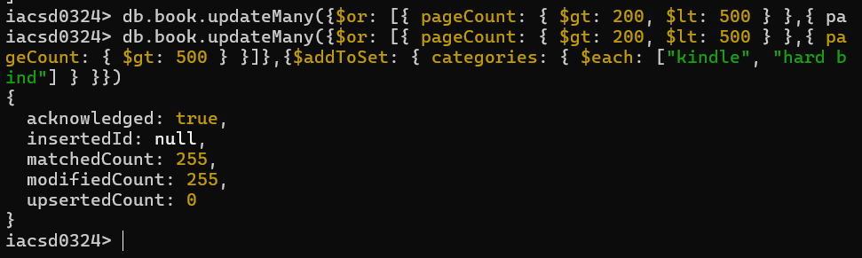

8. List all the books which has thumbnailUrl key

9. Add key type with values [“fiction”,”moral stories”,”adventurous”] in all books whose title starts with Fl and contains a some where in the name

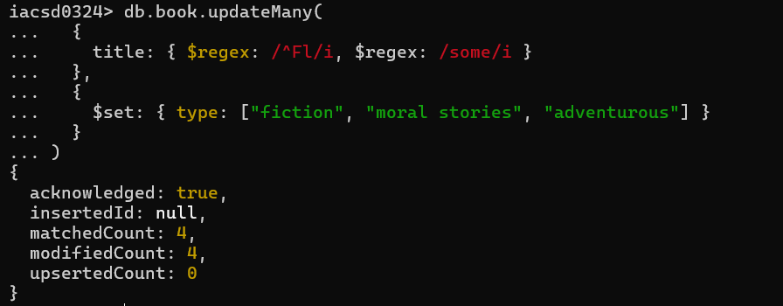

10. Add a key comments :[{comment:” like the book” ,date:ISODate(“2019-09-01”)},

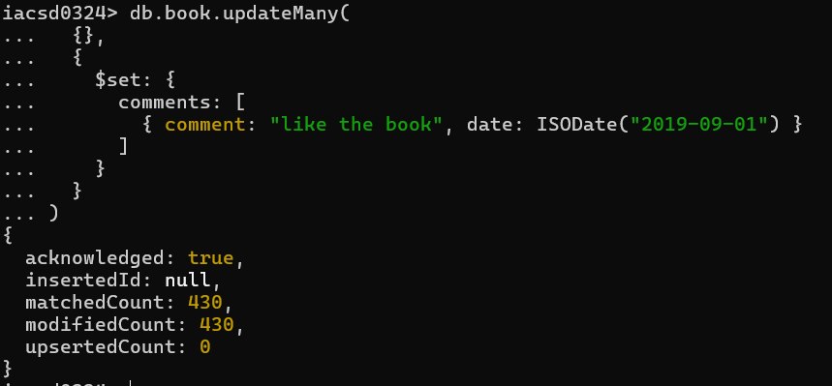

11. Add new author “myauthor” at position 2 for all books whose title starts with h or m and contains s at 2nd last position

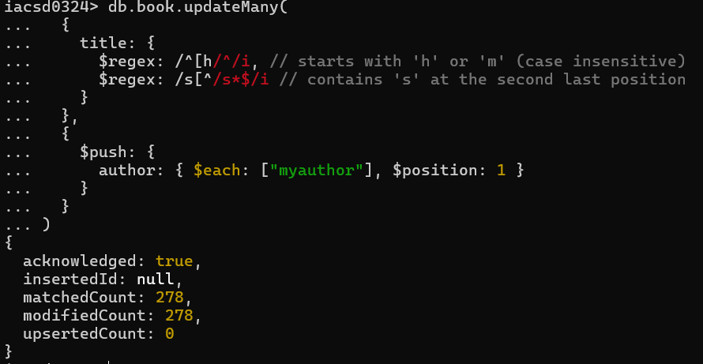

12. Increase pageCount by 100 for all books whose author at 1 st position is “Gal Shachor”

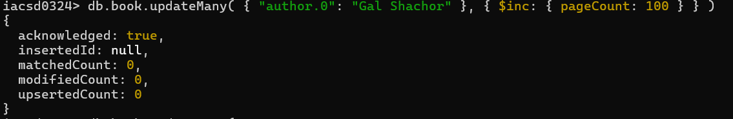

13. Overwrite “Magnus Rydin" with name “Fr”

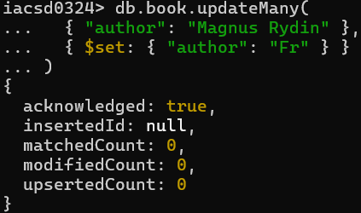

**Day-12**

Create a Employee Collection add 5 documents:

Example:

{emono:111,ename:”Deepali Vaidya”,sal:40000.00,dept:{deptno:12,dname:,”Hr”,dloc:”Mumbai},

Desg:”Analyst”,mgr:{name:”Satish”,num:111},project:[{name:”Project- 1”,Hrs:4},{name:”project- 2”,Hrs:4}]}

1. All Employee’s with the desg as ‘CLERK’ are now called as (AO) Administrative Officers. Update the Employee collection for this.

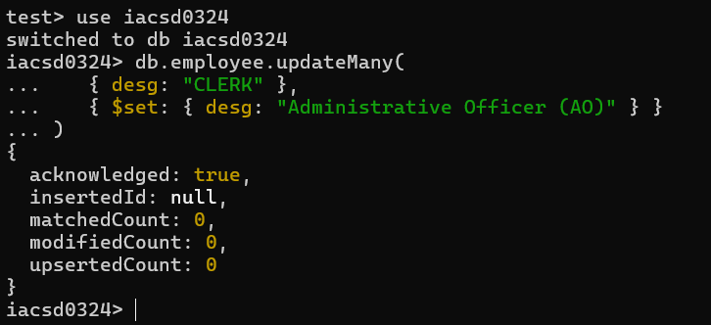

1. Change the number of hours for project-1 to 5 for all employees with designation analyst.

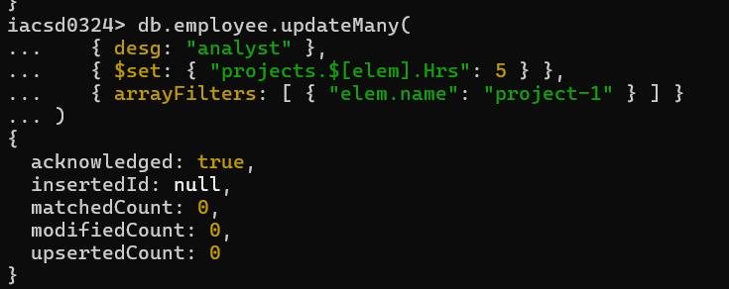

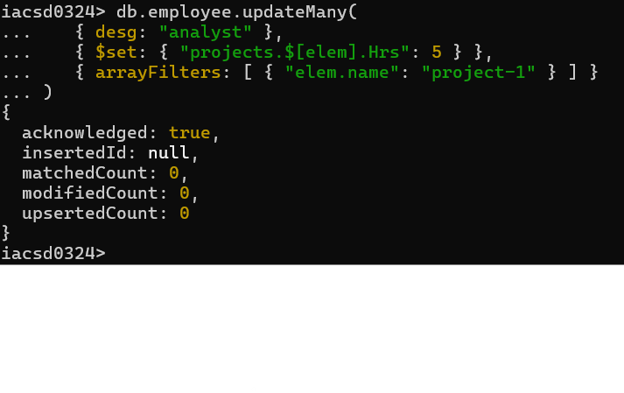

1. Add 2 projects project-3 and project-4 for employee whose name starts with ”Deep” with 2 hrs db.emp.update({name:/^Deep/},{$push:{project:{$each:[{name:'project-

3',Hrs:2},{name:'project-4',Hrs:2}]}}},

{multi:true})

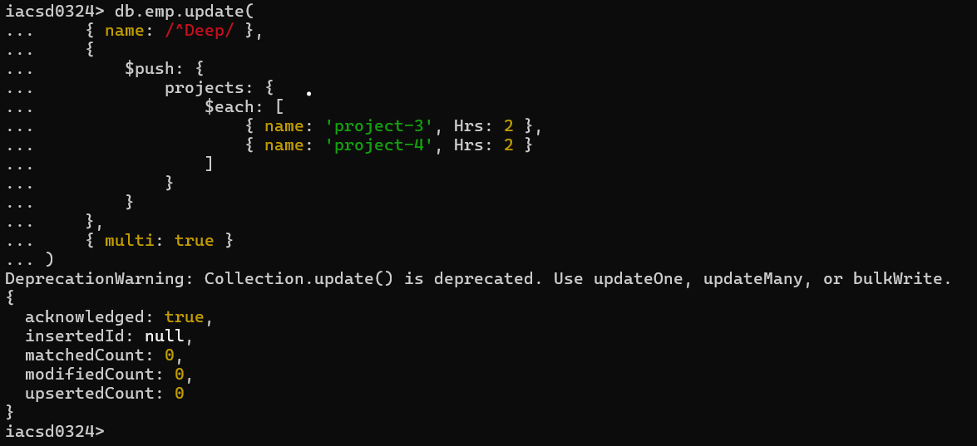

1. Add bonus rs 2000 for all employees with salary > 50000

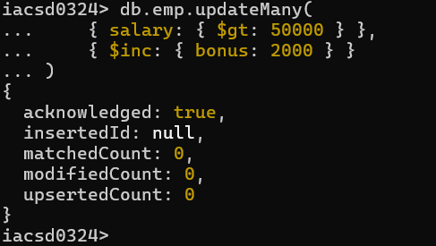

1. add bonus 1500 if salary <50000 and > 30000

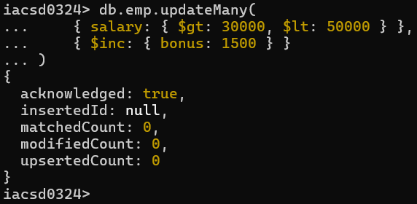

1. add bonus 1000 if salary <=30000

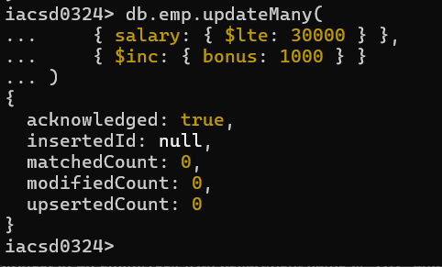

1. Change manager name to Tushar for all employees whose manager is currently “satish”

And manager number to 3333

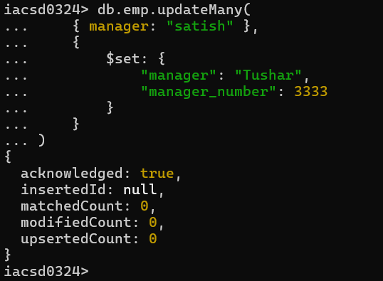

1. Increase salary of all employees from “purchase department” by 15000

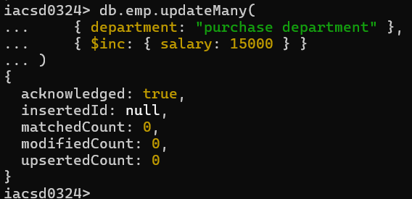

1. Decrease number of hrs by 2 for all employees who are working on project-2

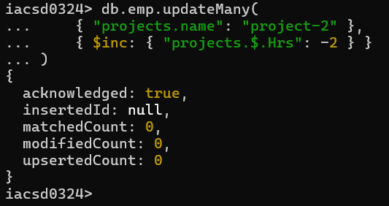

1. Delete project-2 from all employee document if they are working on the project for 4 hrs.

db.emp.update({},{$pull:{“project.name”:”project-

2”,”project.Hrs”:4}},{multi:true})

or

db.Emp.update({},{$pull:{project:{name:'project-2',Hrs:4}}},{multi:true}) or

db.emp.update({},{$pull:{“project:{$elemMatch:{name:”project- 2”,”Hrs”:4}},{multi:true})

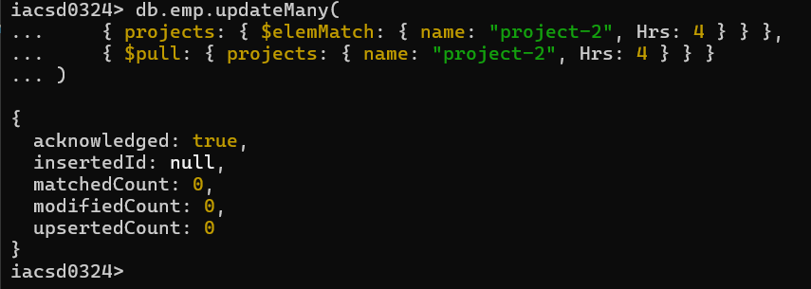

1. Change the salary of employees to 10000 only if their salary is < 10000

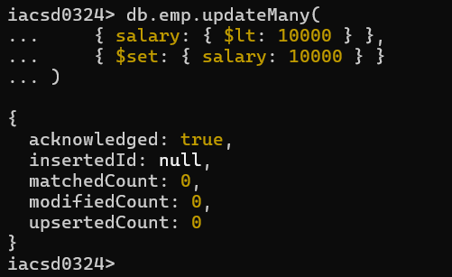

1. Increase bonus of all employees by 500 if the bonus is <2000 or their salary is < 20000 or if employee belong to sales department

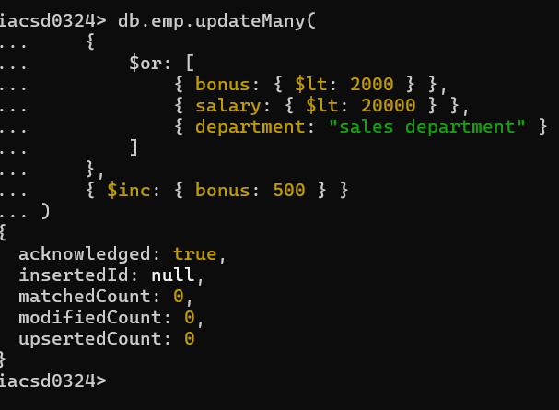

1. Add 2 new project at position 2 for all employees with designation analyst or salary is equal to either 30000 or 33000 or 35000

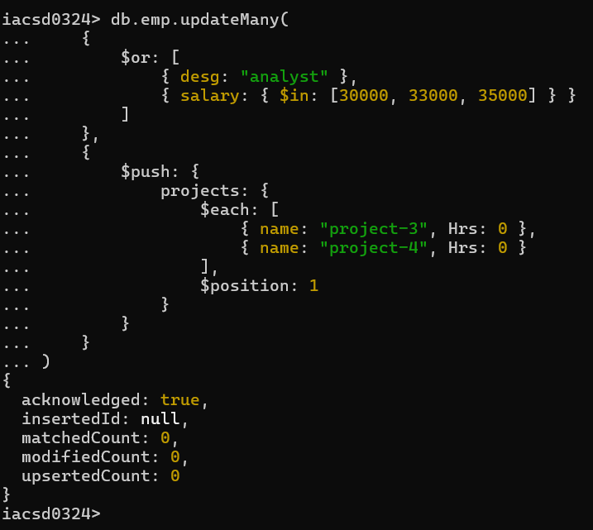

1. Delete last project of all employees with department name is “HR” and if the location is Mumbai

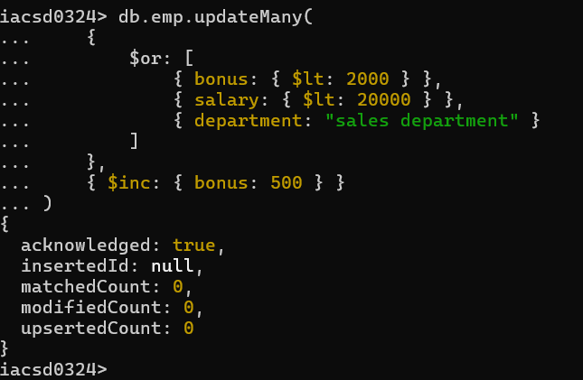

1. Change designation of all employees to senior programmer if they are working on name:”Project-1” for 4 hrs

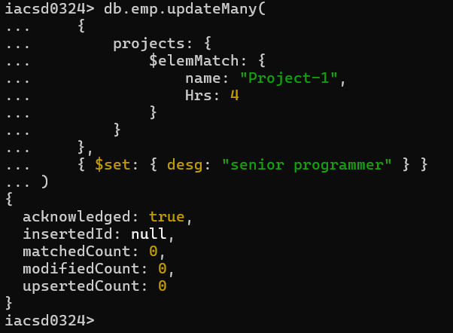

1. Add list of hobbies in all employees document whose manager is Rajan or Revati

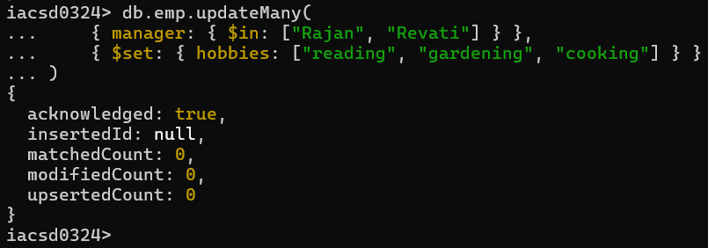

1. Add list of skillset in all employee documents who are working on project-4 for 3 hrs or on project-3 for 4 hrs

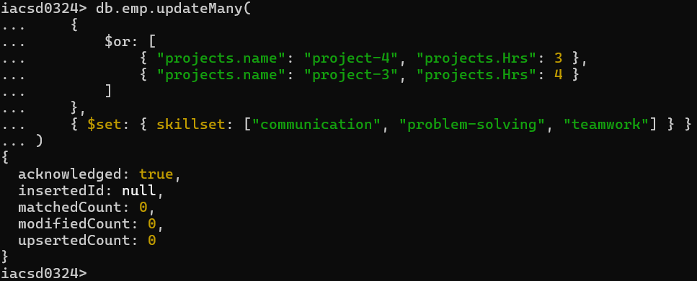

1. Add a new hobby as blogging at 3 position in hobbies array for all employess whose name starts with R or p and ends with j or s

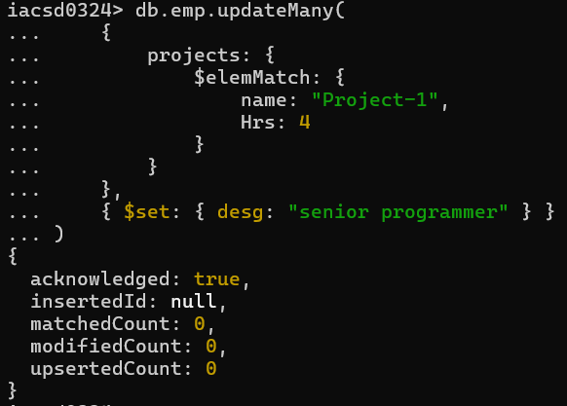

1. Increase salary by 10000 for all employees who are working on project-2 or project-3 or project-1

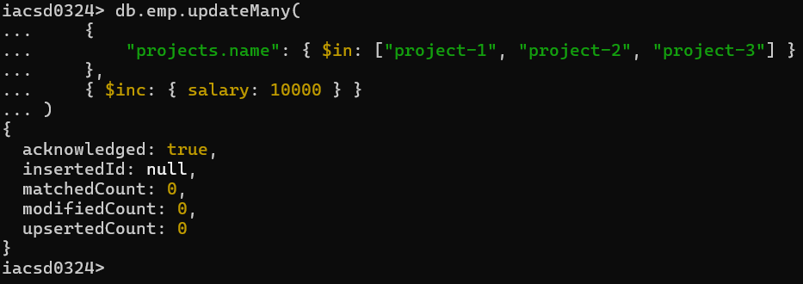

1. Remove all employees working on project-1

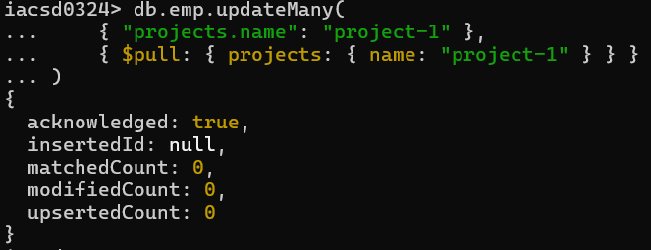

1. Replace document of employee with name “Deepak to some new document

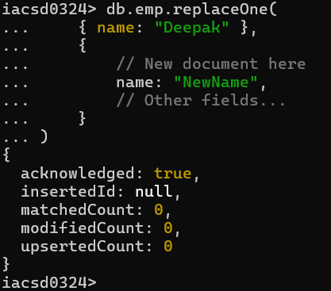

1. Change skill python to python 3.8 for all employees if python is there in the skillset

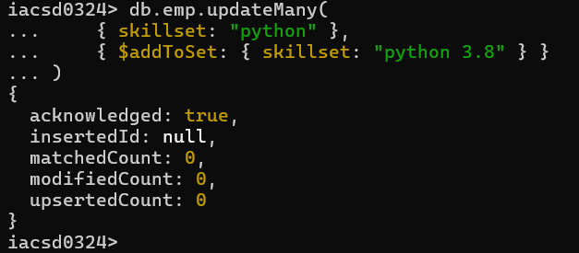

1. Add 2 skills MongoDb and Perl at the end of skillset array for all employees who are working at Pune location

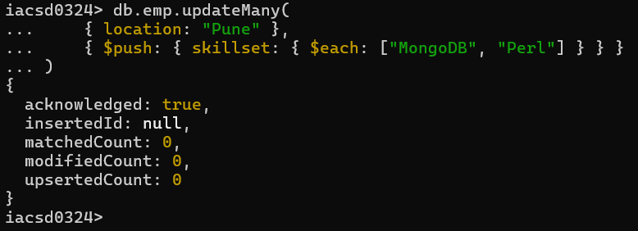

1. Delete first hobby from hobby array for all employees who are working on project-1 or project-2

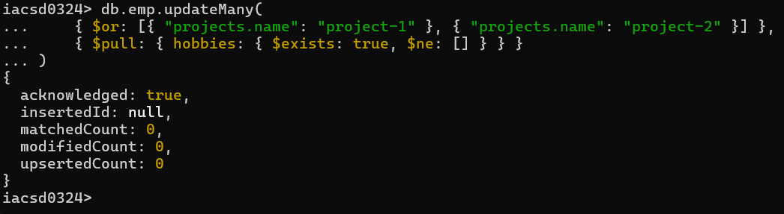

1. Delete last hobby from hobbies array for all employees who are working on project which is at 2 nd position in projects array for 4 hrs

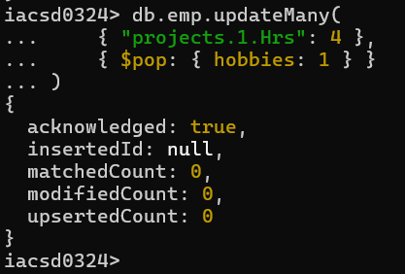

1. Add 2 new projects at the end of array for all employees whose skillset contains Perl or python

